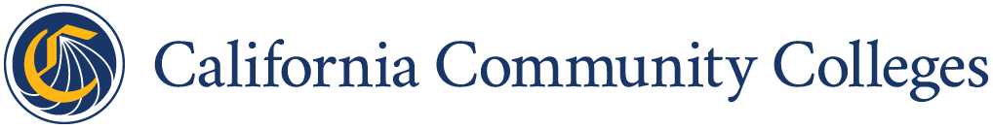

Statement of Assurance
(K12 Partner Agency)

From: [insert Partner LEA name and name of accountable party for the K12 Partner Agency w/ contact info]

To: [insert Lead LEA and name of accountable party for the Partner Agency]

RE: Statement of Assurance

Assurances:
A duly authorized representative for the K12 Partner Agency has reviewed all assurances, certifications, and terms and conditions of the K12 SWP and is familiar with grant expectations. By signing this form, the agency attests that the project is:
- In compliance with K12 SWP legislation (Education Code, Section 88827 – 88828(c)(8)(C)):
  - All partners will report outcomes and financials in the NOVA and DataVista.
- Aligned with district’s most recent Local Control and Accountability Plan.
- Informed by, aligned with, and expands upon the region’s Strong Workforce Regional Plan and planning efforts occurring through the Strong Workforce Program.
- Informed by Labor Market Information, Vision 2030, and regional priorities.
- Staffed by skilled teachers or faculty and provides professional development opportunities for those teachers or faculty members.
The K12 Partner Agency also assures commitment to:
- Report data that can be used by policymakers, LEAs, community college districts, and their regional partners to support and evaluate the program, including, to the extent possible, demographic data used to evaluate progress in closing equity gaps in program access and completion, and earnings of underserved demographic groups.
- Utilize awarded grant funding and the match funds contributed solely for the purpose of supporting the program(s) for which the K12 SWP grant is awarded

[Insert Name of K12 Partner LEA]
Signature:
Printed Name:
Date:

Verified by the Lead LEA [Insert Name of Lead LEA District]
Signature:
Printed Name:
Date

