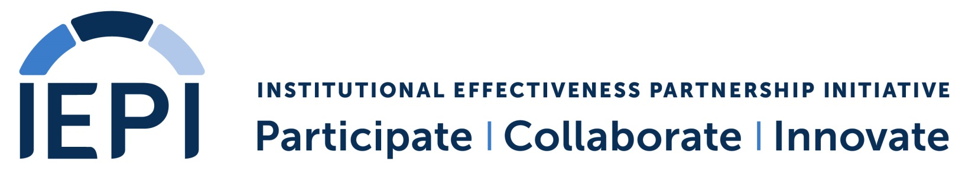

Institutional Effectiveness Partnership Initiative
Partnership Resource Teams
Institutional Innovation and Effectiveness Plan
Date:

Name of Institution:

Area of Focus | Objective | Responsible Person | Target Date for Achievement | Action Steps | Measure of Progress | Status  As of Date:

Request for IEPI Resources to Support Institutional Innovation and Effectiveness Plan

Applicable Area(s) of Focus  (Copy from table above.) | Applicable Objective(s)  (Copy from table above.) | Description of Resource Needed  (Refer to Action Steps above as appropriate.) | Cost of Resource
Total IEPI Resource Request
(not to exceed $200,000 per college)

Approval |  |  | Collegial Consultation with the Academic Senate
Chief Executive Officer |  |  | Academic Senate President  (As applicable; duplicate if needed for district-level I&EP)
Name: |  |  | Name:
Signature or  E-signature: | Date: |  | Signature or  E-signature: | Date:

