STATE OF CALIFORNIA | ELOY ORTIZ OAKLEY, CHANCELLOR
California Community Colleges  Chancellor’s Office  1102 Q street, Suite 4400  Sacramento, Ca 95811-6549  (916) 322-4005  http://www.cccco.edu | 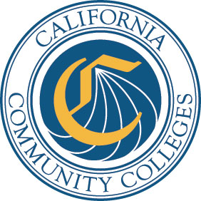

DATE: March 13, 2017
TO: Presidents/Superintendents
Chief Student Services Officers
Chief Instructional Officers
Chief Business Officers
Academic Senate for California Community Colleges
FROM: Pamela D. Walker
Vice Chancellor, Academic Affairs Division

SUBJECT: Fund for Student Success: Mathematics, Engineering, Science Achievement

(MESA) Request for Applications (RFA)

SYNOPSIS: The California Community Colleges Chancellor’s Office is pleased to announce the open competitive bid process for MESA. The purpose of these funds is to support the management of community college MESA programs. MESA programs are designed to provide academic and support services for economically and educationally disadvantaged students majoring in calculus-based fields who seek to transfer to four-year colleges and universities. A dollar-for-dollar match is required. All Districts/Colleges are encouraged to apply, including those funded under the previous FSS-MESA grant.

We invite you to participate in this innovative and proven program. The grants awarded through this Request for Applications (RFA) Specification are for the 2017-18 fiscal year and up to a three-year project. Continued funding is contingent upon completion of the approved prior year’s objectives, the submittal of a renewal application, and state funding.

The Mathematics, Engineering, Science Achievement (MESA) program funding is

contingent upon the State Budget.

RFA Specification Number: | 17-034
Program Division: | Academic Affairs
RFA Title: | MESA Program
Funding Source: | Fund for Student Success (FSS)
Funding Category: | New and Existing Program Funding
Funding Period: | July 1, 2017 through June 30, 2018
Maximum Funds Available: | $2.4 million
Number of Awards: | Based on the number of eligible applications, and not to exceed 35 programs at $70,250 per college

ACTION REQUESTED: Follow the Request for Application No. 17-034 Specifications, Instructions Terms and Conditions. The RFA is available at the Chancellor’s Office website (www.cccco.edu) under Divisions > Academic Affairs > MESA l > RFA and Forms.
Applications must be received at the Chancellor’s Office by 5:00 pm on Monday, May 15, 2017. For additional information or clarification, contact Debbie Velasquez at 916.323.2768 or dvelasquez@cccco.edu
Mail/submit completed applications to:
Chancellor’s Office, California Community Colleges
Academic Affairs Division
Attn: MESA Application Enclosed
1102 Q Street, Fourth Floor
Sacramento, CA 95811-6549

