STATE OF CALIFORNIA | ELOY ORTIZ OAKLEY, CHANCELLOR
California Community Colleges  Chancellor’s Office  1102 Q street, Suite 4400  Sacramento, Ca 95811-6549  (916) 322-4005  http://www.cccco.edu | 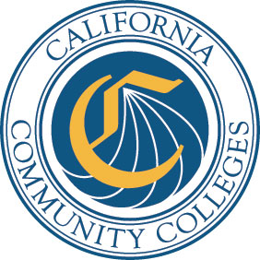

DATE: June 21, 2017 AA 17-39
VIA E-MAIL
TO: Chief Executive Officers
Chief Business Officers
Chief Instructional Officers
Chief Student Services Officers
Academic Senate Presidents

FROM: Pamela D. Walker, Ed.D.
Vice Chancellor, Educational Services

SUBJECT: MATHEMATICS, ENGINEERING, SCIENCE ACHIEVEMENT READERS

The Chancellor’s Office is seeking individuals, from a variety of backgrounds, to read and score Mathematics, Engineering, Science Achievement (MESA) applications.

The MESA program will allocate funding for up to thirty-five MESA programs in California. MESA programs provide academic and support services for economically disadvantaged students majoring in calculus-based fields who seek to transfer to four-year colleges and universities. The application review period will be July 20-27, 2017. Participants will be provided with instructions and application scoring sheets, as they are able to read and score the applications remotely. Each reader will review approximately 5-7 MESA applications, although the total number of applications will not be known until the submission deadline of 5:00 pm on July 14, 2017.

Individuals interested in participating as readers should complete, sign, scan and e-mail the attached form to dvelasquez@cccco.edu by July 7, 2017.

cc: Sally Montemayor Lenz, Dean
Debbie Velasquez, Specialist

