STATE OF CALIFORNIA | ELOY ORTIZ OAKLEY, CHANCELLOR
California Community Colleges  Chancellor’s Office  1102 Q street, Suite 4400  Sacramento, Ca 95811-6549  (916) 322-4005  http://www.cccco.edu | 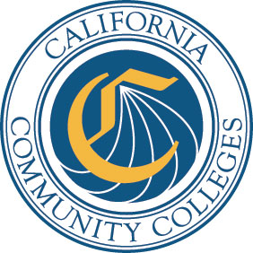

DATE: June 16, 2017 AA 17-33
VIA E-MAIL

TO: Chief Executive Officers
Chief Instructional Officers
Chief Student Services Officers
Academic Senate Presidents

FROM: Jackie Escajeda
Dean, Intersegmental Programs and Credit Curriculum

SUBJECT: California Community Colleges Advanced Placement Credit Policy

Frequently Asked Questions
On September 23, 2016, Assembly Bill (AB) 1985 Advanced Placement Credit (2016, Williams) was signed into law by Governor Brown. Thus, the Chancellor of the California Community Colleges, in collaboration with the Academic Senate of California Community Colleges (ASCCC), developed a uniform policy. This new policy, released in memorandum AA 17-20 Policy Change: Advanced Placement Credit, dated March 30, 2017, from Vice Chancellor Walker, detailed the Advanced Placement Policy Language for General Education Credit. As questions arose regarding the new policy, the Chancellor’s Office and the ASCCC created a list of Frequently Asked Questions (FAQs).

Please contact Raul Arambula at rarambula@cccco.edu if you have any questions.

cc: Raul Arambula, Jr., California Community Colleges Chancellor’s Office
Dave Degroot, Academic Senate for California Community Colleges
Ginni May, Academic Senate for California Community Colleges
Bob Quinn, California Community Colleges Chancellor’s Office

