Telecommunications and Technology

Table of Contents
Executive Summary
Page 1

Methodology
Page 3

TTIP Background
Page 3

Summary of Chancellor’s
Office funded Programs
Page 4

Financial Chart
Page 36

Emerging Concepts
Page 37

Conclusion
Page 38

Acknowledgments
Page 39

Table of Contents
Executive Summary
Page 1

Methodology
Page 3

TTIP Background
Page 3

Summary of Chancellor’s
Office funded Programs
Page 4

Financial Chart
Page 35

Emerging Concepts
Page 36

Acknowledgments
Page 37
Infrastructure Program
Executive Summary

The California Community Colleges serve more than
2.4 million students and is the largest system of higher
Education system in the nation. The state’s 112 colleges
provide workforce training, teach basic math and English,
and prepare students for transfer to four-year universities
and colleges.

The Chancellor’s Office Telecommunications and Technology
Infrastructure Program (TTIP), was created by Budget Act
language in fiscal year 1996-97 to provide system-wide technical
innovations and support and to coordinate activities that
maximize the system’s investment in technology. In the
beginning, TTIP recognized the importance of connecting
educational institutions to the emerging internet community and
ultimately connected colleges to the 4CNET backbone. Connectivity
was then expanded to the video conferencing and satellite networks,
enabling colleges to share both data and video communications.
Library automation, local telecommunications planning,
technology training and e-conferencing were also supported
through TTIP.

In 2001, as the demand for bandwidth increased, 4CNET and the California Community College System began merging with the Corporation for Education Network Initiatives in California (CENIC), an optical network formed by charter partners (University of California, California State University, Stanford University, California Institute of Technology, and University of Southern California) to provide high speed / high capacity networking and represents the common interests of California’s higher education academic and research communities.

In 2008, TTIP funding for critical functions such as libraries and TTIP allocations for colleges to maintain local technology and infrastructure was eliminated. The TTIP budget was reduced from approximately $44 million in 2001 to its current level in 2011-2012 of $15.3 million. This 65 percent reduction requires colleges to finance the technology expenditures that TTIP once supported.

For a second year, TTIP budget cuts have prompted the Chancellor’s Office to ask colleges to partially fund the cost of their backup circuits. Backup circuits provide colleges with an alternate path to the Internet should the primary connection fail. Of the 50 colleges with TTIP funded backup connections in place, 25 percent were forced to cancel their backup circuits due to financial hardships. The colleges and districts rely heavily on general apportionment and other non-TTIP revenue sources to support their technology needs and cuts to all funding sources are putting mission-critical services at risk.

Even with the budget reductions, TTIP continued to provide technical support and technology application innovations, and coordinated activities that maximized the system’s investment in technology with the expressed goal of improving learning outcomes.

This 15th annual report highlights up-to-date information on the programs supported through TTIP. In cooperation with the Corporation for Education Network Initiatives in California (CENIC), Internet connectivity speed for some severely underserved colleges was increased and the Technology Center continued to provide technical assistance and planning, cooperative purchase agreements and supported new statewide technology pilots and ongoing technology programs. The partnership with CENIC provides high-bandwidth connectivity and enables the system to negotiate a flat rate, which is now saving the system as much as $2.2 million annually through the California Teleconnect Fund Program.

Through technology, TTIP strives to improve education and educational services and is committed to innovation and student success. Technology continues to change the way educational institutions run their business and educate their students. The Telecommunications, Technology and Infrastructure Program brought high-speed broadband to the California Community Colleges and the program continues to challenge the status quo through innovative solutions.

TTIP funding remained steading this year at $15.3 million. TTIP worked with CENIC, the California Public Utilities Commission, and the California Teleconnect Fund to reduce Internet costs for all colleges in the system and worked diligently to continue to seek out technology-related grants.

In 2012-2013, TTIP will continue working to implement strategies to deal with long-term, lower technology funding levels. In this vein, one of the principal goals of the Tech IV Plan, created in 2010, is to leverage and build upon our investment in existing projects, reduce costs and develop innovative solutions to support the educational communities of the future.
Through technology, TTIP strives to improve education and educational services and is committed to innovation and student success.
Methodology

The Chancellor’s Office Telecommunications and Technology Unit is continuously engaged with grant teams and personnel throughout the state. In addition to reviewing biannual updates, the technology unit staff attends regular project meetings and participates in impromptu discussions and face-to-face events with the teams. The staff also collaborates on current technology issues with advisory committees from the system’s colleges.

Data used in this report was submitted by the director of each grant project. Additional project details can be found at the following URL and then selecting the individual grant:

http://extranet.cccco.edu/Divisions/TechResearchInfoSys/Telecom.aspx

TTIP Background

The Chancellor’s Office Technology, Research and Information Systems division
governs TTIP, which is guided by provisions of the Tech IV Plan. The Tech IV Plan
builds upon the work established in Tech I, II, and III.

Tech IV programs have the following objectives:
- Protect the state’s prior technology investment.
- Expand and improve student services.
- Utilize current technology to leverage the existing infrastructure.

Funding for some TTIP projects comes from the Chancellor’s Office. Since 1996/97,
the Chancellor’s Office has funded six system-wide technology projects, all with a
competitive grant process. These projects are listed on the next page.

Summary of Chancellor’s Office TTIP Funded Programs

The Chancellor’s Office recognizes that technology is an increasingly integrative and essential part of many services and programs in the college system. The following seven projects are funded with TTIP dollars and the California Community Colleges and are highlighted in this year’s report:

The Technology Center, which incorporates the following programs:

- CCC Systemwide Technology Platform
- CCCApply
- Open CCCApply
- OpenCCC Identity Federation
- eTranscript California
- Corporation for Education Network Initiatives in California (CENIC)

The California Partnership for the Achievement of Student Success (Cal-PASS)

3C Media Solutions

EduStream

CCCConfer

@ONE

California Virtual Campus, which incorporates the following programs:

- ePortfolio California
- CCC / MyEdu Degree Planning
- CCC-CETC (California Educational Technology Collaborative) programs

To maximize resources and services for technology projects throughout the California community colleges, The California Educational Technology Collaborative, was formed. Collaborative members are the project directors from:

Technology Center – Butte College
Cal-PASS – Grossmont-Cuyamaca Community College District
3C Media Solutions – Palomar College
@ONE – Evergreen Valley College & Mt. San Jacinto College
California Virtual Campus – Butte College
CCC Confer – Palomar College
EduStream – San Bernardino Community College District
The Technology Center
The California Community Colleges Technology Center (CCCTC) received funding from a $2,830,353 Chancellor's Office grant with the Butte-Glenn Community College District (prior year funding of $4,527,000). The CCCTC is hosted on the Butte College campus and facilitates and coordinates technology projects. The CCCTC staff disburses funds, manages contracts and identifies resources for external funding.

Technology Center Initiatives
Systemwide Technology Platform | Federated Identity enables access to participating inter-segmental systems, government agencies and vendors through a single user name and password, known as the OpenCCC project.  Service Oriented Architecture enables colleges to access and use parts of existing program code within their applications and enable new features without a complete system upgrade.  Enterprise Portals allow colleges to integrate services into their websites and Student Services Portal will link statewide services.  Elastic Cloud Infrastructure supports high user demand without building new data centers.  Business Intelligence to facilitate analysis of student pathways, outcomes, transfer and institutional performance for continuous improvement.
CCCApply and OpenCCCApply | Systemwide Online Admission Application provides colleges and students with a common web-based application for college.
eTranscript California | Inter-segmental Internet-based system for requesting, sending, downloading and viewing academic transcripts.
CENIC Contract Management | TTIP partners with CENIC to leverage cost-effective network resources to provide Internet connectivity for colleges.
Listserv Services, Web-Hosting | Manages Community College listserves and hosts websites for statewide projects CCCApply, eTranscript California and CCC Clearninghouse. Combined there are a total of more than 69,000 subscriptions and 162 lists that deliver on average more than 300,000 messages per month.
Help Desk Services | Negotiates discounted help desk support services for colleges.
CCC Curriculum Inventory  and Reporting | Statewide curriculum reporting system for electronic submission of curriculum information to the Chancellor’s Office.
Technical Community Support | CCCTechEdge, a technology email newsletter / website  Systemwide Architecture Committee Governance  Telecommunications & Technology Advisory Committee

The Technology Center
California Community College Systemwide Technology Platform
The California Community College’s Technology Center is developing a CCC Systemwide Technology Platform standard that will allow the system to build new Web 2.0 applications that work together, provide sharable services to the colleges, and incorporate legacy functionality to enable transition to the next generation.
The technical infrastructure of the California Community Colleges and the larger system of education in California is comprised of numerous databases and technical applications. These systems are not networked and the lack common standards and data structures that enable automated connectivity and data sharing. The California Community College Systemwide Technology Platform will provide the technical framework and guidelines for existing and future statewide technology projects.

In 2010-11, development commenced on the California Community College Systemwide Technology Platform to support a new common application to college, OpenCCCApply. The new federated account system (OpenCCC) is nearing completion as the primary account system for OpenCCCApply. Both systems are being developed to leverage Service Oriented Architecture (SOA), Enterprise Portal Technology, and Elastic Cloud Infrastructure to scale to the millions of students accessing the systems every year. This work forms the basis for all future California Community College technology development.
This graphic diagrams the CCC Technology Platform and shows the relationship between the components.

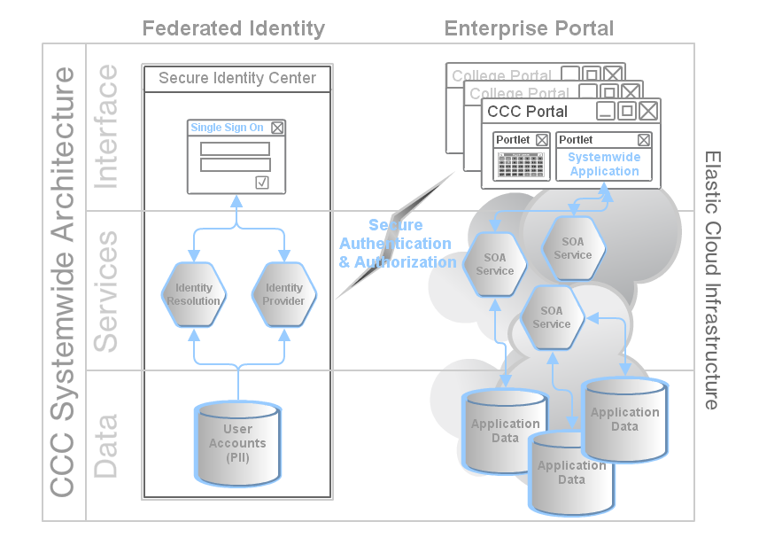

The Technology Center
CCC Systemwide Technology Platform
The Systemwide Technology Platform is composed of the following technologies:
FEDERATED IDENTITY
- Enables a common log-in for the student and staff across applications and
institutions while increasing security and privacy.
- The greatest potential benefit for the Chancellor’s Office may be in
transferring student account data to California State University (CSU) or
University of California (UC).
- CSU and UC have Federated Identity initiatives based on the InCommon
Federation.
- InCommon includes more than 200 higher education institutions, government
agencies and vendors.

SERVICE-ORIENTED ARCHITECTURE
- Deconstructs isolated systemwide applications into their component
services and connects them using secure Internet communications.
- This enables component services to be reused by college or vendor
applications and combined into composite applications.

ENTERPRISE PORTALS
- There is a growing trend of colleges moving to web portal interfaces for
students.
- Systemwide applications will be provided as portlets so colleges can
easily provide additional services and functionality for students.
- In addition, a student services portal would tie together statewide
applications with a common introductory page.

ELASTIC CLOUD INFRASTRUCTURE
- Elastic cloud platforms move the computing power behind deployed
applications.
- The platform is monitored and will scale up or down depending on
demand.
- The dynamic system has made it possible to efficiently support the
annual cyclic student demand on student services applications without
having to build a large data center to handle peak loads.
- This efficiency will result in lower costs to the colleges.

BUSINESS INTELLIGENCE
- To facilitate analysis of student pathways, outcomes, transfer, and institutional performance for continuous improvement, there is a need to bring together various disparate data sourced from the existing applications within our system and tie it together into usable structures that can be easily researched and presented to end users in a usable format for immediate and future decision making purposes, elastic cloud platforms move the computing power behind deployed
applications.

The Technology Center
Striving to Improve Educational Services and Student Success
The Technology Center strives to improve education and educational services and is committed to innovation and student success.
The Technology Center serves students and supports student success by establishing the technical platform that supports the initiatives set forth by the Student Success Taskforce(SSTF) and ultimately SB1456, the Student Success Act of 2012.
- SSTF Recommendation 2.3
  - Community colleges will develop and use centralized and integrated technology, which can be accessed through campus or district web portals, to better guide students in their educational process.

The Technology Platform developed by the Technology Center provides solutions designed for and made available to all colleges in the California Community College System.
The Federated Identify Project addresses a reality within the California Community Colleges: students are increasingly mobile and attend multiple institutions to achieve their educational goal, even attending multiple institutions in the same semester. As such, each institution will assign the same student a different student identifier which makes tracking and providing services to students within the community colleges extremely difficult. The Federated Identity Project established a single identifier for a student and effectively makes the student a student of the California Community College System and expands the Chancellor’s Office ability to provide centralized and commonly available services to help guide a student through the educational process.
The Services Oriented Architecture and Enterprise Portal Projects will increase the service offerings that colleges can make available to students by lowering the design, development and implementation costs associated with new service offerings. With continuous input from local community college experts, services and applications will only need to be designed and developed once, at the state level, and will be available for use at all colleges. Since most colleges have very limited information technology(IT) staff (some have 1-2 staff in support of an entire campus), a centrally developed application increases the offerings to students who attend campuses with limited IT resources and helps to reduce inequalities within the System, in addition to creating a “common look and feel” across all California Community Colleges. A “common look and feel” allows students to focus on exploring and planning their education versus learning to navigate a variety of technical applications.
The Elastic Cloud Infrastructure of the Technology Platform provides a flexible system that responds to fluctuating usage cycles to provide students with a stable and responsive technical experience. Finally, the Business Intelligence Project will serve as the data mining tool for students to explore program and transfer requirements, plan a degree and request and/or receive information related to student services and support.

The Technology Center
Systemwide Online Admission Application - CCCApply
CCCApply is a web-based student application process available to all community colleges and is funded through the Technology Center Grant at Butte College. The site (www.cccapply.org) provides comparative descriptions of the colleges and their programs in an efficient, automated program. To date, 103 colleges subscribe to CCCApply.

Fiscal Year | Student Applications
July 2007-June 2008 | 1,169,555
July 2008 – June 2009 | 1,596,578
July 2009 – June 2010 | 1,794,147
July 2010 – June 2011 | 2,180,000
July 2011 – June 2012 | 1,925,407

OpenCCCApply

The existing application to college (CCCApply) is now over 11 years old. The legacy technology and vendor hosting environment present issues with student experience, cost, security and service to the colleges. In response, the Technology Center initiated the OpenCCCApply project.

OpenCCCApply features a Web 2.0 open source application to colleges built on the California Community College Systemwide Technology Platform.

This state-of-the-art, highly secure system will feature:

- A streamlined application to college, including Spanish language help and a Board of Governor’s Fee Waiver

- Business Intelligence tools for college reporting

- Integration of the OpenCCC federated systemwide account offering students one login account for all participating California Community Colleges.

Once fully implemented, OpenCCCApply is projected to save the colleges more than $600,000 each year through cost savings in hosting, open source licensing and support.

The Technology Center
OpenCCC – Identity Federation

OpenCCC is the California Community Colleges’ Federated Identity Initiative.

OpenCCC allows students and staff access to Web-based information technology applications across colleges and within the California Community College system via a single sign-on account. The initiative eliminates the need to manage a multitude of accounts and passwords, and reduces opportunities for accounts to be compromised. Central to linking systemwide and college data through OpenCCC is the application of a systemwide identifier (CCCID). As many of our students attend several colleges over the course of their academic experience, tying their disparate data together not only will help the system do a better job of serving each student, but will also support data analysis, the identification of trends and strengthen the California Community Colleges effectiveness as a system.

Help Desk
Currently 92 percent of all support calls for CCCApply are account recovery related issues. This number is expected to drop significantly with the application of the OpenCCC federated account, but help desk services are provided for users who cannot access their accounts.

Community Based Support Platform
A community based support platform is in place where students can ask questions, see similar questions and answers, report problems, share an idea, or give praise. Other staff and students can comment and provide input on the issues as well. As students self-serve to find answers to questions this type of community platform should increase student satisfaction and drive down support costs as a knowledge base of frequently asked questions and answers is built.
The Technology Center
eTranscript California

The Chancellor’s Office has established a statewide Internet-based system for
requesting, transmitting, downloading and viewing academic transcripts. This system is
referred to as “eTranscript California” and was formerly known as “CCCTran”
(http://www.eTranscriptCA.org). Current participants live and/or implementing include:
California Community Colleges | 49 of 112
California State University | 19 of 23
University of California | 10
Private universities | 5

With the addition this year of the University of California system and Los Angeles Community College District, 83 institutions across California participate in the network and enjoy the benefits and significant cost savings of up to $10 per transcript inherent in electronic transcripts.

SB1056, legislations backed by the eTranscript California intersegmental steering committee and proposed by California Community Colleges Chancellor’s Office, was signed into law in 2011 and requires all California Community Colleges to transmit and receive electronic transcripts. This initiative would result in significant savings for the system as approximately half of all community college transcripts are sent to other community colleges.

The California Community Colleges Chancellor’s Office received $500,000 in one-time funds from the California Assembly to support the implementation of electronic transcripts. In response, the California Community College Electronic Transcript Mini-Grant Program was implemented.

The program promotes the usage of the California Transcript Standard for transmission of California specific data such as General Ed, IGETC, and Transfer Degrees by CCC. A community college may implement through the eTranscript California network or a third-party vendor, as long as the California standard is adopted. The eTranscript California staff is working closely with vendors to promote the standard within their systems for the college’s mini grant projects.

The mini grant offers $5,000 to accomplish any one of three options for colleges that are brand new to eTranscripts or are furthering their implementations:

- Send and Receive Transcripts
- Automatically Send Transcripts based on an Electronic Request
- Receive Transcripts into Campus Systems such as Education Planners, Degree Audit, Student Information System, etc.

Colleges may apply to complete projects for more than one option. To receive grant funds they must complete their projects by June 30, 2013 and communicate their success to the other institutions. The application deadline is Dec. 31, 2012.

The Technology Center
eTranscript California

Current Mini-Grant Status:
- 61 colleges have applied for mini grants and are working on or have completed their projects
- 16 colleges have given verbal commitments to apply before the application deadline
- 13 colleges have indicated they are considering the mini grant

eTranscript California highlights include:
- Reduced per transcript processing cost from as much as $10 to 50 cents.
- Reduced staff workload--500 transcripts automatically process in 15 minutes.
- High school electronic transcript capability in production.

Participation in Electronic Transcripts Continues to Increase
 | 2008-09 | 2009-10 | 2010-11 | 2011-12
Transcripts Delivered | 85,000 | 150,000 | 267,000 | 355,000
Institutions | 51 | 57 | 74 | 82

Estimated costs savings to the Californian Educational System in 2011-12
Paper transcripts cost between $7 to $10 to send, whereas an electronic transcript costs 50 cents. In 2011-12, colleges sent 355,000 electronic transcripts. If these transcripts were sent in paper format, the cost to the system would have been $3 million compared to $177,500 for electronic transcripts.

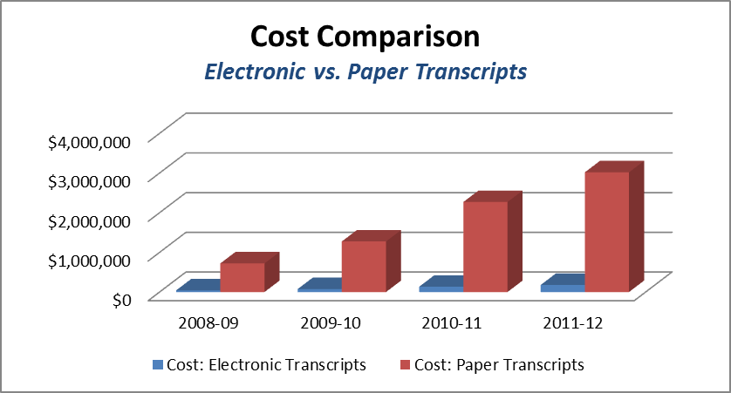
$2.84 Million Dollars in estimated savings in 2011-12
*Cost estimates for paper transcripts based upon an average cost of $8.50 to send
**Cost estimates for electronic transcripts based upon 50 cents per transcript
***These CCC savings do not include the substantial savings to the CSU and UC systems by directly receiving data.

The Technology Center

Corporation for Education Network Initiatives in California (CENIC)

TTIP funds a portion of initiatives for California's education and research communities. TTIP leverages resources to obtain the most cost-effective networking. Partnering with CENIC to use the California Research and Education Network (CalREN), a high-bandwidth, high-capacity Internet network that consists of 3,000 miles of CENIC-owned and managed fiber, has resulted in millions of dollars in savings for the community colleges. This strategy supports TTIP missions and answers the growing needs of faculty, staff, and students.

CENIC designs, implements, and operates CalREN specifically to meet the unique requirements of the education and research communities. CENIC consists of charter members from the University of California, California State University, the California Community Colleges and K-12, Stanford, California Institute of Technology and the University of Southern California. For more information see http://www.cenic.org.

CENIC provides:

- Centralized funding for no local cost Internet connection at all colleges.

- $2 million in savings on Core Network Backbone costs through the California Teleconnect Fund program because of CENIC's initiative with the California Public Utilities Commission.

- Connection at all colleges and districts to the CalREN for data, Internet access and video.

- An additional $4.4 million savings on colleges' circuit/connectivity costs through the California Teleconnect Fund program, a 50 percent discount due to CENIC backing the CCC.

- Economies of scale and peering (where two or more networks exchange traffic between each other’s customers freely, and for mutual benefits) continue to assist in improving connectivity rates that are saving $112,500 per year.

- Connection at 16+ approved off-site centers to CalREN.

- Services to schedule and connect systemwide video conferences on the K20 network saving $515,000.

CENIC has continued to provide very reliable and high performing networking to the California Community Colleges, with decreasing or fairly flat fees. If each college acquired Internet access independently they would gain a burden of workload at substantially increased administrative costs simply in monitoring and making payments for connectivity. Based on several analyses that have been conducted, the cost of using the CENIC CalREN network are substantially less than those that would be incurred by colleges for the same level of connectivity and bandwidth obtained via other means. This is due to the fact that CENIC is uniquely positioned to leverage education community-owned networking infrastructures and resources, as well as inter-segmental aggregation of demand across the education community in California, to maximize cost-savings opportunities for California Community Colleges.

The Technology Center

Corporation for Education Network Initiatives in California (CENIC)

Additionally, some of the services offered by CENIC cannot be duplicated or provided with equivalent performance via other means. For example, CENIC connects its network directly to a variety of major sites of high interest to community colleges, such as Google, Amazon and Microsoft. These direct network connections enhance the ability of colleges to use desirable and cost-effective services such as Google e-mail, Amazon cloud services, etc. Other Internet providers would offer connectivity to these sites, but not as reliable and high-quality network performance as with CENIC. Moreover, CENIC's private network supports cost-effective emerging technologies such as Voice-Over-Internet Protocol, a new offering of CENIC, not able to be supported as effectively over alternative Internet connectivity approaches. Lastly, CENIC's expert staff frequently review connection routes and offer suggestions for reconfiguration that save the college and system even more. Individual colleges probably would not have this expertise and a for-profit Internet provider would not readily assist in reducing their own profits to the benefit of the colleges.

CENIC: Increased Bandwidth and Circuit Upgrades
The CENIC partnership keeps the colleges connected to the Internet and is funded through a grant with Butte College's Technology Center. CCCTC staff manages and disburses funds to CENIC. A total of $2,830,353 was funded in 2011-12.

Bandwidth upgrades to high priority sites, such as districts serving multiple campuses, were completed in 2009 and provided greater bandwidth delivery from one connection. Upgrades were expanded to the remaining colleges on Dec. 1, 2008 when the California Community Colleges became eligible for California Teleconnect Fund discounts. These discounts were initiated by CENIC with support from the California Public Utility Commission. The cost savings realized -- approximately a 50 percent discount -- provided resources for these additional circuit upgrades through 2010-11.

As mentioned, due to CENIC's understanding and efforts on behalf of the California Community Colleges the cost for Internet connectivity has remained stable while bandwidth has increased dramatically. In fiscal year 2006-07 costs were $3.8 million for DS-3 circuits at most of the college/district sites; a few rural sites were still operating on T-1 circuits. During 2011-12 the California Community Colleges spent only $448,000 more than in 2006-07 and 91 percent of the 119 sites and 16 centers now have connectivity via a GigE circuit. Addition of the these gigabit circuits has enabled more than 50 percent of the sites to preserve their DS-3 as secondary diverse circuit and/or a backup circuit for peak usage.

CENIC: Increasing Connectivity Options
CENIC and private sector partner CVIN (The Central Valley Independent Network LLC) created the Central Valley Next Generation Broadband Infrastructure Project, which was awarded $46.6 million in federal government stimulus funds. Additionally, CVIN LLC committed $13.2 million cash match and the CPUC will provide $6.6 million. This project will increase the availability of broadband networking infrastructure for 18 counties within the central valley and will result in a profound reduction in costs to the California Community Colleges. Again, CENIC is leveraging resources that neither the Chancellor's Office nor the colleges have at their disposal.

This fiber-optic project will result in significant savings as college and district sites reconfigure so that as many as 30 circuits will connect directly to the CalREN network for an annual savings of more than $400,000.

CENIC: Diverse Circuits – Budget Impact
Diverse circuits, also known as redundant or backup circuits, provide colleges and districts with an alternate path to the Internet should the primary connection fail.

Cuts in TTIP funding during 2009-10 and 2010-11 and lack of funding restoration in 2011-12 have forced the Chancellor's Office to seek assistance from California Community Colleges and districts in covering the cost of these vital secondary circuits. Approximately 50 sites have a secondary circuit, which means those sites no longer have a single point of failure and thus security of uninterrupted Internet connectivity. Now, colleges and districts that are already financially challenged are being asked to pay part of the cost of these secondary circuits. As of the writing of this report, 25 percent of those sites have been forced to shut off their secondary circuits for lack of funds.

Library Automation and Electronic Information Resources

In prior years, TTIP provided the California Community Colleges with financial assistance through the TTIP allocation process. In 2009/10, the library community suffered severe cutbacks and TTIP allocations to libraries were eliminated.

In an effort to support the libraries, TTIP offered a leadership grant to help sustain the community while library leadership developed a new approach to supplying content. The library leadership grant team proposed the central purchase and statewide adoption of a library content database. The team estimated a cost savings of 50 percent if the content database was purchased and adopted centrally versus at the individual college level.

Even in the presence of severe cutbacks in TTIP funding, TTIP recognized the importance of library content to community college accreditation and opted to make budgetary cutbacks in other areas of the program. The library leadership grant team issued a Request for Proposal and in early 2012, selected EBSCO as the statewide community college library content provider. By moving to a centralized contract, the system collectively has saved more than $3 million.

California Partnership for the Achievement of Student Success, Cal-PASS
The California Partnership for the Achievement of Student Success (Cal-PASS), supported through a $1,139,000 grant with the Grossmont-Cuyamaca Community College District, began in 1998 to enable the collection, analysis and sharing of student data in order to track performance and improve success from elementary school through university. The Cal-PASS was rebid for the upcoming 2012-13 fiscal year and the grant was awarded through the competitive grant process to the San Joaquin Community College District.

Cal-PASS Services
- Connect K-12, community college and university students and faculty using a large scale student transcript level data system.

- Analyze K-16 student performance data through systematic research projects, data reviews and analysis tools.

- Assemble educators to analyze K-16 student data, make alignments and adjustments in curriculum and pedagogy across the educational segments based upon performance data.

Cal-PASS provides a critical service to the Californian educational system since California lacks a single repository for student data. Without a single repository, research and analysis nears impossible.

Membership
Since its inception, Cal-PASS has brought together primary, secondary and postsecondary educational
segments through voluntary regional data-sharing partnerships. Members upload data to the Cal-PASS database, which maintains 440 million student records across the segments. Membership includes all of the University of California and California Community College institutions. Currently 18 of 23 California State Universities and 8,573 K-12 schools (66 percent) are members. Over the past three years, growth in all segments has remained steady or increased slightly as membership nears 100 percent. The K-12 system is the remaining area of potential growth in California.
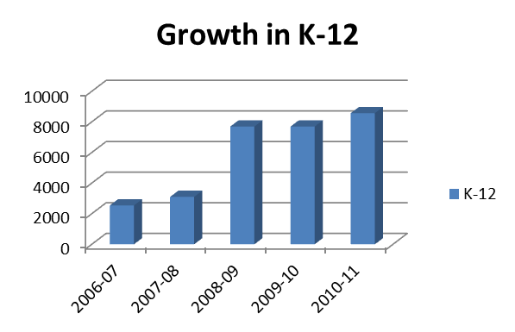
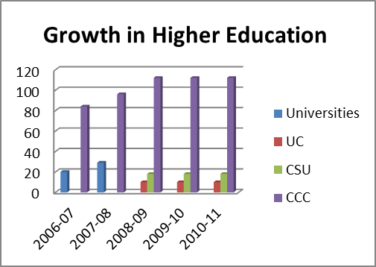

*UC and CSU systems reported as “Universities” in 2006-07 and 2007-08

California Partnership for the Achievement of Student Success (Cal-PASS)
Professional Learning Councils, (PLC)

To further the efforts of curricular alignment, 24 PLCs representing approximately 1,000 K-16 English, math, counseling, science, career technical education, English as a second language and allied health educators meet and are led by trained regional coordinators to improve transition across the segments and reduce barriers to student success.

PLC and Faculty Participation Trends
 | 2006-07 | 2007-08 | 2008-09 | 2009-10 | 2010-11 | 2011-12 | Decline from  prior year
PLC | 25 | 55 | 66 | 64 | 47 | 24 | 49%
Faculty | 400 | 1000 | 1400 | 1200 | 1000 | ~500 | 50%

Budget Cuts Trigger Decline in PLC Participation
Cal-PASS state funding decreased from $2.3 million to its current $1.139 million. At its peak, Cal-PASS maintained 66 professional learning councils in English, Math, English Learner (EL), Counseling, Science, Health Careers Pathway and Career Technical Education (CTE) in 26 regions throughout California. Currently, there are 24 California PLCs, supported in a variety of ways through a combination of state funding, grants, and external/local funding through school districts and colleges. Of these, 19 rely solely on state funds. While the work to date is impressive, the reduction in funding has resulted in fewer PLCs, meaning that fewer faculty across the segments have access to the tools, the training and support to align curricula and implement ground-level and lasting change.

Professional Learning Council Process
Professional Learning Council meetings are comprised of discipline-specific faculty from K–12 districts, community colleges and universities, who meet monthly after school on a faculty member’s own time. The meetings begin with an examination of regional data regarding student transition from high school to post-secondary. Most faculty are shocked to find out that anywhere from 42 to 94 percent of students took, as their first course at post-secondary, the same course they successfully completed in high school with a grade of C or better.

This shock propels the conversation among the faculty at the meeting. They begin to talk about what they do in their classrooms. They share state standards, texts, assignments and assessments. The outcome of this sharing usually points to the misalignment between one level of English or math (or whatever discipline is under study) and the next, and often explains why students are not doing well as they move from grade to grade or across the segments.

Based on the data and their understanding of what needs to be done to improve alignment and student outcomes, and facilitated by trained Cal-PASS Regional Coordinators, their conversation leads to action, including developing changes in practice or designing innovations.

Dissemination of PLC Findings
The work accomplished in the PLCs does not stay within the confines of the PLC faculty group itself. Their findings, resources, knowledge and best practices are disseminated to other faculty and administrators in their departments, schools, districts, regions and across the state in a variety of ways. The dissemination of this information leads to both better informed teachers and administrators and increased opportunities for communication, collaboration and alignment across the segments.

Improving Student Success, Innovations and Outcomes
There have been a significant number of funded innovations across the state in 2010-11, several of which have resulted in lowering remediation rates and improving student outcomes. A few innovations are listed below; the Cal-PASS website, www.calpass.org, maintains a comprehensive list.

More than 250 research studies have been conducted over the last three years. These reports have led to numerous changes in policy and practice throughout K-16.

The English Curriculum Alignment Project (ECAP), impacting approximately 12,000 students, improved CST (California Standards Test) and API (Academic Performance Index) scores in participating schools.

Algebra 1 through Pre-calculus deconstruction guides were developed by Math PLC faculty across the state. Data have shown that math entrance and exit expectations do not align across the segments and the four guides, available on the Cal-PASS website, were developed and used for teacher training, scope and sequence work, formative assessments and textbook selection.

Students who participated in a chemistry bridge course, developed by a Science PLC, have a higher success rate in chemistry than their matched peers (students receiving a “C” in algebra) who did not take the course.

Trying to increase the districts’ college going rate, a counseling PLC reviewed articulation agreements for CTE courses between regional high schools and community colleges. They found approximately 1,800 students were on track to successfully complete course requirements for dual high school and college credit. Savings to the state in terms of the reduction of duplicated coursework are immense. The counselors involved in this effort estimated that approximately $50,000 was saved in 2010-11 alone.

3C Media Solutions and EduStream, a partnership
3C Media Solutions
3C Media Solutions, www.3CMediaSolutions.org, began in 1999 as CCCSAT, a satellite system for broadcasting distance education, instructional and professional development programs to the California Community Colleges. The unit was renamed 3C Media Solutions in 2007 to reflect an expanded vision of multimedia services and support for the California Community College system. In 2008, 3C Media Solutions partnered with EduStream in response to the growing need for storage and on-demand video streaming. 3C Media Solutions and EduStream along with CCCConfer and @One Training are supported through a $3.275 million grant to Palomar Community College District.
3C Media Solutions Services:
Video Production | Capture, edit, caption and index
Conference Support | Capture, edit and distributed for virtual viewing
Podcasting for Educators | Storage and distribution of educational materials
Student Film and Video  Festival Support | Support student filmmakers, showcase student work
Educational YouTube | Upload and share educational materials free of advertisements

Demand for 3C Media Services in 2011-12
Service | 2009-10 | 2010-11 | 2011-12 | %Growth
Conference Presentations/Lectures  Captured and Distributed | 120 | 182 | 318 | 43%
Videos Added | 123 | 277 | 510 | 46%
Educational YouTube Views | 7500 | 40,000 | 93,308 | 57%
Student Film Fest Entries | 170 | 185 | 177 | -5%
3CRSS Podcasters | 141 | 193 | 207 | 7%
MPEG-over-IP Installs | 0 | 42 | 0* | n/a
YouTube Subscribers | 12 | 126 | 232 | 46%
*MPEG-over-IP receivers no longer installed, related to discontinued broadcasting services
Television Broadcasting
3C Media Solutions operated two educational television channels, 3CTV and 3C Community, that broadcast educational and professional development programs produced by California Community Colleges. 3CTV provided educational programming such as telecourses in mathematics, statistics, English, Spanish and applied physical science. While some colleges remained heavy users of the broadcasting service, budget cuts and a decline in usage resulted in the discontinuation of television broadcasting services in 2011-12.

Video Production
3C Media Solutions provides all video production services, including video creation, editing and distribution. Media and video, in particular, are in a period of profound transition. Technology has rendered many of the processes of media creation, distribution, and consumption faster and less costly than ever before, making it easier for both faculty and students to produce their own videos.

Demand in Higher Education
A number of studies—those of the Pew Charitable Trusts Internet and American Life Project (http://www.pewInternet.org/reports.asp) foremost among them – document that a range of high-quality, high-value audiovisual material is being digitized and made available online for use in higher education as a result of unprecedented demand from educators.
Instructors are increasingly recording the following to support and/or enhance course curriculum:
- Lectures
- Tutorials
- Laboratory Exercises
- “How-to-Videos”
- Field Interviews
- Case Studies
As a result, there’s an abundance of digital content that must be stored and indexed (digitally labeled to enable users to search and find content) in order to be made available and accessible by classrooms and larger audiences.
Educational YouTube
3C Media Solutions also maintains an educational YouTube channel, content from any college or organization in the system – regardless of length – can be uploaded and shared with anyone, anywhere. This single port-of-entry saves users the need to search in multiple places to find desired content or videos. To date, there have been more than 93,000 viewers on the project’s YouTube channel.
3C Media specializes in providing services to the educational community, as a result, colleges receive the benefits of private sector services without the limitations, costs and advertising that are common when purchasing technology commodities.

3C Media Solutions and EduStream, a partnership
Conference Support
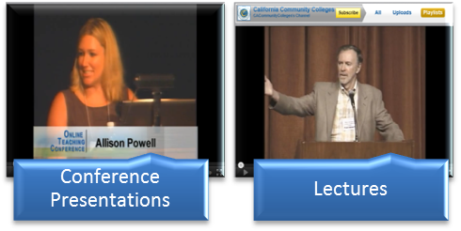
In addition to its TV channels and YouTube services, 3C Media Solutions provides multimedia conference support for organizations wishing to make conference presentations and events available to members unable to attend face-to-face or to those who wish to review past events. Conference sessions are captured in high quality, edited and captioned, if desired, and made available for Web viewing, often with opportunities for interaction with the presenters.
In 2011-12, more than 24,000 (up from 5,000 in 2010-11) people attended conferences virtually, potentially saving millions of dollars in travel expenses.
As colleges were forced to cut travel budgets, 3C Media Solutions provided a critical service… to connect members of the educational community.

Examples of 3C Media Solutions conference support:
- American Association of Colleges and Universities
- Basic Skills Initiative
- Butte Sustainability Conference
- California Career Technical Education
- California Teachers of English to Speakers of Other Languages
- California Community Colleges Real Estate Center
- California Distance Learning Health Network
- California Virtual Campus
- CENIC

- Chief Information Systems Officers Association
- Earth Sciences Information Partners
- EdSource
- eTranscript California
- National Public Health Information Coalition
- North County Higher Education Alliance
- Online Teaching Conference
- The Research and Planning Group
- MPICT :Mid-Pacific Information Comm. Tech.
- FACCC: Veterans
- Town Halls, Student Success Task Force
Travel costs based on miles driven at $0.55 a mile and a $60 nightly hotel rate.
- CARL: Creativ

3C Media Solutions and EduStream, a partnership
EduStream
EduStream, www.EduStream.org, was envisioned by San Bernardino Community College District as a way to provide quality online educational media for faculty and staff to use in their online
courses. EduStream is a digital repository providing each California Community College with 100 Gigabits of free storage space and partners with content vendors to provide high quality, American Disability Act compliant educational media for the benefit of faculty, staff, and students.

Faculty and staff link educational media into their course management systems where students can view it during the online course. Learning objects provide a more interactive learning experience and increased academic rigor. In 2008, EduStream partnered with 3CMedia Solutions to provide storage and streaming support to the entire California Community College system.

EduStream Services

Streaming Media | Broadcasting media (video, audio, etc.) over the Internet. No download or wait-time for user.
Digital Repository | 100 gigabytes of free storage.  100GB equals roughly…40, 1-hour-long videos.
Access to Content | Partnerships give educators access to 6,400 proprietary educational videos for their courses.
Digital Content and Learning Management System(LMS) Integration | Faculty can include digital content in an LMS, like Blackboard or Moodle, to help explain concepts to students in online courses.
Live Streaming Channels | 24x7 live event streaming for member institution.
Online Tutoring Program, pilot | Students can receive live help from faculty.

EduStream Membership Trends
Edustream membership consists of educational institutions from across the United States, including 104 of the 112 California Community Colleges (CCC).
*4 additional California Community Colleges are in the process of joining EduStream
**Non-CCC totals generated by Dallas Learning, partner

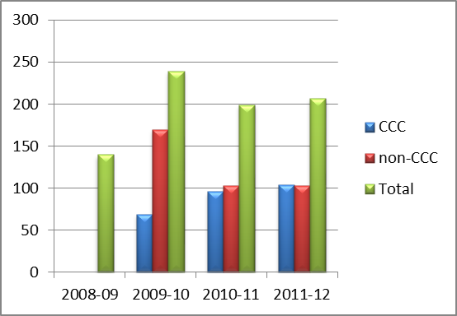

3C Media Solutions and EduStream, a partnership
Demand for EduStream Content in 2011-12
 |  |  |  | 2010-11 |  | 2011-12
 | CCC | Faculty |  | 29,314 |  | 29,030
 |  | Students |  | 81,548 |  | 152,288
 | non-CCC | Faculty |  | 23,631 |  | 23,631
 |  | Students |  | 10,537 |  | 77,457
 | Total |  |  | 145,030 |  | 282,406
Streaming Media Services
EduStream provides the optimal environment for higher education by providing educational institutions with unlimited streaming and bandwidth usage in an advertising-free environment. Streaming distributes media over the Internet compared to other forms of broadcasting such as television.
Online Education
Streaming media has enabled distance education to become more interactive and accessible than was previously possible. Faculty have access to a wider variety of educational tools and students are now able to take online courses at a time and place suitable for them as long as there is an Internet connection. EduStream recently also acquired a 10 gig connection (along with San Bernardino CCD as a whole) enabling EduStream to stream content and HD levels.
The availability of streaming media services enables faculty to:
- Include digital educational materials in their online courses.
- Create, store and stream digital content
- Seamlessly link content to any learning management system such as Blackboard and Moodle.
- Enhance the explanation of concepts through downloadable handouts, video clips, and receive student feedbacks through mediums like live chats and emails.
Event Streaming
24x7 dedicated live streaming channels are available to member institutions to stream their live events. In collaboration with partners at 3CMedia and @ONE, EduStream has participated in live webcasting events such as the Online Teachers Conference (OTC) and the CCC Real Estate Educators Conference. Additional community college live streaming events include:
College programing and announcements | Live online tutoring sessions
Monthly college board meetings | Sporting events
Live class sessions | Martin Luther King Jr. Day celebrations
Live conferences | College President’s welcome speech for faculty

3C Media Solutions and EduStream, a partnership
Access to Educational Content
Through EduStream’s relationship with Dallas TeleLearning and Ambrose Video, members receive access to 6,400-plus pre-licensed, full-length videos and clips for use in their online courses that are compliant with the Americans with Disabilities. The proprietary video content is professionally produced and academically vetted to ensure its educational value. The video-on-demand service allows faculty and staff to link any digital media to their Learning Management System or website of choice and the media is streamed directly to the student through EduStream’s infrastructure.
Online Tutoring Program, pilot
The Online Tutoring Program pilot involves Crafton Hills College and San Bernardino Valley College of the San Bernardino Community College District. The program has received positive feedback from students and faculty and in a typical session, three to 15 students log in with a healthy flow of questions for the instructor.
The program offers the tutoring in four subjects:

- Elementary algebra
- Intermediate algebra
- Biology
- American Sign Language

Students log in online into a general meeting room where they can view the instructor and ask questions via a live chat function. The instructor then answers questions or explains concepts in real time. Instructors are able to use a variety of methods of demonstration such as white boards, power points and table computer technology. Also, if the instructor has materials such as handouts or PowerPoint demonstrations, those are all viewable and downloadable via the online interface. For students that miss the live sessions, they are able to view the recorded sessions in an archive. EduStream plans to roll this pilot program out to two additional sister community colleges by spring 2012 with the eventual plan to offer this service to all 112 California Community Colleges.

EduStream and 3CMedia Solutions, a Partnership
Recognizing the synergies of the two projects, 3CMedia Solutions and EduStream formed a partnership in 2008. 3CMedia provided conference support, video production and RSS feed support, whereas, EduStream provided large media storage and Internet streaming capabilities. The two projects continue to provide unique services as well as collaborate on complementary functions that support the California Community Colleges’ need to create, store and access high-quality educational video and media.

Systemwide e-Conferencing, CCCConfer
CCCConfer provides no cost, systemwide audio and electronic Internet-based conferencing services to all college staff and faculty. The $3.5 million e-Conferencing grant awarded to Palomar College in 2001 funded the development of a comprehensive, coordinated e-conferencing tool to complement the decentralized infrastructure of the California Community College system. Initially supporting meetings, the success of CCCConfer eventually prompted a separate grant to encourage and expand the use of e-conferencing technologies in the classroom. CCCConfer along with 3C Media Solutions, EduStream and @One Training are supported through a $3.275 million grant to Palomar Community College District.
CCCConfer Services

Audio-Visual Virtual Meetings | Meet&Confer meetings allow large and small groups to quickly setup a conference call bridge and an Internet site to engage in discussions, share documents, presentations and video.
Audio Meetings | Call Confer meetings allow large and small groups to quickly setup a conference call bridge and engage in discussions and meetings.
Online Class Delivery | Instructors deliver lectures, assess student learning, solicit responses and feedback from students all online.
Instructor Office Hours | Students can meet with instructors in a virtual setting to ask questions and further learning
Archiving | Meetings and classes are recorded and saved for viewing at any time or location over the Internet. More than 560 archived sessions viewed per month.
Device Accessibility | Students, faculty and administrators can be connected on fixed or mobile devices.

Demand for e-Conferencing Services Continues to Increase
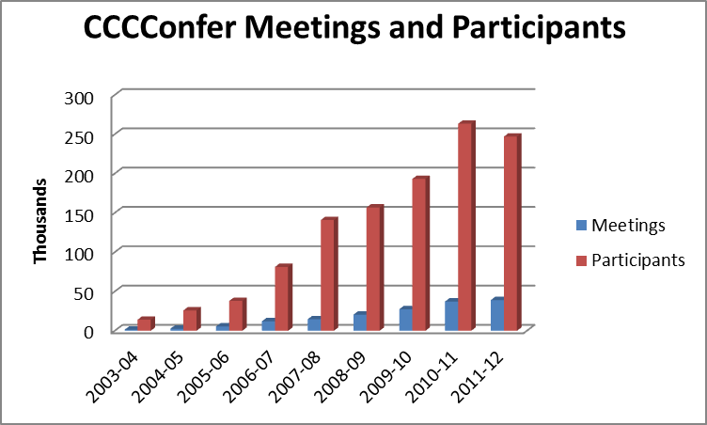
Since 2003-04, virtual meetings have increased from 1,309 to 39,083.
Participants in virtual meetings have soared from 14,108 to 247,001.

Systemwide e-Conferencing, CCCConfer
Note: 2011-12 usage is assumed to be higher since these statistics do not reflect the use of CCC Confer from Course Management Systems (e.g., Blackboard, Moodle, Etudes) or from direct links, both of which have become popular options among the users. The project will be using statistics collected from its vendor (Blackboard Collaborate) in future reports to provide a more accurate reflection of usage. Blackboard Collaborate reports that, for the last five years, there has been 569% growth in CCC Confer participants, 637% growth in sessions, and 956% increase in recordings.

e-Conferencing Trends in the California Community College System
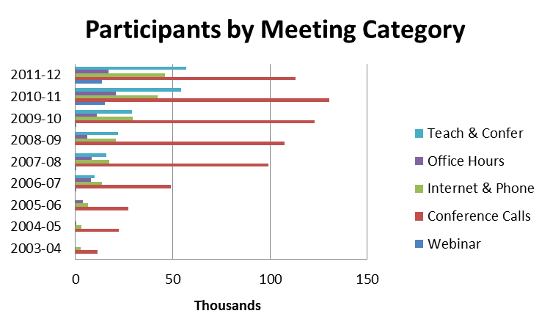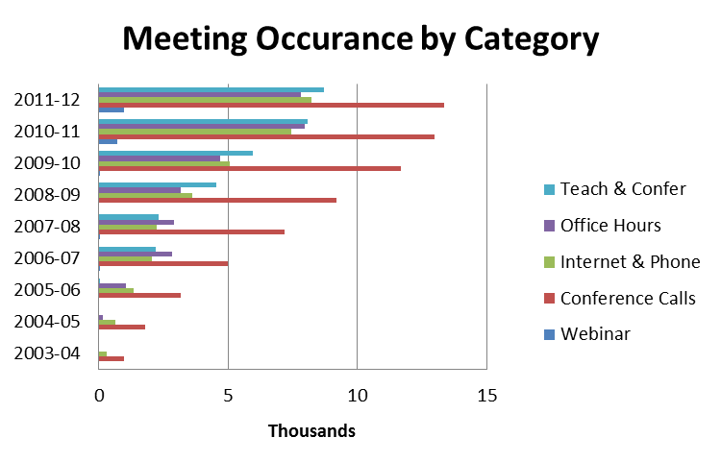
In 2011-12, conference calls (Call&Confer) and meetings utilizing both the internet and call features (Meet&Confer) increased. Call&Confers increased 2 percent and Meet & Confers showed an 11 percent increase. Webinar volume increased dramatically by 39 percent due to including this option on the meeting request screen in late 2009. Office Hours declined by 2 percent and Teach and Confer Meetings increased by 8 percent.
The decrease in Office Hours and the marginal growth in Teach and Confer meetings could be attributed to a decline in distance education course enrollments which generated 120,906 FTES in 2010-11 and declined to 113,520 as colleges cut programs. In addition, as noted on the previous page, new tracking methods will be deployed next year as many users are now entering the CCCConfer application via other mechanisms.

Systemwide e-Conferencing, CCCConfer
E-Conferencing Impacts on the CCC System

Providing the California Community College with an e-conferencing system produces an estimated cost saves by reducing travel-related expenses, but more importantly, more community college faculty, students, staff and administrators are connected to one another and to the broader educational community.
The following chart shows the number of people (students, faculty, staff and administrators) in 2011-12 able to participate in no-cost virtual classes, meetings and informational sessions. Without the option of virtual attendance, many participants would have been excluded due to cost and distance factors.
e-conferencing strives to eliminate barriers to participation and learning.
Meeting Category | Number of Participants
Conference Call and Call/Internet | 159,195
Webinar’s | 13,596
Teach and Confer | 57,104
Office Hours | 17,106

The benefits of this technology include:
- Minimized travel expense, since meetings and classes are conducted over the Internet
- Time savings, since participants do not have to go anywhere, set up any rooms or equipment
- Training and professional development can be extended from small groups and locations to large groups in several locations, and recorded for future dissemination
- Timely and efficient personal contact between instructors and students, administrators and constituents, organizational leaders and members
- Removal of geographical limitations to the information flow of large organizations, ensuring that all individuals are on the same page and able to strategize, act and react faster than ever before
- Toll-free telephone calls and free captioning to accommodate differently-abled participants

Systemwide Technology Training for Faculty and Staff (@ONE)
Striving to improve instruction through technology, @One offers free or low-cost ($100 maximum) training for the faculty and staff of the colleges, thereby providing colleges with a substantial cost savings for high quality professional development. Instructors provide face-to-face training, online and self-paced courses, webinars, accessible archives, and downloadable materials. @One (http://www.onefortraining.org/) provides training and technology information. @One along with 3C Media Solutions, EduStream and CCCConfer are supported through a $3.275 million grant to Palomar Community College District.
Professional Development Services
Online Courses | Training delivered in a virtual setting to participants over the Internet. Courses are four weeks long.
Trainer’s Bureau | Customized face-to-face training offered at a college and delivered to a large group of faculty or staff by @One approved trainers.
Online Teaching Certification Program | Certification curriculum pattern aligned with the International Association for K-12 Online Learning standards for instructors of distance education.
Online Teaching Conference | Inter-segmental conference focused on curriculum, pedagogy and technology to improve online instruction and learning.

The In-Person Institute and Desktop Seminars portion of the Professional Development Series were temporarily suspended due to budget cuts. Desktop seminars were still available, but new offerings were suspended.

Trainings fall into five general areas and are designed in various skill-level tracks to address the needs of faculty and staff:

- Fundamental technology skills… Microsoft Excel, Word
- Technology-enhanced instruction… Developing Effective Online Assessments
- Multimedia… Building Online Community with Social Media
- Online teaching and learning … Teaching with Moodle, Blackboard
- Technical training… Creating Accessible Online Courses

Trends in Professional Development Offerings and Participation
@One experienced declines in Desktop Seminars and In-Person Institutes whereas Online Courses and Trainer’s Bureau Sessions showed increased participation. The Online Teaching Certification Program and Conference participation demonstrated the educational communities continued need and interest in acquiring skills related to online teaching and learning.
Training Sessions
Category | 2008-09 | 2009-10 | 2010-11 | 2011-12 | % Change
Desktop Seminars | 55 | 60 | 45 | 9 | -400%
Online Courses | 23 | 25 | 34 | 30 | -13%
In-Person Institute | 22 | 10 | 4 | 0 | n/a
Trainer’s Bureau Sessions | 7 | 4 | 22 | 9 | -144%

Participants by Training Category
Category | 2008-09 | 2009-10 | 2010-11 | 2011-12 | % Change
Desktop Seminars | 3853 | 2925 | 1634 | 788 | -107%
Online Courses | 510 | 550 | 911 | 845 | -8%
In-Person Institute | 365 | 157 | 64 | 0 | n/a
Trainer’s Bureau | 135 | 91 | 409 | 125 | -227%
Online Teaching Certification | N/A | N/A | 274 | 236 | -16%
*OTC: In-Person | 242 | 268 | 306 | 276 | -11%
*OTC: Online | 298 | 520 | 663 | 313 | -112%
*OTC, Online Teaching Conference
Budget Cuts Impact Offerings and Participation
Cuts in TTIP funding during 2009-10 and 2010-11 forced the Chancellor's Office to reduce funding for the @One program, which subsequently triggered a reduction in staff and course offerings. In addition to the budget cuts for @One, the colleges also were reducing budgets for professional development and travel. The lack of travel funds made it difficult for faculty and staff to attend @One’s In-Person Institutes. As a result, @One tested a new In-Person Institute model and located the Institute in a multi-college district which enabled participants to commute to the training. Only a single In-Person Institute was offered in 2010-11 based on this model. The new model was successful but with only a single institute offering, it produced the 60 percent reduction in attendance in 2010-11. Ultimately, with no restoration of funds in 2011-12, the In-Person Institutes were temporarily suspended.
In addition, budget constraints reduced desktop seminars in 2010-11 representing a 400 percent reduction in the number of seminars and a more than 40 percent reduction in participants. However, the numbers do not reflect the access to our archived seminars that are available on demand.

Demand for Training Services
Requests for training from California Community College faculty and staff led @One to realize that the demand for training was as great as it always has been (if not greater because local colleges had largely lost their own staff development professionals). However, budget constraints, such as the lack of travel funds, were making it necessary to meet the demand through new and flexible services. Thus, the demand for the @One Trainers’ Bureau grew considerably in 2010-11, because colleges could afford ($700 for one day or up to $2,100 for three days) to have an @One trainer come to the college and train a large group of faculty and staff. However, continued budget restrictions ultimately impacted participation in all professional development offerings.
It should also be noted that the numbers reported in the tables represent participants taught by @One facilitators. @One also provides its curriculum to colleges and districts at no charge so that colleges can train faculty and staff locally. The availability of reusable @One curricula saves the colleges and districts money needed to develop training curriculum as well as ensure that they are getting a quality instructional experience. @One’s use of the Creative Commons for its materials is a significant system-wide benefit. Creative Commons is a non-profit organization that enables the legal sharing and usage of creative works, such as curriculum.
The Online Courses and the Certification Program showed considerable growth that reflected the demand for quality online instruction. Likewise, the Online Teaching Conference provides a unique development opportunity for experienced online instructor to share their expertise and learn from other experienced instructors. The conference is the only development activity for experienced instructors to network and learn. Most of the other activities are aimed at new or recent online instructors.
The demand for @One services is greater than it has ever been, due to college budget situations and the prevalence of technology in all aspects of teaching. Further, with the emphasis of Accreditation on Student Learning Outcomes and a greater scrutiny on online course quality, the Certification Program is providing a mission-critical service that individual colleges cannot deliver.

Thousands Saved in Professional Development
@One provides the California Community Colleges with substantial cost savings when compared to the cost of training provided by a non-@One institution. The following chart compares the cost of an average @One Online and In-Person training session to the average cost a private consultant training session based upon actual participation in @One offerings. In addition, the cost of Online Teaching Certification course sequence and practicum is provided.
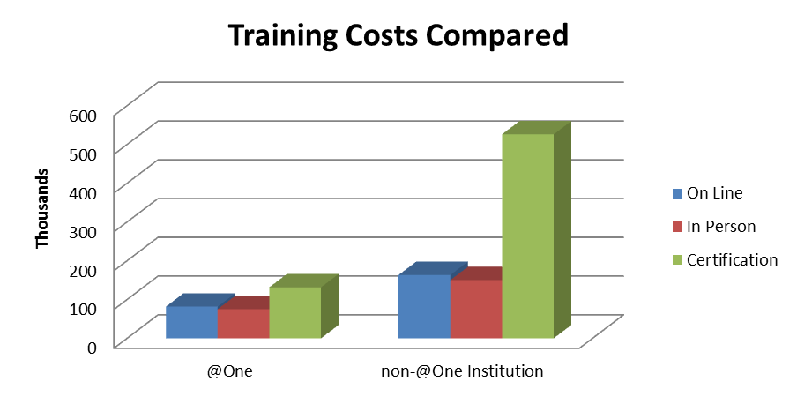
In 2011-12 @One provided professional development at a reduced cost with an estimated savings of…
$81,650 for Online Trainings
$75,000 for In-Person Trainings
$394,500 for Online Teaching Certification

Savings would have been greater but participation fell due to a lack of course offerings and in-person institutes.

*Online cost estimates based on an average cost of $50 per @One course and an average cost of $100 for a non-@One course.
*In-Person cost estimates based upon an average of $600 per @One course and an average of $1200 for a non-@One course.
*Certification cost estimates based upon a cost of $500 for @One and $2000 for non-@One institutions

California Virtual Campus
The California Virtual Campus (CVC) is a statewide community college system program to create comprehensive instructional support for faculty and students. It addresses development of content and delivery of online and hybrid instruction. The principle goals are to support the California community colleges in online course offerings, e-learning and/or distance education. It is funded through a $1,389,600 grant in partnership with Butte College.
The CVC program made successful progress during the first three quarters of the 2010—2011 fiscal year in pilot activities, statewide services and infrastructure services provided to California Community Colleges and partners in intersegmental efforts supported as authorized by legislation passed regarding the CVC (Senate Bill 1437).
In the fourth quarter, grant funding was reduced 10 percent and further reductions resulted in the elimination of CVC staff. Despite funding challenges, CVC addressed many of the goals authorized or mandated by SB 1437.
The following activities are in direct support of SB 1437:
Support faculty access to professional development training focused on online course development. | Dissemination of best practices in online teaching through participation in statewide and national conferences.
Increase availability of learning objects for online courses. | Partnered with MERLOT to increase quantity and quality of peer-reviewed learning objects.
Providing services for faculty and online students | Developed a self-service matriculation portal for distance education students. Also available via mobile devices.  Implemented the CVC Online Course Catalog enabling students to locate distance education course offerings throughout the System.  Continued the Online Degree Planner Project  Continued the ePortfolio Project
Facilitating collaborations and joint efforts relating to the use of technology and Internet connectivity | Community Based Online Learning Project to provide high-speed Internet access to low-income neighborhoods.  CETC K20 to facilitate use of technology resources to support teaching and learning

The Chancellor’s Office has responded to the direction of this bill by:

- Disseminating best practices in online teaching through active participation in program committees and planning efforts for multiple statewide and national conferences including the Online Teaching Conference (OTC), the Sloan 4rd Annual Emerging Technologies for Online Learning Conference and the WCET organization.

As funding reductions resulted in the elimination of CVC staff by the end of the fiscal year support participation has been stopped.

- Partnering with MERLOT, a free and open online community of resources designed primarily for faculty, staff and students of higher education from around the world to share their learning materials and pedagogy.

- Creating a one-stop self-service portal for distance education students, with a dashboard featuring a flexible and adaptable suite of online student matriculation services to serve as the front-end interface. The portal contains a new College Directory Service providing profiles for each of the colleges, existing tools for career exploration (California Career Resources Network), information about financial aid, information concerning transfer, access to student services on the ePortfolio California site, and large System-wide services such as CCCApply and ASSIST.

- E-Portfolio System allows participating students to demonstrate attainment of academic learning objectives, skills, and knowledge that relate to career interests, and completion of prerequisites for participation in courses or training programs
  - Website redesign and updated daily content
  - Average 2,300 hits per month on ePortfolio website
  - Weekly newsletter received by 266 faculty and staff
  - ePortfolio California Team and PESC (Postsecondary Electronic Standards Council)

- CVC and the California Community Colleges Technology Center (CCCTC) continued to partner with CSU in the development of a software prototype for an application that would improve available online planning. The program’s working title was “California Online Program Planner.”
  - Budget cuts at CSU and CCC, caused CVC to change course and develop a partnership with MyEdu to deliver an online degree planner and associated student services to the colleges as a pilot program at no cost. Marketing efforts were put into effect and by the end of the reporting period, several colleges have expressed interest.

- Community-Based Online Learning project (CBOL) is a multi-year project, focused on providing access to high-speed networking and computers, and ensuring access to adequate technical and operational support for community-based organizations in low-income neighborhoods. The grant directly funds a maximum of $100,000 to cover the costs of setting up and managing Internet connectivity and ongoing arrangements with Internet.

- CVC has worked with these segments to create the K20 CETC (California Educational Technology Collaborative) as this stakeholder group, to enable CVC to develop new capabilities, pedagogies, open source curricula, and services through technology projects that will benefit the students and faculty of California as well as the schools that support and educate them.
Community College Educational Technology Collaborative
The California Community College Educational Technology Collaborative’s (CCCETC)
(http://www.cccetc.org) mission is to foster collaboration between systemwide
technology projects and the individual colleges to improve and enhance technology
resources and services.

The collaborative strives to maximize resources and services available to the California
Community College system through:
- Effective resource management
- Resource sharing
- Prevention of service duplication
- Increasing funding opportunities

CCCETC members are technology infrastructure providers, service providers, fundraising
experts, program directors and Chancellor’s Office staff.

Current memberships include:
CCCConfer -- e-Conferencing
3C Media Solutions -- satellite broadcasting, pod-casting, streaming
EduStream -- IP-based media content broadcast
@ONE -- faculty/staff training
CVC -- California Virtual Campus
CCC Technology Center -- shared information infrastructure services

The collaborative's partner organizations include:

- Foundation for California Community Colleges, fiscal agent
- CENIC, network provider

CCCETC highlights:
- Furthering improvement and enhancement in reach of technology resources and services.

- Managing and sharing resources to eliminate duplication of services.

- Expanding membership and opportunities in K-20.

- In partnership with CENIC, ongoing review and reconfiguration of college topology to increase bandwidth, decrease cost or both.

- Furthered Affordable Content Initiative by conducting faculty and student surveys to provide recommendations.

Financial Chart

The Chancellor’s Office provided $15,290,000 through the TTIP budget to provide Internet connectivity and fund statewide technology projects. Funding for technology infrastructure and training at the college level was eliminated in 2007-08 and library funding was eliminated in 2009-10. The table below shows TTIP funding over the previous seven fiscal years.

Year | Funded Amount | Percent Change from previous year | Comments
2001-02 | $44,300,000 | 58 | Continuation of prior year’s services.
2002-03 | $18,500,000 | <139> | Videoconferencing upgrade; Phase 1 of connectivity upgrade (T-1 to DS-3); all local technology initiatives and technology training monies eliminated.
2003-04 | $22,050,000 | 16 | 4Cnet merges into CENIC; DS-3 connectivity upgrade continues; dedicated video T-1 is eliminated and moved onto CENIC.
2004-05 | $23,397,000 | 6 | Completion of Internet & video upgrades; addition of California Virtual Campus line item into TTIP.
2005-06 | $24,397,000 | 4 | CCCApply introduced international applications and a BOG Fee Waiver; 300 percent increase in CCC Confer usage; completion of CVC program transition.
2006-07 | $26,397,000 | 8 | 10 year anniversary of TTIP program; CCC-Tran goes live after beta-test phase; Cal-PASS expansion with additional funding; @ONE and CCC Confer increase usage by faculty and staff.
2007-08 | $26,197,000 | 0 | Same budget as previous year. Began adding the official off-site centers to CalREN. Increased bandwidth for colleges maxing out on current connection. Began the K-20 CETC.
2008-09 | $26,197,000 | 0 | Same budget as previous year.
2009-10 | $15,290,000 | <42> | Additional one-time Federal Stimulus Fund payment of $1,595,811.
2010-11 | $15,290,000 | 0 | Actual reduction of 9.45% from prior year due to the lack of additional stimulus funding.
2011-12 | $15,290,000 | 0 | Same budget as previous year.

Emerging Concepts

In the spirit of continuous improvement, the Chancellor’s Office Telecommunications, Technology and Infrastructure Program is looking to the following areas where technology could enhance the educational experience and generate efficiencies. Each area is defined and highlighted below:

Centralized Testing and Assessment (CCCAssess): a centralized assessment test delivery system and data warehouse for the California Community Colleges. Centrally selected assessment instruments will be delivered via the Internet and test scores, along with additional assessment data, will be stored in the data warehouse. It allows for a reduction in testing instrument costs, improves test portability and provides comparable data to improve predictors of student success.
2011-2012 Update: AB743 and SB1456 were signed into law and both have language supporting the development of a common and centralized assessment test for the California Community Colleges but both pieces of legislation require ongoing funding. A Budget Change Proposal was submitted for 2013-14 to support CCCAssess and was rejected. The project team is currently pursuing the development of a central data warehouse to collect and validate multiple measures used in the assessment process. Multiple measure information will be provided to the colleges through a web-based user interface.

ePortfolio
ePortfolio California is part of the California Virtual Campus (CVC). CVC serves the needs of distance education students statewide. ePortfolio California is focused on delivery, evaluation, research and development of a vibrant and interconnected community of practice, expanding on the work of the Electronic Portfolio Action and Communication (EPAC) group.
2011-12 Update: Under the leadership the ePortfolio California team, the PESC (Postsecondary Electronic Standards Council) Academic ePortfolio Workgroup was chartered to develop interoperability standards for ePortfolios. The scope of work completed, members recruited, and meetings are now being scheduled on a regular basis. Phase III has been and will focus on the transition to steady state, where the emphasis will be on delivery of core services.
Acknowledgements

Chancellor Brice W. Harris would like to acknowledge and thank those individuals who have made significant contributions to this report. The Telecommunications, Technology and Infrastructure Program report was made possible through the efforts of the following individuals and their teams:

CHANCELLOR’S OFFICE
Telecommunications and Technology Unit
Bonnie Edwards, director
Office of Communications
Paul Feist, vice chancellor, communications
Paige Marlatt-Dorr, director of communications
PROJECT MANAGERS
Edwin Smith, CENIC
Tim Calhoon, director, The Technology Center & California Virtual Campus
Brad Phillips, director, Cal-PASS
Blaine Morrow, director, 3C Media Solutions and CCCConfer
Andrew Chang, director, EduStream
Micah Orloff, director, @One Training

