California State Community Colleges
Storm Water Management Program
Template

San Mateo County Community College District
Bay Area Facilities Managers
November 2013

Prepared By:

-This page intentionally left blank.-

Purpose of the SWMP
This document has been developed to highlight the (name of District) District’s intent to align with the U.S. EPA Phase II NPDES requirements promulgated under the Clean Water Act, and specifically to align with the Phase II Small Municipal Separate Storm Sewer System (MS4) Program’s Phase II Small MS4 Permit (Order No. 2013-0001 DWQ) (Permit) which was adopted on February 5, 2013 and became effective on July 1, 2013. A non-traditional MS4 is defined by the Permit as an entity that is operated similarly to a traditional MS4, but is operated at a separate campus or facility. Examples of non-traditional MS4s include, but are not limited to, universities, state hospitals, state prisons, military installations, school districts, and other special districts.
The ______District proactively develops and implements this SWMP to cover all of the facilities on the District’s three campuses.
The purpose of the SWMP is to:
- Identify the various sources (pollutant and constructed facilities) that could potentially affect the quality and quantity of storm water discharges
- Provide Best Management Practices (BMPs) for municipal and construction activities and campus community education to reduce contamination in storm water
- Provide measurable goals to assess the effectiveness of BMPs that are designated to reduce discharge of pollutants into the storm drain system and associated waterways

Acknowledgement
As an exempted non-traditional MS4 I hereby acknowledge that this document and all attachments were prepared under my direction or supervision in accordance with a system designed to assure that qualified personnel properly gather and evaluate the information submitted. Based on my inquiry of the person or persons who manage the system, or those persons directly responsible for gathering the information, the information submitted is, to the best of my knowledge and belief, true, accurate, and complete.

________________ DISTRICT

___________________________________________ __________________
Signatory Date
Title

Table of Contents (Edit to fill in page numbers)

Purpose of the SWMP ii
Acknowledgement ii
1.0 Introduction 1
1.1 Regulatory Background 1
1.1.1 Phase I 1
1.1.2 Phase II 1
1.1.3 _____ District 1
1.2 Comparison of District SWMP to Phase II Permit (Optional) x
1.3 Storm Water Management Process x
1.4 Storm Water Working Group x
1.5 Sustainability Committee x
1.6 Key Personnel x
2.0 Site Information x
2.1 District Overview x
2.1.1 District Geographic Location and Area Climate x
2.1.2 Site Drainage x
2.1.3 Facility Operation x
2.2 Campus-Specific Descriptions x
2.2.1 College No. 1 x
2.2.2 College No. 2 x
2.2.3 College No. 3 x
3.0 Potential Sources of Pollution x
4.0 Minimum Control Measures and Best Management Practices x
4.1 How to Use BMP’s to Meet SWMP Goals x
5.0 Development and Implementation of BMP’s x
5.1 MCM 1: Education and Outreach on Storm Water Issues x
5.1.1 Program Goal x
5.1.2 BMP Implementation Details and Measurable Goals x
5.2MCM 2: Campus Community Involvement and Participation x
5.2.1 Program Goal x
5.2.2 Implementation Details and Measurable Goals x
5.3 MCM 3: Illicit Discharge Detection and Elimination x
5.3.1 Program Goal x
5.3.2 Implementation Details and Measurable Goals x
5.4 MCM 4: Construction Site Storm Water Runoff Control x
5.4.1 Program Goal x
5.4.2 Implementation Details and Measurable Goals x
5.5 MCM 5: Post Construction Storm Water Management in New Development
and Redevelopment x
5.5.1 Program Goal x
5.5.2 BMP Implementation Details and Measurable Goals x
5.6 MCM 6: Pollution Prevention and Good Housekeeping for Facilities
Maintenance and Operation x
5.6.1 Program Goal x
5.6.2 BMP Implementation Details and Measurable Goals x
6.0 Record Keeping x
6.1 SWMP Updating x
6.2 SWMP Public Access x
6.3 SWMP Record Keeping x
7.0 Program Evaluation and Monitoring x
7.1 Program Evaluation x
7.2 Water Quality Monitoring Activities x

Appendices
- District Organization Chart
- Vicinity Map – District Campus Locations
- Overall Campus Drainage Patterns and Locations of Discharge to Downstream MS4s
  - College No. 1
  - College No. 2
  - College No. 3
- Storm Drain Inlet and Outfall Location Maps
  - College No. 1
  - College No. 2
  - College No. 3
- Storm Drain Inlet and Outfall Inspection Sheets
- Sample Contract Language
- Resources
- Acronyms and Abbreviations
- Glossary
- References

1.0 INTRODUCTION

1.1 Regulatory Background
1.1.1 Phase I
In 1990, in accordance with the Federal Clean Water Act, the United States Environmental Protection Agency (U.S. EPA) promulgated rules establishing Phase I of the National Pollutant Discharge Elimination System (NPDES) storm water program. The Phase I Program for Municipal Separate Storm Sewer Systems (MS4s) requires operators of “medium” and “large” MS4s (i.e., those that generally serve populations of 100,000 or greater) to implement a storm water management program as a means to control polluted discharges from those MS4s.
In response to the Phase I Program, the nine Regional Water Quality Control Boards (RWQCB) in the State of California adopted NPDES storm water permits for medium and large municipalities in their regions. These permits are reviewed, revised and reissued as their terms expire.
1.1.2 Phase II
In 1999, the U.S. EPA Storm Water Phase II Regulations became effective, which required permit coverage under the NPDES storm water program for Small MS4s. A Small MS4 is an MS4 which is not permitted under Phase I of the NPDES storm water program.
In 2003, the California State Water Resources Control Board (SWRCB) adopted a Statewide Phase II Small MS4 General Permit in response to the 1999 Phase II Regulations. The SWRCB adopted the statewide permit to efficiently regulate discharges from numerous, qualifying, small MS4’s under a single permit. Small MS4’s were categorized as either “Traditional” or “Non-Traditional”. “Traditional MS4’s” operate throughout a community. “Non-Traditional MS4’s” are MS4’s which are similar to a Traditional MS4, but operate at a separate campus or facility. Most Non-Traditional MS4’s throughout California were not designated as having to comply with the statewide Phase II Small MS4 General Permit, although the SWRCB reserved the right to allow the Regional Water Quality Control Boards to designate, at any time following due process, any single Non-Traditional MS4, if it deemed necessary.
On February 5, 2013, the SWRCB adopted an updated Phase II Small MS4 General Permit in accordance with U.S. EPA Storm Water Phase II Regulations. As with the 2003 Statewide Phase II Permit, most Non-Traditional MS4’s remained undesignated while the RWQCB’s were retained the right to designate them to comply with the permit at any time, following due process. Additionally, the 2013 Phase II Permit included prescriptive requirements for “Designated” Non-Traditional MS4’s.

1.1.3 __________ District
Polluted storm water runoff is often transported to MS4s and ultimately discharged into local waterways (rivers, streams, lakes, and bays) without treatment. Common storm water pollutants include oil and grease from roadways and parking lots, pesticides from lawns, sediment from construction sites, and trash. These pollutants are deposited into nearby waterways, impacting beneficial uses of the resource and interfering with the habitat for fish, other aquatic organisms, and wildlife.
________ District (District Acronym or District) recognizes the environmental and societal benefits of preparing a Storm Water Management Program (SWMP). This SWMP identifies the District’s existing management strategies related to storm water. Additionally this SWMP identifies strategies to adopt and administer for environmental management and education related to storm water in order to reduce the discharge of pollutants to the “maximum extent practicable” and protect water quality.

1.2 Comparison of District SWMP to Phase II Permit
(This is an optional section. This section is a tool for comparing the District SWMP to the components of the Phase II Small MS4 Permit related to Non-Traditional MS4’s. It is useful for planning and discussion.)

This SWMP aligns with Section F of the Phase II Small Municipal Separate Storm Sewer System (MS4) Program’s Phase II Small MS4 Permit (Order No. 2013-0001 DWQ) as follows:
Comparison of District SWMP with Phase II Permit – Status as of Fiscal Year July 1, 20xx - June 30, 20xx
District SWMP Section  (indicate SWMP sections which may mirror the Phase II Permit Item) | District Action  (describe existing District measures or District intentions which may mirror the Phase II Permit Item) | Phase II  Small MS4 Permit  Section F.5. Item & Heading | Phase II  Small MS4 Permit  Section F.5. Task
 |  | a. Program Management Element | Legal Authority
 |  | b. Education and Outreach Program | Compliance Participation Options / Public Education and Outreach / Staff and Site Operator Training and Education specific to Illicit Discharge / Staff Pollution Prevention and Good Housekeeping
 |  | c. Campus Community Involvement and Participation Program | Involve the public in the development and implementation of activities related to the program.
 |  | d. Illicit Discharge Detection and Elimination | Outfall Mapping / Field Sampling to Detect Illicit Discharges / Illicit Discharge Detection and Elimination Source Investigations and Corrective Actions
 |  | e. Construction Site Runoff Program | Develop and implement contract language ensuring all outside contractors comply with the CGP and implement appropriate BMP’s.
 |  | f. Pollution Prevention / Good Housekeeping | Inventory of Permittee-Owned or Operated Facilities / Map of Permittee-Owned or Operated Facilities / Facility Assessment / Storm Water Pollution Prevention Plans / Inspections, Visual Monitoring and Remedial Action / Storm Drain System Assessment and Prioritization / Maintenance of Storm Drain / Permittee-Operations and Maintenance Activities (O&M) / Pesticide, Herbicide and Fertilizer Application and New Landscape Design and Maintenance Management
 |  | g. Post-Construction Storm Water Management Program | Site Design Measures / Low Impact Development Standards / Alternative Post-Construction Storm Water Management Program / O&M of Post-Construction Storm Water Management Measures
 |  | h. Program Effectiveness Assessment and Improvement | Program Effectiveness Assessment and Improvement Plan / Storm Water Program Modifications
 |  | i. Total Maximum Daily Loads Compliance Requirements | Comply with Applicable TMDL’s / Waste Load Allocations, Load Allocations and Effluent Limitations / Regional Board to review TMDL-specific requirements / Permittee to report status of TMDL implementation requirements / Permittee to comply with implementation requirements in Category 4b demonstrations for 303d.
 |  | j. Record Keeping | Relates to Non-Traditional who don’t have to submit online. Use of SMARTS. Retain all Annual Report Supporting Info through the next Fiscal Year and have available for review by RWQCB. Permittee to submit detailed online or presentation to Board of the Annual report when requested. Permitees involved in regional programs deciding who submits what annual reporting information.
1.3 Storm Water Management Process
The holistic approach to storm water management is built upon the foundation of Responsibility and integrates the crucial elements of Monitoring, Protection, Planning, Education and Involvement as well as System Maintenance and Repair. Comprehensive storm water management programs and implementation policies may enter this framework at any point as it is a cyclical and evolving process over time. A storm water management program is effective when a community becomes stewards for their environment. In this SWMP, roles are designated, programs are outlined and interrelationships are developed for the following 6 elements:

These six elements interact and constitute the foundation of the six Minimum Control Measures discussed in Section 4 of this SWMP.

1.4 Storm Water Working Group
A Storm Water Working Group (SWWG) will be defined as representatives of various (District) campuses and departments who can provide input into development and implementation of the SWMP. The District’s ____ Office is the approving authority and will administer this SWMP. __________ will be the head of the SWWG. The SWWG will include a representative from the following campuses and offices:
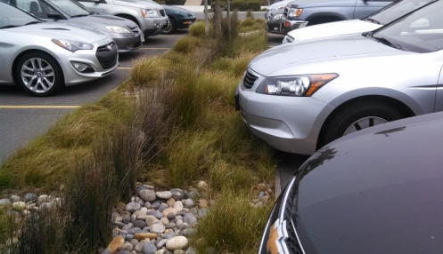 | - College No. 1  - College No. 2  - College No. 3  - Office No. 1  - Office No. 2  - Office No. 3  - Consultant Groups
Representatives will be drawn from the following constituencies – ___________, as well as other (list relevant Staff) and (list relevant Student or other groups).

1.5 Sustainability Committee (or key Committee(s) involved with SWMP Development)

The ____ Committee is comprised of ______.
The purpose of the Committee is _________.
The projects and programs developed by the committee are focused on (or created to provide) _____.

(Delete Example after completing above description.
Example: The San Mateo County Community College District Sustainability Committee is comprised of a diverse group of administrators, staff and students. The purpose of the Committee is to plan and implement sustainability projects and programs throughout the individual campuses and the District as a whole. These projects and programs are focused on providing multiple benefits across economic, ecologic and social equity. The San Mateo County Community College District Storm Water Management Program is one component of a multi-faceted, continuously improving Sustainability Plan.)

1.6 Key Personnel
Key personnel within the District have provided input into development and implementation of the SWMP. Their contact information is listed below:
- Contact Name, Title, Department, District or College Campus
- Contact Name, Title, Department, District or College Campus
- Contact Name, Title, Department, District or College Campus
- Contact Name, Title, Department, District or College Campus
- Contact Name, Title, Department, District or College Campus
- Contact Name, Title, Department, District or College Campus

2.0 Site Information

2.1 District Overview
2.1.1 District Geographic Location and Area Climate
- County
- Number of Campuses
- Relative Location of Campuses within county
- Topographic conditions related to geographic location (e.g. situated in mountains, at top, at base, midway, situated in valley, mild moderate, steep slopes)
- Climatic conditions related to geographic location
  - Seasonal temperatures
  - Seasonal precipitation (dry, fog, rain, snow, etc)
- Anecdotal observations
(Delete Example after completing above description.
Example: SMCCCD is located in San Mateo County, in California and comprises three campuses located in the northern, central and southern portions of the county. Each campus is accessed from main arterial roadways, and in close proximity to Interstate 280 which traverses San Mateo County from north to south, on the east side and parallel to the Santa Cruz mountain range at its northern tip. Each of the three campuses is situated on hilltops, also on the eastern side of the mountain range.
Over the geographic extent of San Mateo County, at an average, the area is mild during summer, when temperatures tend to be in the mid-60s, and cool during winter, when temperatures tend to be in the low-50s. The warmest months of the year are from July through September, with an average maximum temperature of 82 degrees Fahrenheit (ºF) in July in San Mateo, while the coldest months of the year are December and January, with an average minimum temperature of 40ºF in San Mateo.

The annual average precipitation in San Mateo is 20.45 inches. Winter months tend to be wetter than summer months. The wettest month of the year is February, with an average rainfall of 4.09 inches. ¹
Anecdotal observations from SMCCCD employees often highlight that each campus experiences microclimatic conditions beyond the extreme ends of the average area temperature range. Being closer to the coast of the Pacific Ocean, Skyline College, for example, can be 40 degrees cooler than the College of San Mateo on a summer day.)
2.1.2 Site Drainage
Storm water runoff throughout the District’s campuses is conveyed through College-owned storm sewer, open channels and drainage swales. The College-owned storm sewers typically discharge into _______.
(Delete Example after completing above description.
Example: Storm water runoff throughout SMCCCD is conveyed through College-owned storm sewer, open channels and drainage swales located on all three campuses. The College-owned storm sewers discharge into City-owned storm sewers, open channels and drainage swales which eventually discharge into San Francisco Bay to the east.)
Site drainage and storm water facilities are described in greater detail for each campus in Section 2.2.1. Maps showing the general drainage patterns and storm water conveyance systems for the (number of) campuses are presented in Appendices D and E.
2.1.3 Facility Operation
- Describe District historic or current growth
- Who performs maintenance activities affected by the SWMP
- List the facilities, operations and amenities provided by the District’s campus(es).
- List and describe programs and activities currently in place which may assist with the implementation of the SWMP.

(Delete Example after completing above description.
Example: SMCCCD’s college campuses have been undergoing numerous renovations and growth as a result of Capital Improvement projects. Most of this work is being performed by outside contractors and sub-contractors. SMCCCD Facilities staff provides building systems maintenance, completion of campus work requests, daily cleaning of common buildings, grounds maintenance, small construction jobs, and various repair and maintenance activities. Both SMCCCD Facilities staff and outside contractors perform electrical work, plumbing, utility tasks, roofing, painting, and repairs to asphalt and concrete surfaces.
The three campuses include many of the following activities/operations and facilities:
- Parking lots, recreation fields and gardens, food preparation/service facilities, grease traps, loading and unloading areas, trash compactors, science laboratories, swimming pool, auto shop, maintenance yards for vehicles, corporation yard/trash recycle. athletic stadium and athletic fields

The District’s three campuses also engage in the following practices, not only for the prevention of pollution, but also with regard to resource conservation and health preservation, which mirror those promoted in the surrounding communities:
- In the planning and construction of new and redeveloped facilities, the District incorporates low impact development technologies and practices which promote watershed protection in addition to resource conservation. These technologies and practices include the incorporation of pervious surfaces, storm water treatment areas, drought-tolerant landscaping, water efficient irrigation and improved waste stream management technologies for the reduction of litter, energy cogeneration and re-use (i.e. composting and used-oil recycling).
- Areas within the campuses are designated non-smoking. At designated smoking areas at the perimeter of the campuses, enclosed receptacles are provided to collect cigarette butts. The combination of both these practices, in conjunction with regular trash pick-up reduces the number of cigarette butts entering storm water runoff discharged from the campus.)

2.2 Campus-Specific Descriptions
Edit the following, as applicable:
The District has (number of) campus(es) located in the cities of ______, _______, and _____ in the County of _____, California. A vicinity map indicating the location(s) for the (number of) campus(es) is presented in Appendix C.

2.2.1 College No. 1 (Use additional pages for additional colleges)
(Image of Emblem/Logo here, in this cell.) | College No. 1  Address/Street  City, California Zip  (xxx) xxx-xxxx
Facility Location and Operations
Provide description of:
- Geographic location
- Size of campus
- Date of original construction
- Dates of significant expansion or redevelopment.
- Campus Amenities
- Description of educational emphasis of campus

(Delete Example after completing description.
Example: Cañada College, is located midway between San Jose and San Francisco on 131 acres at the base of the Santa Cruz Mountains in Redwood City just to the east of Interstate 280. Initially constructed in 1968, Cañada College is the southernmost campus of SMCCCD. The campus consists of 370,000 gross square feet of facilities which include administrative offices, classrooms, laboratories, maintenance facility, corporation yard, lawn and garden areas, athletic fields, parking lots and open space vegetated with grasses and trees. Cañada College provides the community with a learning-centered environment, ensuring that students from diverse backgrounds have the opportunity to achieve their educational goals by providing transfer, career/technical, and basic skills programs, and lifelong learning. The college cultivates in its students the ability to think critically and creatively, communicate effectively, reason quantitatively to make analytical judgments, and understand and appreciate different points of view within a diverse community.)
Site Drainage and Description of Storm Water Infrastructure
Provide description of:
- Primary direction toward which the campus drains
- Waterways or waterbodies, if any, within campus
- Quantitative or Qualitative description of number of outfalls
- The MS4(s), water body or water bodies that the campus discharges into
- What improvements the campus drainage system is comprised of
- Age and or condition of the storm sewer system
- Number and type of post-construction storm water BMP’s
- Programs, activities or coordination efforts already in place which may, in part, or do fully assist in protection of storm water runoff from the campus or assist with community knowledge of storm water protection (i.e. environmental restoration, mitigation or habitat creation, student clubs, coordination with community program in watershed management, in general or with particular focus such as protecting runoff in agricultural or ranch practices, etc.)
- Indicate watershed management or pollution control activities which are performed by others in the campus community and covered separately from this SWMP

(Delete Example after completing description.
Example: Situated on top of a hill within the Redwood Creek watershed, the campus drains outward in all directions toward its property boundary and is discharged from multiple locations. Runoff ultimately drains to the northeast, into Redwood City and thence into San Francisco Bay. A few outfalls which discharge to the south first discharge runoff into the Town of Woodside before entering the Redwood City MS4. Storm drain facilities include a network of pipes consisting of a combination of corrugated metal pipe (CMP), reinforced concrete pipe (RCP), polyvinyl chloride pipe (PVC) and high density polyethylene (HDPE) pipe. Older pipe networks tend to be composed of concrete and corrugated metal pipe. Newer construction utilizes more HDPE and PVC pipe.)
Downstream Pollutants of Concern
Downstream pollutants of concern include:
- Example: trash
- Example: pesticides
- Example: invasive species
- Example: selenium
- Example: mercury

3.0 Potential Sources of Pollution
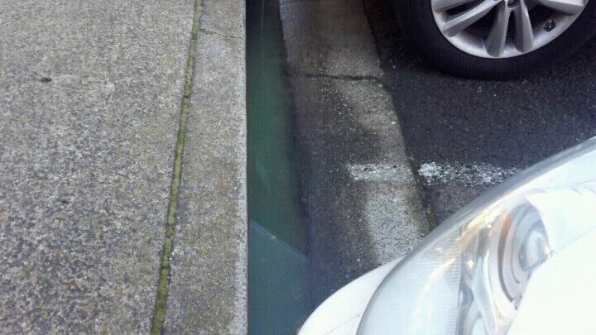 | To aid in the identification of activities and sources of potential pollutants of concern, the key personnel assisting in development of this SWMP utilized information on historic storm water issues as well as knowledge of day-to-day operations to identify activities and sources of potential pollutants of concern.
The BMPs to address the pollutant sources and activities described on Table 3-1 will be developed and implemented as described in Section 5.0.
Table 3-1: Pollutants of Concern and Related Activities and Sources
No. | Activity/Source | Pollutants of Concern
1 | Building maintenance (floor washing, stripping, and waxing; graffiti removal; asbestos and lead abatement) | Wash water, paint chips, asbestos, cleaning products, dirt and sediment
2 | Carpet cleaning waste water | Cleaning products, soap
3 | Chemical spills | Various cleaning compounds, paint, vehicle fluid, diesel, hazardous materials
4 | Construction activities | Asphalt, concrete, de-greasing agents, diesel, drywall, fertilizers, grease, galvanized metal, herbicides, metal fragments, oil, paint, pesticides, sediment, septic fluids, tar, trash, vehicle fluids, dust plumes
5 | Farming activities | Dust plumes, tracking dirt & vegetation, green waste, organic pollutants from unmanaged composting
6 | Ranching/Livestock activities | Denuding vegetated areas, erosion
7 | Pet/Livestock wastes | Salmonella, E. Coli, Cryptosporidium, ammonia/nitrates, antibiotics
8 | Irrigation runoff | Chloramines, fertilizers, pesticides, herbicides, sediment
9 | Ground maintenance | Green waste, fuel, oil, pesticides, herbicides, fertilizers
10 | Food service operations | Wash water, food residue, oil and grease
11 | Impervious areas | Increased flows, pollutant loading
12 | Litter, debris | Litter, debris
13 | Loading and unloading areas | Fertilizers, pesticides, herbicides, cleaning solutions, paint, petroleum products, litter, food residue
14 | Painting (indoor) | Paint or rinse water (oil- and water-based), paint thinner
15 | Roof runoff | Particulate matter and associated pollutants
16 | Rooftop Chiller Discharge | Particulate matter and associated pollutants
17 | Sewer line blockages and seepage | Raw sewage
18 | Trash storage areas | Organic material, hazardous materials
19 | Utility line maintenance and repairs (water/irrigation/sewer) | Chloramines, chlorine, sediment, adhesive cements, primers
20 | Wood chips (ground cover) | Organic material
21 | Erosion | Sediment, organic matter
22 | Outdoor storage of raw materials | Sand, asphalt, organic material,
23 | Parking lot runoff | Oil/grease, litter, heavy metals
24 | Vehicle maintenance | Vehicle fluids, oil, hazardous materials
25 | Science laboratories | Chemicals, hazardous waste
26 | Pool facilities | Acid, calcium chloride, sodium bicarbonate, soda ash, chlorinated water
27 | Miscellaneous non-campus unknown debris (illegal dumping) | Refrigerators, tires, unidentified liquid containers, furniture, electronics, and miscellaneous other trash
28 | Career Education and Training (CET) including art classes (photography, pottery),  Theater, fire, auto and other courses that may dispose chemicals or pollutants of concern | Paints, adhesive cements, clay (fine sediment), monoammonium phosphate (fire extinguishers), chlorinated water, ash slurry, copper, metal filings, primers, petroleum chemicals, biohazard, prescription medications and medical equipment (sharps).

4.0 Minimum Control Measures and BEST MANAGEMENT PRACTICEs
“Minimum Control Measures” (MCMs) is the term used by the U.S. EPA for the six MS4 program elements aimed at achieving improved water quality. This SWMP includes Best Management Practices to address the following six Minimum Control Measures which align with those MCM’s identified in the EPA’s Final Rule and California’s Phase II Permit:
Six MCMs:
- Education And Outreach On Storm Water Impacts
- Campus-Wide Involvement And Participation
- Illicit Discharge Detection And Elimination
- Construction Site Storm Water Runoff Control
- Post-Construction Storm Water Management In New Development And Redevelopment
- Pollution Prevention And Good Housekeeping For Facilities Operation And Maintenance

The goal of the SWMP is to reduce the discharge of pollutants and to identify activities or structural improvements that help reduce the quantity and improve the quality of the storm water runoff. BMPs have been developed for the SWMP to reduce the discharge of pollutants to the storm drain system. BMPs include treatment controls, operating procedures, and practices to control site runoff, spills and leaks, sludge or waste disposal, and/or drainage from raw material storage. BMPs will be updated as appropriate to conform to general changes in the industry for improvement of practices.

4.1 How to Use BMPs to Meet SWMP Goals
While the initial start dates vary, the BMPs described in Section 5.0 have been implemented by District staff and outside contractors. Whenever District staff or contractors perform work at the campuses, procedures outlined for each relevant BMP, or another proven technique that reaches the same goal, must be used for compliance with the SWMP. In some cases, the measure has not been formally documented as a written plan or program. The SWMP will document existing BMPs and outline implementation of additional BMPs. Full development and implementation of BMPs will be completed through the 5-year implementation plan, as presented in the following sections.

5.0 DEVELOPMENT AND IMPLEMENTATION OF BMPS
The (person/department), will oversee the implementation of this SWMP. District students, faculty, staff, and consultants will implement the BMPs. Each BMP is associated with one or more of the campus departments and divisions. Implementation will be the responsibility of specific campus departments and divisions associated with each BMP. The following list of acronyms identifies each department and division that is referenced in the following sections:

- Example: Facilities Planning, Maintenance and Operations (FPO)
- Example: Sustainability Committee
- Example: Storm Water Working Group (SWWG)
Each of the six MCMs contains a BMP table which includes implementation year, description, measurable goal, and the responsible party for each BMP. Following each BMP implementation table is an Implementation Details and Measurable Goals section, which explains how each BMP will be implemented. BMPs will be implemented with the ultimate goal of improving storm water quality entering District MS4s.

5.1 MCM 1: Education and Outreach on Storm Water Issues

5.1.1 Program Goal

The goal of this MCM is to promote greater awareness and compliance throughout the District’s campuses for the storm water management program. Specifically, this minimum measure is intended to teach the District community (students, faculty, staff and visitors) and the District’s contractors and consultants the importance of protecting storm water quality, for the benefit of both the environment and human health.
Table 5-1 presents selected BMPs for this minimum measure. The table identifies the current status of each BMP as well as the implementation details, the implementation year, measurable goals, and the campus division or departments that will be responsible for the implementation.

5.1.2 BMP Implementation Details and Measurable Goals
(The Implementation Details and Measurable Goals are provided as examples. Edit and describe the District Details and Goals for the representative BMP’s selected.)
5.1.2.1 Education and Outreach Program for Faculty, Staff, Students and Visitors
Implementation Details: First, the District will coordinate and integrate storm water awareness in the staff development meetings, sustainability committee meetings and site council meetings. Second, publications incorporating storm water education slogans, graphics, and issues (i.e., spills, illegal dumping, cigarette butt litter and other public awareness issues) will be developed and distributed by the District. Publications may include posters, calendars, stickers, fact sheets, and brochures. Distribution of these publications will be through the coordination meetings, school-specific campaigns, and special events. The District will develop and post storm water-related articles annually in the Skyline Shines newsletter, Olive Press newsletter, New Employee Orientation, and other internal information media.
Measurable Goal: Document all coordination meetings that include storm water awareness issues. The District will distribute all publications to faculty and staff semiannually. Storm water awareness articles will be posted annually in the newsletter. Metrics may include number of audience members in attendance at presentations as well as number of type of collateral developed and distributed.
5.1.2.2 Education and Outreach for District-Wide Contractors
Implementation Details: The District will develop a mechanism to refer all contractors to local, state, and federal storm water education/training. The referral mechanism will include brochures and fact sheets. Distribution of these materials will be through contact packages and safety meetings.
Measurable Goal: The District will refer contractors, where appropriate, to storm water-specific training as applicable to their field.

Table 5-1. BMP Implementation: Education and Outreach on Storm Water Issues
Key
Level 1 - Effective Stormwater Management  (District may already have measures in place.) |  |  | Level 2 – Forward Thinking |  | Level 3 – Superior Strategy |  | Level 4 – Exemplary Example of Environmental Stewardship
Section | BMP | Current Status |  | Implementation Details |  | Measurable Goals |  | Responsible  Party | Year
Level | MCM
5.1.2.1 | Orientation Training for Operations/Maintenance Staff (Employees) | Describe existing practices here |  | Create storm water orientation training module for Operations and Maintenance staff. |  | Describe measurable goals here |  | ___ | __
Level 1 | Education and Outreach on Storm Water Issues
5.1.2.1 | Ongoing Training for Operations/Maintenance Staff (Employees) | Describe existing practices here |  | Ongoing Training for Operations and Maintenance Staff: Discuss stormwater management topics and the District approach to stormwater management/protection at routine meetings. |  | Describe measurable goals here |  | ___ | __
Level 1 | Education and Outreach on Storm Water Issues
5.1.2.1 | Orientation Training for District Faculty and Staff (Employees) | Describe existing practices here |  | Create storm water orientation training module for District Faculty and Staff which discusses the District approach for storm water management. |  | Describe measurable goals here |  | ___ | __
Level 2 | Education and Outreach on Storm Water Issues
5.1.2.1 | Ongoing Updates for District Faculty and Staff (Employees) | Describe existing practices here |  | Ongoing Updates for District Faculty & Staff: Discuss stormwater management topics and the District approach to stormwater management/protection at routine meetings. |  | Describe measurable goals here |  | ___ | __
Level 2 | Education and Outreach on Storm Water Issues
5.1.2.1 | Discuss storm water issues at council and club meetings.  (Students) | Describe existing practices here |  | Discuss storm water management topics at student council and student club meetings. |  | Describe measurable goals here |  | ___ | __
Level 2 | Education and Outreach on Storm Water Issues
5.1.2.1 | Educate regarding District waste stream and storm water practices. (Campus Community) | Describe existing practices here |  | Provide knowledge of District waste stream practices and storm water practices through Campus newspapers, flyers and/or educational signs and billboards. |  | Describe measurable goals here |  | ___ | __
Level 2 | Education and Outreach on Storm Water Issues
5.1.2.1 | Broaden knowledge within related Degree Programs  (Students) | Describe existing practices here |  | Broaden knowledge of Clubs or Students in related degree programs within the realm of storm water issues via share of publications, flyers, guest speakers and lecture series. |  | Describe measurable goals here |  | ___ | __
Level 3 | Education and Outreach on Storm Water Issues
5.1.2.1 | Brochure Distribution | Describe existing practices here |  | Distribute Storm Water Awareness Brochures |  | Describe measurable goals here |  | ___ | __
Level 3 | Education and Outreach on Storm Water Issues
5.1.2.1 | Campus Community – Social Media | Describe existing practices here |  | Share links to local and other applicable storm water programs. Share insider articles, website postings, lectures series, and interviews. Disseminate information and links to online reference materials utilizing a variety of social media outlets. (District/Campus Websites, Newsletters, Blogs, Twitter, Facebook, etc). |  | Describe measurable goals here |  | ___ | __
Level 2 | Education and Outreach on Storm Water Issues
5.1.2.2 | Education Referral Mechanism (Contractors) | Describe existing practices here |  | Develop a referral mechanism for contractors to obtain storm water education through local, state or federal training. Referral mechanism may include brochures that include upcoming training dates and locations. |  | Describe measurable goals here |  | ___ | __
Level 3 | Education and Outreach on Storm Water Issues

5.2 MCM 2: Campus Community Involvement and Participation

5.2.1 Program Goal

The goal of this MCM is to foster active support for the SWMP and provide direction as to its implementation. Participation by the students, parents, faculty, and staff will assist in developing a SWMP which reflects community goals and priorities and thus has the highest potential for success.
Table 5-2 presents selected BMPs for this minimum measure. The table identifies the current status of each BMP as well as the implementation details, the implementation year, measurable goals, and the District’s campus divisions or departments that will be responsible for the implementation.

5.2.2 Implementation Details and Measurable Goals
(The Implementation Details and Measurable Goals are provided as examples. Edit and describe the District Details and Goals for the representative BMP’s selected.)
5.2.2.1 Storm Drain Labeling
Implementation Details: The District will continue its program to label all of the District’s storm drains with the slogan “No Dumping, Drains to Bay.” Labels and/or painted warnings have already been designed and placed on most drain inlets on all campuses.  Measurable Goals: The District will identify labeled and unlabeled inlets by the end of implementation year 1. The District will have 100 percent of all storm drains inlets labeled by the end of implementation year 1. | 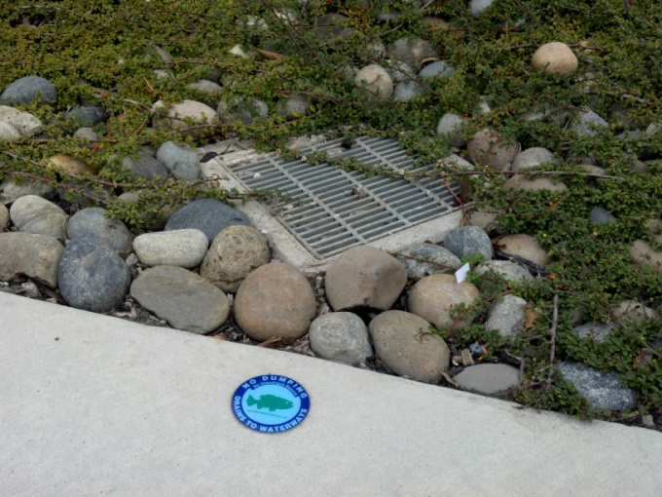
5.2.2.2 Adopt-a-Drain-Inlet Program
Implementation Details: The District may develop an “adopt--a-drain-inlet” program through campus-specific programs. The “adopt-a-drain-inlet” program will involve students, faculty, and campus staff coordinating in an effort to maintain school storm drains at their inlets while providing a hands-on approach to storm water education.
Measurable Goal: Adopt one storm drain inlet on the main campus by the end of implementation year 2 (pilot program). Subsequent additional inlet adoption will be contingent on activity and interest generated during the pilot program.
5.2.2.3 Engage Faculty to Create, Incorporate or Enhance Curriculum Offered within the District
Implementation Detail: Create, incorporate or enhance the curriculum of the District in the areas of environmental stewardship and fostering sustainable behavior. Investigate producing classes for general education fulfillment or continuing education in the area of Community-Based Social Marketing. Engage math, statistical, behavioral studies and other departments to prepare surveys and programs, whether implemented or not, which are related to environmental health and human or other animal response or behavior changes.
Measurable Goal: By implementation year 2, determine feasibility. This may require assessments for potential faculty and student interest and cost analysis among other factors. If feasible, by year 4, implement 1 or 2 strategies (courses or assignments) within offered curriculum per quarter/semester. Subsequent years: Evaluate potential for growth regarding sustainability curriculum.

5.2.2.4 Storm Water Coordination Meetings
Implementation Detail: The District (or____) will coordinate and participate with the following meetings: (1) staff development meeting, (2) safety meeting, (3) college council meeting, (4) city/district liaison meetings, and (5) management team meetings. Each of these meetings will incorporate a discussion of storm water issues and practices to impede or prevent illegal dumping, and methods to promote pollution prevention practices and general storm water awareness.
The potential exists for the formation of various groups dedicated to promoting environmental awareness. The District will engage students, environmental clubs or District sustainability Committees in review and revision of this SWMP.
Measurable Goal: The District will incorporate storm water aspects into any of the above listed meetings at least two times a quarter. Coordination meetings will have, at minimum, one storm water impression annually. Discussion results from meetings shall be used in consideration of enhancement and/or revision of the District’s SWMP and Storm Water Program.
5.2.2.5 Storm Water Pollution Prevention and Mitigation Awareness Surveys
Implementation Detail: The District will develop survey sheets that will target different audiences in the District. These surveys will be distributed at special school day events, environmental events and coordination meetings. The surveys will include questions on general storm water awareness; for example, the difference between storm drains and sanitary sewer drains. The surveys will also include questions on recognition of storm water Low Impact Development (LID) practices throughout the campuses and how those surveyed became aware of their existence and purpose. The survey results will be compiled by the ________Department.
Measurable Goal: The District will complete at least 200 individual surveys by implementation year 5. The surveys will be compared in groups by year to measure whether increases in awareness of storm water issues are occurring over time.
5.2.2.6 Storm Water Hotline
Implementation Detail: District will provide the campus (Facilities Maintenance) phone number to track and refer storm water quality-related questions and concerns. The phone number will be posted on the web site, newsletters, and at the school front offices. District (Facilities Operations) staff will be provided with a referral form to track phone calls. The referral form will include brief questions in order to refer the storm water issue to proper District and campus staff and maintain a formal tracking mechanism for phone calls.
Measurable Goal: The District will document the number of storm water-related calls per year through the referral forms and (its computerized maintenance management work request system (WOLFE)).
5.2.2.7 Campus-Specific Special Events, Campaigns and Activities
Implementation Detail: The District will develop storm water-related aspects into future and existing campus special events and campaigns. Special events that incorporate storm water related aspects have the ultimate goal of gaining support for reducing pollutants of concern is storm water runoff while promoting campus community involvement and participation. Surveys such as those highlighted in section 5.2.2.4 may be distributed and collected at these and other events as necessary or appropriate. Examples of existing and future campus special events campaigns and activities may include the following:
- April – Keep America Beautiful Month
- Earth Day
- Arbor Day
- Campus Clean-up Days
- Recycling Drives
- Community Open Houses
- Wellness Fairs
- Great American Smokeout
- Great California Shake Out
- Campus Riparian Habitat Creation or Restoration
- Native or other Plant Demonstration Garden incorporating Integrated Pest Management
- Construct a portable, interactive storm water issue-related diorama to share with the San Mateo County community
See Appendix H for a list of potential sources from which storm water education materials may be acquired.
Measurable Goal: At least 2 events, campaigns or activities will be implemented by year 2. The District will document the events, campaigns or activities where storm water awareness was promoted to the community. Based on anticipated resources and community interest available, and response to the previous year’s events, the District community will decide how often, where and how to encourage community involvement in promoting the awareness of storm water issues.

Table 5-2. BMP Implementation: Campus Community Involvement and Participation
Key
Level 1 - Effective Stormwater Management  (District may already have measures in place.) |  |  |  | Level 2 – Forward Thinking |  | Level 3 – Superior Strategy |  | Level 4 – Exemplary Example of Environmental Stewardship
Section |  | BMP | Current  Status |  | Implementation  Details |  | Measurable  Goals |  | Responsible  Party | Year
Level |  | MCM
5.2.2.1 | Storm Drain Labeling |  | Describe existing practices here |  | Identify all drain inlets that are missing labels. Label all storm drain inlets. |  | Describe measurable goals here |  | _____ | __
Level 1 | Campus Community Involvement & Participation
5.2.2.2 | Adopt-a-Drain Inlet Program |  | Describe existing practices here |  | Involve students, faculty, and campus staff coordinating in an effort to maintain school storm drains at their inlets while providing a hands-on approach to storm water education. |  | Describe measurable goals here |  | _____ | __
Level 3 | Campus Community Involvement & Participation
5.2.2.3 | Engage Faculty to Create, Incorporate or Enhance Curriculum Offered within District. |  | Describe existing practices here |  | Create, incorporate or enhance the curriculum of the District in the areas of environmental stewardship and fostering sustainable behavior. Investigate producing classes for general education fulfillment or continuing education in the area of Community-Based Social Marketing. Engage math, statistical, behavioral studies and other departments to prepare surveys and programs, whether implemented or not, which are related to environmental health and human or other animal response to changed environmental conditions or promoted watershed protection effort. |  | Describe measurable goals here |  | _____ | __
Level 4 | Campus Community Involvement & Participation
5.2.2.4 | Storm Water Coordination Meetings |  | Describe existing practices here |  | Coordinate & participate in the following meetings: (1) staff development meetings, (2) safety meetings, (3) site council meetings, (4) city/district liaison meetings, (5) management team meetings.  Focus meetings in the beginning within the campus community.  Broaden coordination as time and availability present themselves so that discussion progresses to City/District liaison meetings. |  | Describe measurable goals here |  | _____ | __
Level 2 | Campus Community Involvement & Participation
5.2.2.4 | SWMP: Campus Community Review |  | Describe existing practices here |  | Annually present the SWMP online for review and response. Obtain campus feedback and incorporate revisions. |  | Describe measurable goals here |  | ______ | __
Level 3 | Campus Community Involvement & Participation
5.2.2.4 | Student/Staff Sustainability Committee |  | Describe existing practices here |  | Strengthen involvement within District faculty, staff and student representatives. Provide an education review process. |  | Describe measurable goals here |  | _____ | __
Level 3 | Campus Community Involvement & Participation
5.2.2.5 | District Awareness Survey |  | Describe existing practices here |  | Develop survey sheet that will target different audiences in the District. These surveys will be distributed at meetings or event as applicable. (i.e. Earth Day and Arbor Day). |  | Describe measurable goals here |  | _____ | __
Level 3 | Campus Community Involvement & Participation
5.2.2.6 | Facilities and Public Safety Hotline |  | Describe existing practices here |  | Provide the campus front desk phone number to field & refer water quality related questions. The number will be posted on the web site, newsletters, & at the campus front office. Campus front office staff will be provided a referral form to fill out while fielding phone calls. |  | Describe measurable goals here |  | ___ | __
Level 1 | Campus Community Involvement & Participation
5.2.2.7 | Campus Community Activities |  | Describe existing practices here |  | Examples include, but are not limited to: Native or other Plant Demonstration Garden incorporating Integrated Pest Management, Composting Club, Diorama Construction, Educational Signs at Bioretention Facilities or Pervious Pavement, Campus Riparian Habitat (Maintenance, Restoration or Creation.) |  | Describe measurable goals here |  | ____ | __
Level 3 | Campus Community Involvement & Participation
5.2.2.7 | Campus Special Events |  | Describe existing practices here |  | Include storm water aspects into future & existing campus-specific special events & campaigns (i.e. Earth Day, Cleanup Days, Open House). |  | Describe measurable goals here |  | ____ | __
Level 3 | Campus Community Involvement & Participation

5.3 MCM 3: Illicit Discharge Detection and Elimination

5.3.1 Program Goal

The goal of this MCM is to reduce pollutants in storm water runoff to receiving waters. It required the development and implementation of a program to identify and eliminate sources of illicit discharge and illegal dumping.
Table 5-3 presents selected BMPs for this minimum measure. The table identifies the current status of each BMP as well as the implementation details, the implementation year, measurable goals, and District campus division or departments that will be responsible for the implementation.

5.3.2 Implementation Details and Measurable Goals
(The Implementation Details and Measurable Goals are provided as examples. Edit and describe the District Details and Goals for the representative BMP’s selected.)
5.3.2.1 Separate Storm Sewer System Mapping
Implementation Details: The District will have digital mapping prepared to identify storm drain locations, outfall locations and constructed storm water BMPs. A paper copy of the mapping will be augmented to include locations of discharge to adjacent MS4’s, and flow direction for each of the campuses.
Measurable Goal: The storm water conveyance maps will be created by implementation year one and will be updated as necessary with major construction and changes in the storm water management program.
5.3.2.2 Storm Drain and Outfall Inspections
Implementation Detail: The District will augment the Grounds yard inspection checklists to include visual observations of the condition storm drains and outfalls. Visual observations will be conducted by identifying disrepair, excessive debris, spills or illicit discharges. The checklists are submitted to the FPO on an as-needed basis. At a minimum, inspections will occur every August in preparation for the first significant storm of the winter season.
Measurable Goal: Document at least 90 percent of all storm drain and 100 percent of outfall inspections annually. Tracking will occur through submittals of the checklists and occur at minimum annually by implementation year 2.
5.3.2.3 Hotspot -Visual Inspection Tracking for Maintenance and Corporation Yards
Implementation Details: The District will retain the inspection checklists in a binder or database. The database and/or binder will be maintained by the campus Facilities Maintenance Center. The District will track these inspections on an annual basis.
Measurable Goal: Document at least 100 percent of all yard inspections for potential hotspots are tracked annually by implementation year 2.
5.3.2.4 Non-Storm Water Discharge Program
Implementation Details: District Grounds staff will conduct the regular inspections of the campuses and report to their campus Facilities Maintenance Center. The inspections will be augmented to incorporate the identification of the non-storm water discharges such as seeps, breakages for utility pipes associated with water (e.g. irrigation, sanitary sewer, chillers and steam), irrigation overspray and groundwater seepage. The checklist will also include the identification of the illegal discharges, debris, and potential pollutants of concern. Tracking of the checklists will be conducted by the District.
Measurable Goals: Document that at least 90 percent of all campus areas are inspected for non-storm water discharges annually.
5.3.2.5 Storm Water Training for Facilities Operations Staff
Implementation Details: The District will augment the existing training procedures and materials to include storm water pollution prevention information. The District will track the existing training meetings through agendas and sign-in sheets. Agendas and/or sign in sheets will be retained at the District FPO Office.
Measurable Goals: 25 percent of all Grounds staff will be trained annually. 100 percent of all facilities staff will be trained by implementation year 5. New hires will be made aware of the training program upon orientation. FPO will retain documentation of training attendance with SWMP for future review and discussion of measureable goals. Facility Managers and other relevant staff will be certified by the agencies and/or certification programs deemed appropriate by the District
5.3.2.6 Signage for Public Use Areas
Implementation Details: The District will develop signage to address illegal dumping, litter, and storm water protection. The signs will include the appropriate notification and reporting hotline phone number. Enforcement will be the responsibility of the FPO fielding the hotline calls. Issues will be referred to City Code Enforcement Officers at the discretion of the FPO. Public use areas may include athletic fields.
Measurable Goal: 100 percent of all public use campus areas will have signage addressing storm water protection and illegal dumping and will develop a method to address historically problematic areas by end of implementation year 2.
5.3.2.7 Storm Water Program
Implementation Details: The District will develop and maintain a storm water program. The program will address illegal discharges, illegal dumping, and identified unauthorized non-storm water discharge. The program will also identify an enforcement escalation mechanism to address situations of non-compliance. For example, the mechanism may include verbal warnings, written warnings, and referrals to City Code Enforcement.
Measurable Goal: The District will develop a comprehensive program by implementation year five.
5.3.2.8 Trash Reduction and Recycling
Implementation Details: The District currently has a full AB75 plan implemented to address trash reduction and recycling.
Measurable Goal: See annual AB75 report to the state.
5.3.2.9 Review of Pollutant Sources
Implementation Details: Currently the District conducts a review of pollutants to fulfill AB75 requirements. The pollutant sources are further addressed in the District’s Hazardous Materials Business Plan. The District will continue to conduct reviews in accordance with AB75 requirements.
Measurable Goal: See annual AB75 report.

Table 5-3. BMP Implementation: Illicit Discharge Detection and Elimination
Key
Level 1 – Effective Stormwater Management  (District may already have measures in place) |  |  | Level 2 – Forward Thinking |  | Level 3 – Superior Strategy |  | Level 4 – Exemplary Example of Environmental Stewardship
Section | BMP | Current  Status |  | Implementation  Details |  | Measurable  Goals |  | Responsible  Party | Year
Level | MCM
5.3.2.1 | Basic Storm Sewer System Mapping | Discuss existing practices here |  | Hand marked map of inlet and outfall locations. Label inlets and outfalls with identifiers. (Outfall 1, Inlet 12, etc) |  | Describe measurable goals here |  | ___ | __
Level 1 | Illicit Discharge Detection and Elimination
5.3.2.1 | Upgrade Storm Sewer System Mapping | Discuss existing practices here |  | Electronic record / GIS mapping of inlet and outfall locations. Label inlets and outfalls with identifiers. (Outfall 1, Inlet 12, etc) |  | Describe measurable goals here |  | ___ | __
Level 2 | Illicit Discharge Detection and Elimination
5.3.2.2 | Storm Drain Inlet and Outfall Inspections – Historic Routine Maintenance | Discuss existing practices here |  | Inspect all inlets and outfalls yearly within 1 to 2 months of rainy season to do cursory check for suspicious or allowed non-stormwater discharges, the condition of the storm drain and in order to schedule removal of trash and debris and perform repairs. |  | Describe measurable goals here |  | ___ | __
Level 1 | Illicit Discharge Detection and Elimination
5.3.2.2 | Storm Drain Inlet and Outfall Inspections – Formal Illicit Discharge Detection & Maintain Detailed Records of Inspections | Discuss existing practices here |  | Inspect all inlets and outfalls yearly with formalized illicit discharge detection (non-stormwater discharge detection) program. Also check the condition of the storm drain and determine need to schedule removal of trash and debris and perform repairs. |  | Describe measurable goals here |  | ___ | __
Level 2 | Illicit Discharge Detection and Elimination
5.3.2.3 | Hotspot Visual Inspections (Maintenance and Corporation Yards) - Maintain Historic Routine | Discuss existing practices here |  | A good housekeeping item - Activity may already be covered under Industrial General Permit or mandated by other Code requirements to control pollutant generating activities. Includes having potential pollutants stored appropriately so they are neither exposed to elements nor a threat to water quality. |  | Describe measurable goals here |  | ___ | __
Level 1 | Illicit Discharge Detection and Elimination
5.3.2.3 | Hotspot Visual Inspections (District/Campus-wide) | Discuss existing practices here |  | Formalize Hotspot Visual Inspection Routine. Expand to all areas of campus where there may be potential discharges of pollutants. |  | Describe measurable goals here |  | ___ | __
Level 3 | Illicit Discharge Detection and Elimination
5.3.2.4 | Training (Awareness) for Food Service, Custodial, Grounds Staff in Illicit Discharges | Discuss existing practices here |  | Incorporate discussion regarding pollutant-generating activities in safety meetings or other regularly scheduled meetings. (Related to MCM 1 - Education and Outreach) |  | Describe measurable goals here |  | ___ | __
Level 1 | Illicit Discharge Detection and Elimination
5.3.2.5 | Training (Formalized) for Food Service, Custodial, Grounds Staff in Illicit Discharges | Discuss existing practices here |  | Staff to complete Certificate Programs related to their jobs. Alternatively, have a formal in-District training program developed. Prepare quiz/questionnaire. Also helps with MCM 1 - Education and Outreach |  | Describe measurable goals here |  | ___ | __
Level 2 | Illicit Discharge Detection and Elimination
5.3.2.6 | Post Signs in Public Areas addressing illegal dumping. | Discuss existing practices here |  | An effort to eliminate pollutant source. |  | Describe measurable goals here |  | ___ | __
Level 2 | Illicit Discharge Detection and Elimination
5.3.2.6 | Hotline to report discharges of pollutants. | Discuss existing practices here |  | Assists with discharge detection and elimination. |  | Describe measurable goals here |  | ___ | __
Level 1 | Illicit Discharge Detection and Elimination
5.3.2.8 | Trash Reduction and Recycling (AB75) | Currently _____ |  | Assists with eliminating potential pollutant source & also helps with MCM 6 - Pollution Prevention and Good Housekeeping. |  | Describe measurable goals here |  | ___ | __
Level 1 | Illicit Discharge Detection and Elimination
5.3.2.9 | Hazardous Materials Business Plan | Discuss existing practices here |  | Review of pollutant sources to assess for potential BMPs to reduce the source & also helps with MCM 6 - Pollution Prevention and Good Housekeeping. |  | Describe measurable goals here |  | ___ | __
Level 1 | Illicit Discharge Detection and Elimination

5.4 MCM 4: Construction Site Storm Water Runoff Control

5.4.1 Program Goal

The goal of this MCM is to prevent sediment and construction waste at construction sites from entering the storm water conveyance system.
Table 5-4 presents selected BMPs for this minimum measure. The table identifies the current status of each BMP as well as the implementation details, the implementation year, measurable goals and District offices that will be responsible for implementation.

5.4.2 Implementation Details and Measurable Goals
(The Implementation Details and Measurable Goals are provided as examples. Edit and describe the District Details and Goals for the representative BMP’s selected.)

5.4.2.1 Construction Site Inspections

Implementation Details: The District will track construction site inspections conducted by the District’s Construction Management Team. The program may consist of a database to track information such as the following:
- site name
- site owner, contract information
- site acreage
- Risk Level if site acreage exceeds 1 acre and is not exempt from submitting a SWPPP to the SWRCB
- Qualified SWPPP Developer (QSD) and Qualified SWPPP Practitioner (QSP) if site acreage exceeds 1 acre and is not exempt from submitting a SWPPP to the SWRCB
- Notice of Intent(NOI) filing date and WDID#
- inspection log
- by Construction Management Team if less than an acre
- by QSP and within SWPPP if greater than 1 acre and not exempt.
- Change of Information (COI) submittals
- Notice of Termination (NOT) filing date
- comments
Measurable Goal: Construction sites less than 1 acre or greater than 1 acre and exempt from Construction General Permit requirements are inspected weekly.
Construction sites, greater than 1 acre, which are not exempt from Construction General Permit requirements, will maintain compliance with the Construction General Permit requirements.

5.4.2.2 Receipt of Comments for Construction Activities
Implementation Details: The District will provide the campus Facilities Maintenance Center front office phone number as the hotline. Front office personnel will be included in storm water awareness training and will be knowledgeable in dealing with storm water calls. Front desk staff will also be equipped with referral forms indicating various issues such as illegal spills, construction waste, and issues of noncompliance. The hotline number will be posted at the construction site as well as on the web site.
Measurable Goal: The District will document the number of storm water-related calls through referral forms. The District will document 100 percent of all calls related to construction.
5.4.2.3 Construction Contract Specifications through Bid Package
Implementation Details: The District distributes storm water-specific contract language for all hired construction contractors and maintains strict design standards for new construction and major remodel/additions that requires contractors to subscribe to green buildings and sustainable design standards like those set forth in the LEED certification process. Contracts will continue to include language regarding waste materials, non-storm water discharges, illegal dumping, spill containment, erosion and sediment controls, and BMP maintenance. Contract language will also continue to include enforcement actions for occurrences of non-compliance. Contracts will be updated annually.
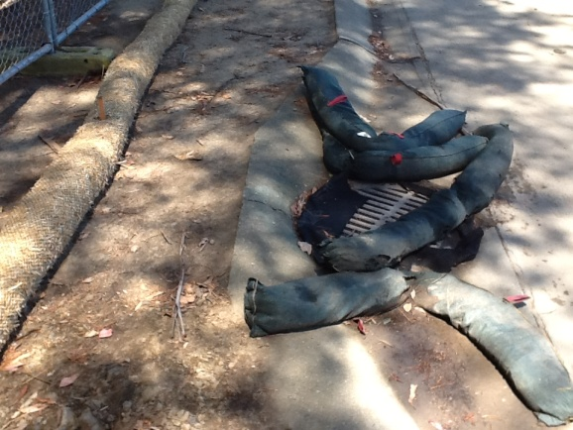 | Measurable Goal: Contracts provided to construction contractors will contain storm water-specific language as applicable. Storm Water Pollution Prevention and Mitigation language will be augmented with construction and design standards to meet the SWMP where necessary.
5.4.2.4 Internal Inspector Training
Implementation Details: District Construction Managers will undergo appropriate training and attain applicable certifications in order to properly identify and manage storm water construction controls, waste, spills, and other issues. Tracking will be included in the construction inspections tracking database.
Measurable Goal: The District will provide internal construction managers all inspectors’ storm water training.
5.4.2.5 Construction Plan Review
Implementation Details: The District will develop a mechanism to review storm water controls and design from architect submittal prior to submittal to approving agency for final approval. The District will implement a plan review and pre-design meeting with the architect to discuss storm water issues. Plans will be reviewed for post-construction considerations, erosion and sediment control feasibility, and other storm water considerations.
Measurable Goals: The District will document 100 percent of all plans submitted and reviewed.
5.4.2.6 Storm Water Program
Implementation Detail: The District will develop a District-wide storm water program. The program will address erosion and sediment controls, waste management, spills, and unauthorized non-storm water discharges. The storm water program will also address occurrences of noncompliance, associated enforcement actions, and referral to City Code Enforcements.
Measurable Goals: The program will be developed by implementation year 5.

Table 5-4. BMP Implementation: Construction Site Storm Water Runoff Control
Key
Level 1 – Effective Stormwater Management  (District may already have measures in place) |  |  | Level 2 – Forward Thinking |  | Level 3 – Superior Strategy |  | Level 4 – Exemplary Example of Environmental Stewardship
Section | BMP | Current  Status |  | BMP Description |  | Measurable  Goal |  | Responsible  Party | Year
Level | MCM
5.4.2.1 | Construction Site Inspections | Describe existing practices here |  | Construction Management Team to monitor sites for proper application of BMPs and verify that appropriate reporting is occurring (i.e. in accordance with Construction General Permit) |  | Describe measurable goals here |  | ___ | __
Level 1 | Construction Site Storm Water Runoff Control
5.4.2.2 | Construction Site Inspections Database | Describe existing practices here |  | Create database of construction sites and log acreage disturbed, contractor, risk level (if applicable), due dates for routine inspections, inspector information, checklist for any BMPs that are called out in contract specifications. |  | Describe measurable goals here |  | ___ | __
Level 2 | Construction Site Storm Water Runoff Control
5.4.2.3 | Receipt of Comments regarding Construction Activities | Describe existing practices here |  | Most likely campuses already have a hotline or number for the community to call in to report concerns. |  | Describe measurable goals here |  | ___ | __
Level 1 | Construction Site Storm Water Runoff Control
5.4.2.4 | Construction Contract Specifications | Describe existing practices here |  | Provide minimum criteria for construction site BMPs and activities that Contractor must follow. |  | Describe measurable goals here |  | ___
Level 1 | Construction Site Storm Water Runoff Control
5.4.2.5 | Construction Contract Specifications | Describe existing practices here |  | Provide minimum criteria for all construction site BMPs (including less than 1 acre) and activities that Contractor must follow. |  | Describe measurable goals here |  | ___ | __
Level 2 | Construction Site Storm Water Runoff Control
5.4.2.6 | Construction Plan Review | Describe existing practices here |  | Develop a mechanism to review during-construction storm water controls and design from architect submittal prior to submittal to approving agency for final approval. |  | Describe measurable goals here |  | ___ | __
Level 1 | Construction Site Storm Water Runoff Control
5.4.2.7 | Internal Inspector Training | Describe existing practices here |  | Construction Managers undergo appropriate training in order to properly identify and manage storm water construction controls, waste, spills, and other issues. |  | Describe measurable goals here |  | ___ | __
Level 2 | Construction Site Storm Water Runoff Control

5.5 MCM 5: Post Construction Storm Water Management in New Development and Redevelopment

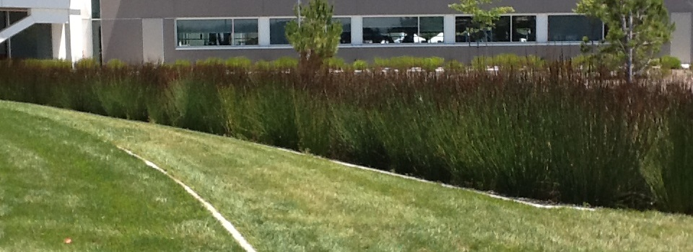

5.5.1 Program Goal

The goal for this MCM is to reduce non-point source pollution from urban runoff through planning and design, prior to development or redevelopment. Post construction runoff control focuses consideration on the site, design and ultimate project use, which are most effective when addressed in the planning and design stages of project development. Effective long-term management and maintenance are critical, so the best design opportunities are those needing the least amount of maintenance. The goal of the program is to integrate basic and practical storm water management techniques into new development to protect water quality.
Post-construction storm water management controls include permanent structural and non-structural BMPs (e.g., conservation of natural and permeable areas, permeable pavers, rooftop runoff infiltration galleries, and mechanical storm drain filters) that remain in place after the project is completed. Post-construction storm water management controls also include consideration in landscape design and accommodations for end-user practice in pollution prevention.
Table 5-5 presents selected BMPs for this minimum measure. The table identifies the current status of each BMP as well as the implementation detail, the implementation year, measurable goals, and District offices that will be responsible for implementation.

5.5.2 BMP Implementation Details and Measurable Goals
(The Implementation Details and Measurable Goals are provided as examples. Edit and describe the District Details and Goals for the representative BMP’s selected.)
5.5.2.1 Design Contract Specifications for Long-term Management and Maintenance
Implementation Details: The District has developed design standard language in contracts for construction sites. Until adoption of a District Storm Water Program, the language of proposed contracts will be augmented, on a case-by-case basis to include conditions requiring runoff controls and BMP’s for the long term management and maintenance of storm water facilities. The District will look to the San Mateo Countywide Water Pollution Prevention Program, LEED or the Statewide Phase II MS4 Permit (Section F) for the applicable avenue to which long-term storm water protection shall be incorporated.
Measurable Goal: Within implementation year 1 and until the District’s Storm Water Program is executed, the District will include storm water language in applicable contracts for the reference of planning, design and construction professionals.
5.5.2.2 Storm Water Program
Implementation Details: The District will develop a storm water program. The program will address pollution mitigation and prevention for storm water runoff, long-term maintenance of the District’s MS4s, including both the traditional conveyance components and post-construction BMPs. The program will also be structured to address campus community activities and behaviors in awareness and practice of pollution prevention. Additionally, the program will include an enforcement mechanism to address occurrences of non-compliance. Enforcement actions may include referral to the City Code Enforcements.
Measurable Goals: The District will develop the storm water program by implementation year 5.
5.5.2.3 Continuously Improve Design Review Process
Implementation Details: The District will continuously improve the SWMP and related processes. The FPO is the authorized authority for reviewing all applicable new development and redevelopment projects for impact to water quality. Where necessary, the District conditions projects with a combination of structural and non-structural BMPs intended to prevent or minimize storm water pollution. District review and conditioning of architectural and construction site plans will be documented prior to submittal with the California Department of General Services, Division of the State Architect.
Measurable Goal: Applicable projects shall be designed appropriately to prevent or minimize water quality impacts to the maximum extent practicable and at a minimum to the least restrictive of the following: the Statewide Construction General Permit (CGP) requirements for Post Construction, the Statewide Municipal Phase II MS4 Permit or the C3 requirements for San Mateo County. Note that projects which disturb more than one acre will be subject to the Post Construction requirements of the Construction General Permit. Where possible and appropriate, natural control systems (i.e.: bio swales) will be implemented.
5.5.2.4 Enhance the Design Review Cycle to Include Other District Departments
Implementation Details: Enhance the design review cycle to include other District departments. By including other departments in the Design Review cycle, projects can be evaluated and planning can be accommodated for future BMP implementation. Through a multi-department review structure, protective measures for water quality can be incorporated and be inherent in proposed project to address post-construction activities and behaviors which promote storm water protection.

Measurable Goal: By implementation year 2, for applicable projects, acquire sign off by all Departments included in the review process.
5.5.2.5 Maintenance Employee Training for Post-Construction Storm Water Management.
Implementation Details: Provide training for maintenance employees for the recognition and relevance of post-construction structural and non-structural BMPs for storm water quality and quantity management. Provide training on applicable maintenance strategies for post-construction BMP’s.

Measurable Goal: 50% of maintenance employees to have training by implementation year 2. 100% of maintenance employees to have training by implementation year 4. New hires are to undergo training, as part of the District's orientation program, beginning in implementation year 5.

5.5.2.6 Track Impervious Surfaces
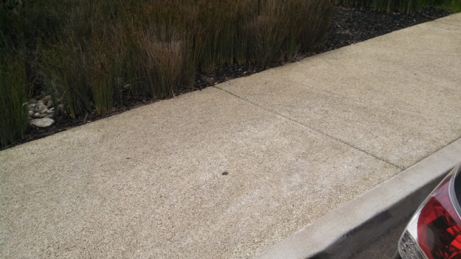 | Implementation Details: The District will review, update and maintain a record of square footage of impervious surfaces in the construction database. The District will track the existing square footage of impervious surfaces upon alteration of the campus upon completion of applicable construction projects.
Measurable Goal: The District will update the tally of impervious surfaces upon completion of projects which alter impervious surface coverage.

Table 5-5. BMP Implementation: Post-Construction Storm Water
Key
Level 1 – Effective Stormwater Management  (District may already have measures in place) |  |  | Level 2 – Forward Thinking |  | Level 3 – Superior Strategy |  | Level 4 – Exemplary Example of Environmental Stewardship
Section | BMP | Current  Status |  | BMP Description |  | Measurable  Goal |  | Responsible  Party | Year
Level | MCM
5.5.2.1 | Review Storm Water-Specific Contract (Architect) Specifications | Describe existing practices here |  | Continue to review existing language for the architect and other consultants as applicable. The language should be modified to address Low Impact Development, long-term BMP’s, applicable maintenance programs and projected activities and campus community behavior. Boilerplate contract documents will include language referring to the adherence to the District’s Storm Water Program. |  | Describe measurable goals here |  | ___ | __
Level 1 | Post Construction Storm Water
5.5.2.2 | Develop a Storm Water Program | Describe existing practices here |  | The program will address storm water pollution prevention, long-term maintenance of post-construction BMPs, hydromodification management and anticipated public activity and behavior. Criteria shall reference a local storm water program, LEED or the Statewide Phase II MS4 Permit as applicable to the type of project or activity proposed. |  | Describe measurable goals here |  | ___ | __
Level 1 | Post Construction Storm Water
5.5.2.3 | Develop a review and scoping process | Describe existing practices here |  | Develop a mechanism to review storm water controls and design from architect submittal prior to submittal to approving agency for final approval. Implement a plan review and pre-design meeting with the architect to discuss storm water issues related to the project. For example, mirroring the process outlined in “Blueprint for a Clean Bay” |  | Describe measurable goals here |  | ___ | __
Level 2 | Post Construction Storm Water
5.5.2.4 | Enhance the design review cycle | Describe existing practices here |  | Enhance the design review cycle to include departments other than Facilities and Maintenance with storm water quality in evaluating and planning for the implementation of the District, the architect’s or consultant’s project vision. |  | Describe measurable goals here
Level 3 | Post Construction Storm Water
5.5.2.5 | Training of maintenance employees regarding Post-Construction Storm Water Management | Describe existing practices here |  | Create training for maintenance employees for the recognition and relevance of post-construction structural and non-structural BMPs for storm water quality and quantity management. Provide training on applicable maintenance strategies for post-construction BMP’s. Related to MCM 1 Education and Outreach. |  | Describe measurable goals here |  | ___ | __
Level 1 | Post Construction Storm Water
5.5.2.6 | Track Impervious Surfaces | Describe existing practices here |  | Include the review of impervious surfaces in the construction database. Track impervious surface by square foot. |  | Describe measurable goals here |  | ___ | __
Level 3 | Post-Construction Storm Water

5.6 MCM 6: Pollution Prevention and Good Housekeeping for Facilities Maintenance and Operation
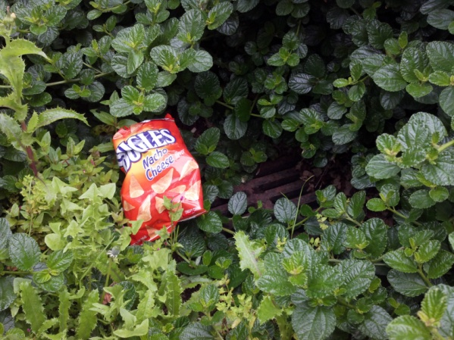  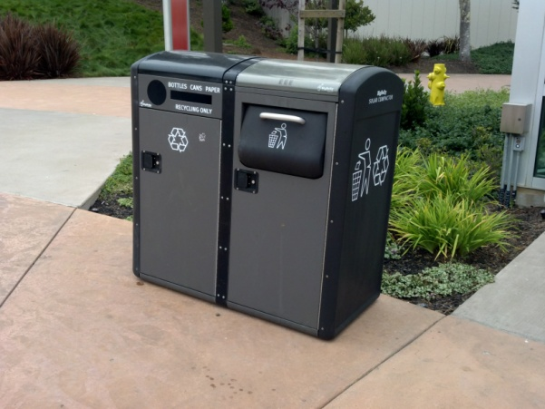 | 5.6.1 Program Goal  The goal of this MCM is to assure that District Facilities Maintenance and Operations activities occur in a manner protective of storm water quality. The District will develop and implement a maintenance and operations program that includes a training component and has the ultimate goal of preventing or reducing pollutant runoff from District operations. The District will use training materials that are available from the U.S. EPA, State, or other organizations, include employee training to prevent and reduce storm water pollution from activities such as park and open space maintenance, fleet building maintenance, new construction and land disturbances, and storm water system maintenance.  Table 5-6 presents selected BMPs for this minimum measure. The table identifies the current status of each BMP as well as the implementation details, the implementation year, measurable goals and District offices that will be responsible for BMP implementation.

5.6.2 Implementation Detail and Measurable Goals
(The Implementation Details and Measurable Goals are provided as examples. Edit and describe the District Details and Goals for the representative BMP’s selected.)
5.6.2.1 Centralized District Automobile Maintenance and Vehicle Washing and Program Regarding Car Wash Fundraising
Implementation Details: The District will continue to educate District staff to wash district-owned vehicles at the designated campus Facilities Maintenance Center (FMC) locations. The designated FMC locations are equipped to prevent wash water from entering the storm drain. Additionally, the District will implement, as part of the storm water program, the practice of using soaps, cleaners and detergents that are labeled phosphate-free or biodegradable. The District will also address, as part of the storm water program, restrictions or guidelines thereof, for practices related to car washing fundraisers. The District will forward information prepared by the San Mateo Countywide Water Pollution Prevention Program regarding appropriate car-wash practices to prevent contamination of storm water runoff whether at home or at work. In preparation for any guidelines related to car-wash fundraisers, the District will review the practices of programs such as the “River-Friendly Fundraiser Carwash Program” promoted by the Sacramento Stormwater Quality Partnership. The message will be disseminated through staff newsletters, safety meetings, and mass e-mails (as appropriate).
Measurable Goal: Document 100 percent of district-owned vehicles maintenance and washing. Tracking will occur through maintenance logs.
5.6.2.2 Custodial, Operations and Maintenance Staff Training
Implementation Detail: The District will augment the existing mandatory training bulletins to address storm water controls, oil/water separators, grease trap inspections, trash bin exposure issues, trash compacting procedures, spill containment and cleanup, wash water disposal (i.e., mop water, floor cleaning water), as well as other operations and maintenance activities.
Measurable Goal: The District will include, at a minimum, storm water issues in one training meeting annually. Where possible and appropriate, maintenance staff will use non-toxic cleaning materials.
5.6.2.3 Landscape Maintenance and Integrated Pest Management Program
Implementation Detail: The District will compare its existing landscape management program to the practices promoted by the San Mateo Countywide Water Pollution Prevention Program’s and other Bay-Friendly recommended landscape and maintenance practices. Additionally, the District will compare the practices of its pest management program to Integrated Pest Management strategies promoted by San Mateo County and other San Francisco Bay Area programs.
Measurable Goal: Comparison of strategies against locally promoted practices will occur by implementation year 2. If not already in practice, the District will determine Bay-Friendly and IPM techniques to adopt. The District will prepare a plan for implementation to enhance the existing landscape management program with the chosen techniques. By implementation year 4 the new strategies will be adopted.
5.6.2.4 Campus Spill Kit Campaign
Implementation Detail: The District will augment the Grounds daily yard inspection to include visual observations of storm drains and outfalls. Inspections will include identification of debris, obstructions, illegal spills or signs of illegal discharges. The daily logs will also include actions taken to clean storm drains. The daily checklists will be submitted to the FM monthly and maintained at the respective campus FMCs.
Measurable Goals: Document that at least 90 percent of all storm drains and outfalls are inspected annually. Development of a Storm Drain Inspection checklist will be completed by implementation year 4.
5.6.2.5 Storm Drain Inspections/Cleanout
Implementation Detail: The District will augment the Grounds daily yard inspection to include visual observations of storm drains and outfalls. Inspections will include identification of debris, obstructions, illegal spills or signs of illegal discharges. The daily logs will also include actions taken to clean storm drains. The daily checklists will be submitted to the FM monthly and maintained at the respective campus FMCs.
Measurable Goals: Document that at least 90 percent of all storm drains and outfalls are inspected annually. Development of a Storm Drain Inspection checklist will be completed by implementation year 4.
5.6.2.6 Compliance with the Industrial General Permit
Implementation Details: The District will update the Industrial Facility Storm Water Pollution Prevention Plan (SWPPP) annually, submit annual reports, conduct annual facility inspections, and collect two storm water samples per wet season. Although these tasks are required under the Industrial General Permit (CAS000001), the District identifies this activity as a Best Management Practice assisting with the attaining the goals of this SWMP.
Measurable Goal: The District shall update the SWPPP as required, submit annual updates, conduct regular facility inspections, and collect two storm water samples per wet season.
5.6.2.7 Used Oil Recycling Program
Implementation Details: The District will use the existing program to track the amount of used oil recycled annually. Although the used oil program is regulated under a different program, the District will account for the indirect improvement to water quality by ensuring that the used oil is stored, hauled, and documented in the proper manner.
Measurable Goal: The District will document the total volume of oil recycled annually.
5.6.2.8 Regular (Sanitary Sewer Overflow) SSO Inventory
Implementation Details: The District will develop and inventory all grease traps and oil/water separators located within the jurisdiction of the District. The inventory may account for inspections with county health to assess the status of the grease traps and oil/water separators.
Measurable Goal: The District will inventory 100 percent of all possible SSO (Sanitary Sewer Overflow) devices (i.e., grease traps, oil/water separators).
5.6.2.9 Campus Road/Parking Lot Sweeping
Implementation Details: The District will continue with the current sweeping program. By implementation year 4, the District will have all campus roads and parking lots swept, at minimum, within the month before October 15 in preparation for the rainy season. Then again, as needed after the first wind or rain storm which produces a significant accumulation of trash and debris which could pollute runoff or impact storm drain infrastructure.  Measurable Goal: 100% of campus streets and parking lots swept yearly within the month before October 15 and as additionally needed after the first significant storm (wind or rain) which produces a large quantity of fallen leaves and debris. | 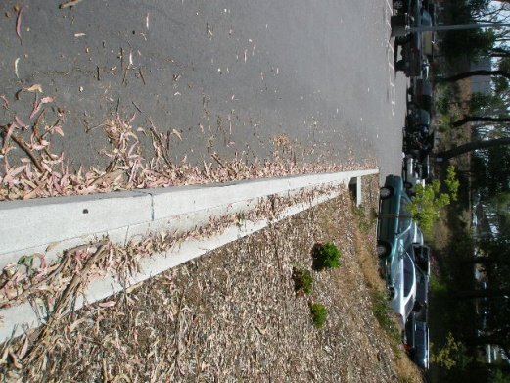

Table 5-6. BMP Implementation: Pollution Prevention/Good Housekeeping
Key
Level 1 – Effective Stormwater Management  (District may already have measures in place) |  |  | Level 2 – Forward Thinking |  | Level 3 – Superior Strategy |  | Level 4 – Exemplary Example of Environmental Stewardship
Section | BMP | Current  Status |  | BMP Description |  | Measurable  Goal |  | Responsible  Party | Year
Level | MCM
5.6.2.1 | Automobile Maintenance and Car Washing | Describe existing practices here |  | Educate District staff to wash District owned vehicles designated locations. The District will compare its car wash methods and program to those promoted by the local storm water program. |  | Describe measurable goals here |  | ___ | __
Level 1 | Pollution Prevention/ Good Housekeeping
5.6.2.2 | Campus Spill Kit Campaign | Describe existing practices here |  | Procure small spill kit packages for each school to be used by custodial staff in spill occurrences |  | Describe measurable goals here |  | ___ | __
Level 1 | Pollution Prevention/ Good Housekeeping
5.6.2.3 | Storm Drain Inspections/ Clean Out | Describe existing practices here |  | During daily yard inspection to identify litter, broken glass, and other safety issues, report whether inlets need to be cleaned of recently accumulated litter or vegetal debris. |  | Describe measurable goals here |  | ___ | __
Level 1 | Pollution Prevention/ Good Housekeeping
5.6.2.4 | Storm Drain Inspections/ Clean Out | Describe existing practices here |  | Modify the Grounds daily yard inspection checklists to include visual observations of scheduled inspection for storm drain inlets and outfalls. The daily checklists are submitted to the FOM monthly. (Related to MCM 3 - Illicit Discharge Detection and Elimination) |  | Describe measurable goals here |  | ___ | __
Level 2 | Pollution Prevention/ Good Housekeeping
5.6.2.5 | Used Oil Recycling Program | Describe existing practices here |  | Track and document the amount of used oil recycled at Facilities / Maintenance and in applicable classrooms/labs. |  | Describe measurable goals here |  | ___ | __
Level 1 | Pollution Prevention/ Good Housekeeping
5.6.2.6 | Sanitary Sewer Overflow (SSO) Inventory | Describe existing practices here |  | Develop and inventory of all the grease traps and oil/water separators. The inventory may already be accounted for through inspections with county health to assess the status of the grease traps and oil/water separators. |  | Describe measurable goals here |  | ___ | __
Level 1 | Pollution Prevention/ Good Housekeeping
5.6.2.7 | Campus Road / Parking Lot Sweeping | Describe existing practices here |  | District will have all campus roads and parking lots cleaned of debris, at minimum, within 30 days of the rainy season (which begins 10/15). Then again, as needed after the first significant wind or rain storm which produces a significant accumulation of trash and debris which could pollute runoff or impact storm drain infrastructure. |  | Describe measurable goals here |  | ___ | __
Level 1 | Pollution Prevention/ Good Housekeeping
5.6.2.8 | Landscape Maintenance / Integrated Pest Management | Describe existing practices here |  | District will compare its existing landscape management program to the practices promoted by the local storm water program and other environmentally-friendly recommended landscape and maintenance practices. Additionally, the District will compare the practices of its pest management program to Integrated Pest Management strategies promoted by regional or other applicable programs. |  | Describe measurable goals here |  | ___ | __
Level 2 | Pollution Prevention/ Good Housekeeping

6.0 RECORD KEEPING

6.1 SWMP Updating
The SWMP will be reviewed annually and be updated as needed by the Vice Chancellor for Facilities Planning, Maintenance & Operations, or their designee, whenever changes in activates or operations occur. The District will update the SWMP whenever there are changes in activities or operations that may significantly affect the discharge of storm water pollutants.
Annually, the SWMP will be reviewed and examined for the following:
- an assessment of the appropriateness and effectiveness of the identified BMPs
- the status of the identified measurable goals
- results of information (including monitoring data, if any) collected and analyzed during the reporting period
- a summary of the storm water activities the District plans to undertake during the next reporting cycle
- any proposed changes to the SWMP, along with justification of why the changes are necessary
- any change in the person or persons implementing and coordinating the SWMP

6.2 SWMP Public Access
This SWMP is a public document and is intended for use by District students, faculty, and staff. Requests for copies of the SWMP can be obtained by calling the District office at (phone number).
District Website Link:

6.3 SWMP Record Keeping
A copy of the SWMP will be kept on file at the District upon initial implementation. Upon annual review and update as described in Section 6.1, the SWMP will be from the previous year will be discarded from the District files and replaced with the most current version.

7.0 Program Evaluation and Monitoring

7.1 Program Evaluation
The intent of the Program Evaluation and Monitoring Section is to evaluate the measurable goals, minimum control measures, and overall program for effectiveness. The measurable goals described in the Minimum Control Measure (MCM) section of the Storm Water Management Program (SWMP) will be used to help establish a baseline against which future progress at reducing pollutants to the Maximum Extent Practicable (MEP) can be measured.

7.2 Water Quality Monitoring Activities
Describe any current or planned water quality monitoring activities. Delete Example after providing description.
Example: Currently the District is not proposing to conduct any monitoring programs at this time. The only monitoring that will occur will be the twice annual wet season monitoring that is part of the industrial permit for the maintenance facilities.

APPENDICES
APPENDIX A
Organization Chart

San Mateo County Community College District (Example)

APPENDIX C
Vicinity Map – District Campus Locations
(Provide a map showing the location of District campuses relative to each other within the region (i.e. the county or watershed))
Appendix D
Overall Drainage Patterns and Locations of Discharge to Downstream MS4’s
(provide a map showing where each part of the campus(es) drain to and the locations that concentrated discharge leave District property)

Appendix E

Storm Drain Inlet and Outfall Location Maps

(Provide map of Campus storm drain systems and outfall locations)
Appendix F

Storm Drain Inlet and Outfall Inspection Sheets
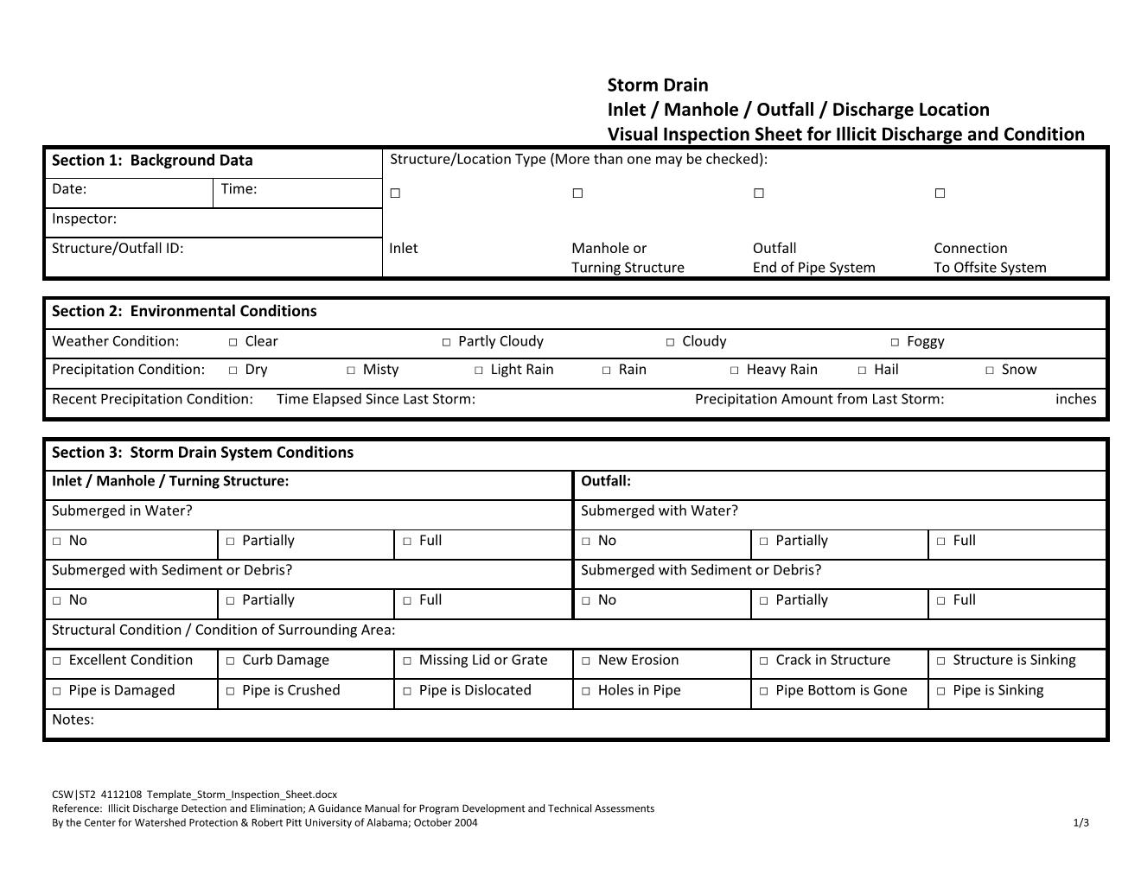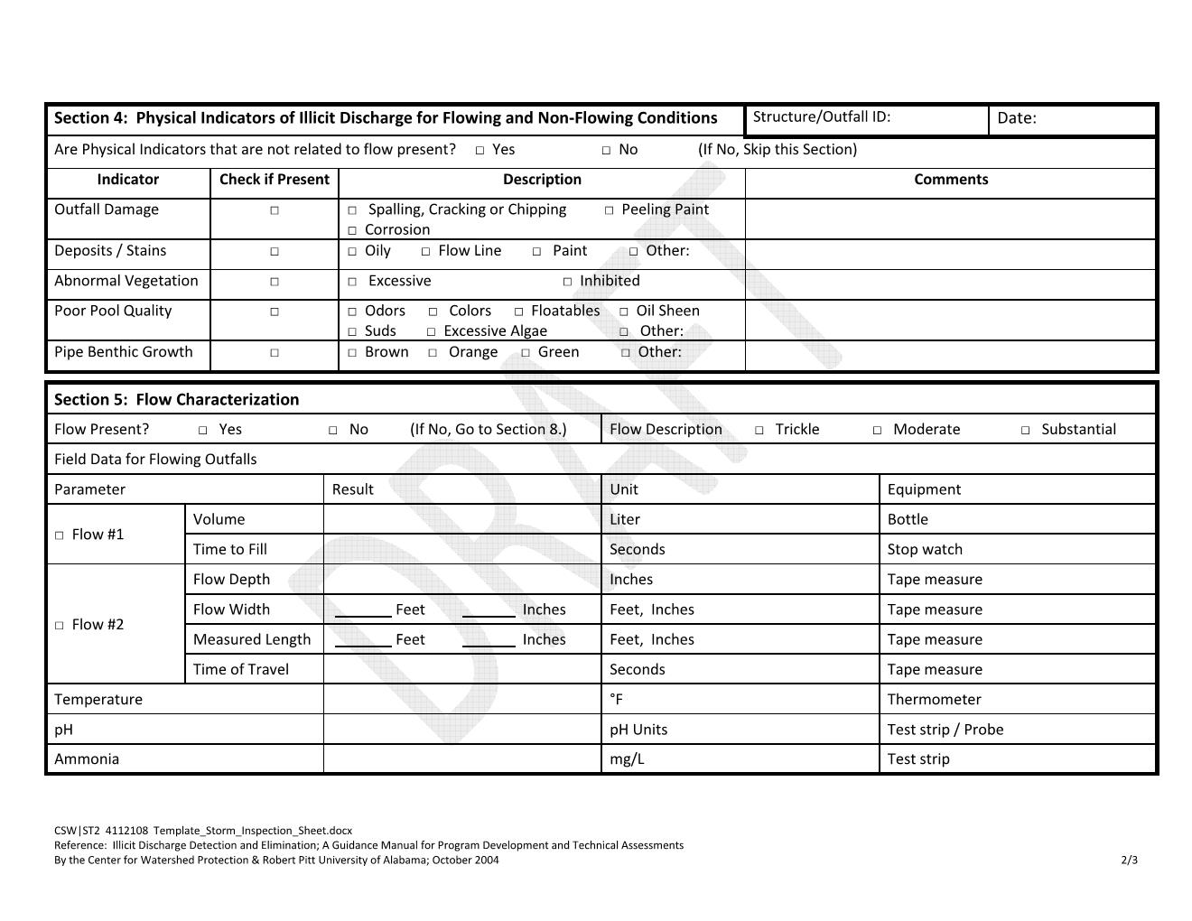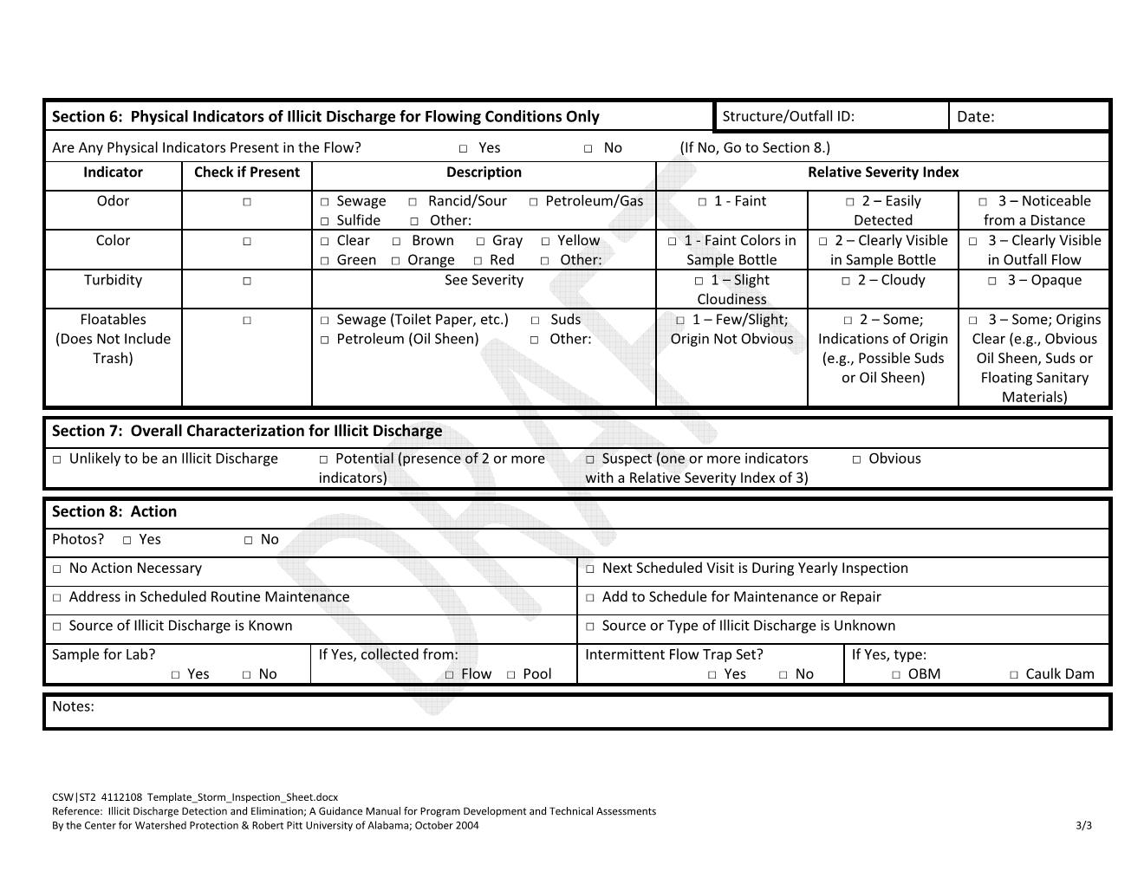

Appendix G
Sample Contract Language

Appendix H
Resources

Resources

Low Impact / Sustainable / High Performing Development:

San Mateo Countywide Water Pollution Prevention Program (SMCWPPP)
http://www.flowstobay.org/bs_new_development.php - C.3 Stormwater Technical Guidance

California Stormwater Quality Association (CASQA)
http://www.cabmphandbooks.com/ - Stormwater Best Management Practice (BMP) Handbook for New Development and Redevelopment

California Stormwater Quality Association (CASQA)
http://www.casqa.org/LID/tabid/240/Default.aspx - California Low Impact Development (LID) Portal

United States Environmental Protection Agency (US EPA)
http://cfpub.epa.gov/npdes/stormwater/menuofbmps/index.cfm -National Menu of Stormwater Best Management Practices

US Green Building Council – Leadership in Energy & Environmental Design
http://www.usgbc.org/leed

Collaborative for High Performance Schools (CHPS)
http://www.chps.net/dev/Drupal/

Construction:

California Stormwater Quality Association (CASQA)
http://www.casqa.org/LeftNavigation/ConstructionBMPHandbookPortalSWPPPTemplate/tabid/200/Default.aspx - CASQA BMP Handbooks Portal (subscription required to view)

United States Environmental Protection Agency (US EPA)
http://cfpub.epa.gov/npdes/stormwater/menuofbmps/index.cfm -National Menu of Stormwater Best Management Practices

Illicit Discharge Detection and Elimination:

United States Environmental Protection Agency (US EPA)
http://cfpub.epa.gov/npdes/stormwater/menuofbmps/index.cfm?action=min_measure&min_measure_id=3

Landscaping:

Bay-Friendly Landscaping & Gardening Coalition
http://www.bayfriendlycoalition.org/ - non-profit program developed in Alameda County by StopWaste.Org
Resources include, not limited to:
-Bay Friendly Qualified Professional training (Including for municipal maintenance workers. Seven-session class with written exam. Need to renew every two years with 4 CEUs.
-webpage on tools and resources for Municipalities and Landscape Professionals
-sample language for RFP’s
-model Policies and Ordinances
-Bay Friendly Landscape Scorecard
-Resources
-Potential Campus Event – Sponsor a Bay-Friendly Training

EcoWise
http://www.ecowisecertified.org/index.html - Certification program, which is a project of the Association of Bay Area Governments, funded by the SWRCB, focused for professionals to provide effective, prevention-based pest control, minimizing the need to use pesticides.
Resources include, not limited to:
-List of Certified IPM Service Providers
-Online Course through BIRC
-EcoWise IPM Contracting Tool Kit http://www.ecowisecertified.org/toolkit/ For Public Agencies and Businesses.

Bio-Integral Resource Center (BIRC)
http://www.birc.org/index.html - specializes in finding non-toxic and least-toxic integrated pest management solutions to urban and agricultural pest problems.
Resources include, not limited to:
-journals
-EcoWise Certification

Our Water Our World
http://www.ourwaterourworld.org/Home.aspx - Collaboration among regional and local water agencies in the SF Bay Area, managing home and garden pests in a way that helps protect water.
Resources include, not limited to:
-ask an expert feature
-Healthy gardening workshops to educate the general public about healthy gardening. Workshops and seminars are held in various communities.
-Promotional Materials
-Potential Campus Event – Sponsor a Healthy Gardening Workshop (Marin County Stormwater Pollution Prevention Program workshop table of contents http://www.ourwaterourworld.org/Portals/0/documents/pdf/Healthy-GardensTOC.pdf )

UC IPM Online
Resources include, not limited to:
http://www.ipm.ucdavis.edu/index.html - IPM resource
http://www.ipm.ucdavis.edu/training/ - Free online training on IPM topics

Recycle / Disposal:

CalRecycle
http://www.calrecycle.ca.gov/
California’s Department of Resources Recycling and Recovery
Resources include, but are not limited to:
-Recycling Information for many materials including medication waste, construction and demolition debris and electronics
-Information for recycling and waste prevention at home
-Information for Teachers and Kids

Recycle Works
http://www.recycleworks.org/business/index.html
San Mateo County – Public Works Department Program
Resources include, but are not limited to:
-composting workshops
-links to cooking oil recycling

StopWaste.Org
http://www.stopwaste.org/home/index.asp?page=1 – Alameda County Waste Management Authority and the Alameda County Source Reduction and Recycling Board operating as one public agency.

Outreach and Community-Based Social Marketing:

United States Environmental Protection Agency (US EPA)
http://cfpub.epa.gov/npdes/stormwater/menuofbmps/index.cfm?action=min_measure&min_measure_id=1 – Public Education and Outreach on Stormwater Impacts

United States Environmental Protection Agency (US EPA)
http://cfpub.epa.gov/npstbx/index.html - Nonpoint Source (NPS) Outreach Toolbox

Fostering Sustainable Behavior
http://www.cbsm.com/public/world.lasso - Site courtesy of Doug McKenzie-Mohr, Ph.D. – Environmental Psychologist

Education and Storm Water Awareness:

SWRCB / RWQCB Videos
http://www.waterboards.ca.gov/videos/ - approximately 20 videos regarding storm water issues. A few are produced with Spanish subtitles.

Bay Area Stormwater Management Agencies Association (BASMAA)
http://www.basmaa.org/Portals/0/documents/pdf/Pollution%20from%20Surface%20Cleaning.pdf – Pollution from Surface Cleaning (Brochure in English)

http://www.basmaa.org/LinkClick.aspx?fileticket=MoNchH7u%2flE%3d&tabid=57 – Pollution from Surface Cleaning (Brochure in Spanish)

http://www.basmaa.org/Training.aspx - Pollution Prevention Training and Certificate Program for Surface Cleaners

Resources for Internal Inspector/Manager Training

San Mateo Countywide Water Pollution Prevention Program
http://www.flowstobay.org/

(keep an eye on San Francisco Bay Area storm water programs for free/low cost seminars, some of which offer continuing education credits/hours)

Certified Municipal Separate Storm Sewer System Specialist
http://www.cms4s.org/

Certified Erosion, Sediment and Storm Water Inspector (CESSWI)
http://www.cesswi.org/

CASQA Training and Education Program
https://www.casqa.org/TrainingandEducation/tabid/201/Default.aspx

StormwaterONE
http://stormwaterone.com/

National Stormwater Center
https://www.npdes.com/

Appendix I
List of Acronyms and Abbreviations

LIST OF ACRONYMNS AND ABBREVIATIONS
ACOE | United States Army Corps of Engineers
ASF | Automotive Service Facility
BMP | Best Management Practice
CalEPA | California Environmental Protection Agency
CAO | County Administrator’s Office
CBC | California Building Code
CEQA | California Environmental Quality Act
County | County of San Mateo
CPESC | Certified Professionals in Erosion and Sediment Control
CUPA | Certified Unified Program Agency
CURFFL | California Uniform Retail Food Facilities Law
DES | Department of Emergency Services California
DFG | Department of Fish and Game
DI | Depth-integrated
EDC | Environmental Discovery Center
EH | Department of Health Services/  Environmental Health Division
EPA | Unites States Environmental Protection Agency
FMC | Facilities Maintenance Center
FM | Facilities Manager
FPO | Facilities Planning and Operations
HMBP  LID | Hazardous Materials Business Plan  Low Impact Development
MS4 General Permit | General Permit for Storm Water Discharges from Small Municipal Separate Storm Sewers
MCM | Minimum Control Measure
MEP | Maximum Extent Practicable
MS4 | Municipal Separate Storm Sewer
MtBE | Methyl t-Butyl Ether
NMFS | National Marine Fisheries Service
NPDES | National Pollutant Discharge Elimination System
NOI | Notice of Intent
NTU | Nephelometric Turbidity Units
PPP | Pollution Prevention Program
RGO | Retail Gasoline Outlet
RMP | Regional Monitoring Program
RWQCB  Region 2 | Regional Water Quality Control Board (of California)  Region Number for the San Francisco Bay Regional Water Quality Control Board
SAC | Supervised Adult Crews
SMCC | San Mateo County Code
SEMS | Standardized Emergency Management System
SFEI | San Francisco Estuary Institute
SSC | Suspended Sediment Concentration
State Board | California State Water Resources Control Board
SWAMP | Surface Water Ambient Monitoring Program
SWMP | Storm Water Management Program
SWPPP | Storm Water Pollution Prevention Plan
SWRCB | State Water Resources Control Board
SWWG | Storm Water Working Group
TMDL | Total Maximum Daily Load
TPW | Department of Transportation and Public Works
USGS | United States Geological Survey

Appendix J
Glossary

Glossary

At the Point of Discharge(s) – At the point where runoff is discharged from the District MS4 into a municipal MS4. Also the point where runoff exits a pipe.

Beneficial Uses - The Uses of water of the State protected against degradation, such as domestic, municipal, agricultural and industrial supply; power generation; recreation; aesthetic enjoyment; navigation and preservation of fish and wildlife, and other aquatic resources or preserves.

Benthic – An adjective used to associate an activity, an occurrence or an organism to the bottom of a body of water.

Best Management Practices (BMPs) - means schedules of activities, prohibitions of practices, maintenance procedures, and other management practices to prevent or reduce the pollution of waters of the United States. BMPs also include treatment measures, operating procedures, and practices to control facility site runoff, spillage or leaks, sludge or waste disposal, or drainage from raw material storage.

Catch Basin - A catch basin (a.k.a., storm drain inlet) is an inlet to the storm drain system that typically includes a grate or curb inlet where storm water enters the catch basin and a sump to capture sediment, debris and associated pollutants. Catch basins act as pretreatment for other treatment practices by capturing large sediments. The performance of catch basins at removing sediment and other pollutants depends on the design of the catch basin (e.g., the size of the sump), and routine maintenance to retain the storage available in the sump to capture sediment. Commonly, the term “catch basin” also refers to those inlets which are designed to capture runoff, but not designed to capture sediment.

Clean Water Act (CWA) - means the Federal Water Pollution Control Act enacted by Public Law 92-500 as amended by Public Laws 95-217, 95-576, 96-483, and 97-117; 33 USC. 1251 et seq.

Community Based Social Marketing (CBSM) - A systematic way to change the behavior of communities to reduce their impact on the environment. Realizing that simply providing information is usually not sufficient to initiate behavior change, CBSM uses tools and findings from social psychology to discover the perceived barriers to behavior change and ways of overcoming these barriers.

Construction Site - Any project, including projects requiring coverage under the General Construction Permit, that involves soil disturbing activities including, but not limited to, clearing, grading, paving, and disturbances to ground such as stockpiling, and excavation.

Discharge of a Pollutant - The addition of any pollutant or combination of pollutants to waters of the United States from any point source.

Erosion - The physical detachment of soil due to wind or water. Often the detached fine soil fraction becomes a pollutant transported storm water runoff. Erosion occurs naturally, but can be accelerated by land disturbance and grading activities such as farming, development, road building, and timber harvesting.

Erosion Control Measures – Measures used to minimize soil detachment. These may include:
• Vegetation, either undisturbed or planted (e.g., grasses, wildflowers), and other materials, such as straw (applied over bare soil, crimped into soil); protective erosion control blankets; fiber (applied as mulch or hydromulch); and mulch.

Hotspot - Hotspots are specific operations and areas in a sub watershed that may generate high storm water pollution. Hotspots are high priority sites.

Hydromodification - Modification of hydrologic pathways (precipitation, surface runoff, infiltration, groundwater flow, return flow, surface-water storage, groundwater storage, evaporation and transpiration) that results in negative impacts to watershed health and functions.

Illicit Discharge - Any discharge to a municipal separate storm sewer (storm drain) system (MS4) that is prohibited under local, state, or federal statutes, ordinances, codes, or regulations. The term illicit discharge includes all non-storm water discharges not composed entirely of storm water. The term illicit discharge does not include discharges that are regulated by an NPDES permit.

Impaired Waterbody - A waterbody (i.e., stream reaches, lakes, waterbody segments) with chronic or recurring monitored violations of the applicable numeric and/or narrative water quality criteria. An impaired water is a water that has been listed on the California 303(d) list or has not yet been listed but otherwise meets the criteria for listing. A waterbody is a portion of a surface water of the state, including ocean, estuary, lake, river, creek, or wetland. The water currently may not be meeting state water quality standards or may be determined to be threatened and have the potential to not meet standards in the future. The State of California’s 303(d) list can be found at http://www.swrcb.ca.gov/quality.html.

Impervious Surface - A surface covering or pavement of a developed parcel of land that prevents the land's natural ability to absorb and infiltrate rainfall/storm water. Impervious surfaces include, but are not limited to; roof tops, walkways, patios, driveways, parking lots, storage areas, impervious concrete and asphalt, and any other continuous watertight pavement or covering. Landscaped soil and pervious pavement, including pavers with pervious openings and seams, underlain with pervious soil or pervious storage material, such as a gravel layer sufficient to hold the specified volume of rainfall runoff are not impervious surfaces.

Integrated Pest Management (IPM) – a management strategy for the growth of vegetation which incorporates strategies of plant production and less-toxic pest management suited for the available environment and to protect beneficial uses of the surrounding habitat.

Low Impact Development – A sustainable practice that benefits water supply and contributes to water quality protection. Unlike traditional storm water management, which collects and conveys storm water runoff through storm drains, pipes, or other conveyances to a centralized storm water facility, Low Impact Development (LID) takes a different approach by using site design and storm water management to maintain the site’s pre-development runoff rates and volumes. The goal of LID is to mimic a site’s predevelopment hydrology by using design techniques that infiltrate, filter, store, evaporate, and detain runoff close to the source of rainfall. LID has been a proven approach in other parts of the country and is seen in California as an alternative to conventional storm water management.

Maximum Extent Practicable (MEP) - The minimum required performance standard for implementation of municipal storm water management programs to reduce pollutants in storm water. MEP is the cumulative effect of implementing, evaluating, and making corresponding changes to a variety of technically appropriate and economically feasible BMPs, ensuring that the most appropriate controls are implemented in the most effective manner. This process of implementing, evaluating, revising, or adding new BMPs is commonly referred to as the iterative process.

Minimum Control Measure – Practices or behaviors related to a specific topic which can be structured and modified to guide a targeted audience to protect storm water runoff.

Municipal Separate Storm Sewer System (MS4) - The regulatory definition of an MS4 (40 CFR 122.26(b)(8)) is "a conveyance or system of conveyances (including roads with drainage systems, municipal streets, catch basins, curbs, gutters, ditches, man-made channels, or storm drains) owned or operated by a state, city, town, borough, county, parish, district, association, or other public body created to or pursuant to state law.

National Pollutant Discharge Elimination System (NPDES) - A national program for issuing, modifying, revoking and reissuing, terminating, monitoring and enforcing permits, and imposing and enforcing pretreatment requirements, under sections 307, 402, 318, and 405 of the CWA.

New Development - New Development means land disturbing activities; structural development, including construction or installation of a building or structure, creation of impervious surfaces; and land subdivision on an area that has not been previously developed.

Non-Storm Water Discharge - means any discharge to storm sewer systems that is not composed entirely of storm water.

Non-Traditional Small MS4 - Federal and State operated facilities that can include universities, prisons, hospitals, military bases (e.g. State Army National Guard barracks, parks and office building complexes.)

Notice of Intent (NOI) - The application form by which dischargers seek coverage under General Permits, unless the General Permit requires otherwise.

Nuisance - Anything that meets all of the following requirements: (1) is injurious to health, or is indecent or offensive to the senses, or an obstruction to the free use of property, so as to interfere with the comfortable enjoyment of life or property; (2) affects at the same time an entire community or neighborhood, or any considerable number of persons, although the extent of the annoyance or damage inflicted upon individuals may be unequal; (3) occurs during, or as a result of, the treatment or disposal of wastes.

Open Channel - Flow within a distinct natural or modified channel, calculated as flow velocity times channel cross-sectional area.

Outfall - The point where the District municipal separate storm sewer discharges into an offsite municipal separate storm sewer system or outside of the jurisdiction of the District. Alternatively, the point where water discharges from a component of the District storm sewer system.

Parking Lot - Land area or facility for the parking or storage of motor vehicles.

Pathogen – an organism which causes disease.

Pervious Pavement - Pavement that stores and infiltrates rainfall at a rate that exceeds conventional pavement.

Pesticides – Terms Associated with;

Organophosphorous Pesticides (chlorpyrifos, diazinon, and malathion)

Pyrethroids (bifenthrin, cyfluthrin, beta-cyfluthrin, cypermethrin, deltamethrin, esfenvalerate, lambda-cyhalothrin, permethrin, and tralomethrin)

Carbamates (carbaryl )

Fipronil

Point Source - Any discernible, confined, and discrete conveyance including, but not limited to, any pipe, ditch, channel, tunnel, conduit, well, discrete fissure, container, rolling stock, concentrated animal feeding operations, landfill leachate collection systems, vessel, or other floating craft, from which pollutants are or may be discharged. This term does not include return flows from irrigated agriculture or agricultural storm water runoff.

Pollutant - Dredged spoil, solid waste, incinerator residue, filter backwash, sewage, garbage, sewage sludge, munitions, chemical wastes, biological materials, radioactive materials (except those regulated under the Atomic Energy Act of 1954, as amended (42 U.S.C. 2011 et seq.)), heat, wrecked or discarded equipment, rock, sand, cellar dirt and industrial, municipal, and agricultural waste discharged into water.

Pollutants of Concern - Pollutants of concern found in urban runoff include sediments, non-sediment solids, nutrients, pathogens, oxygen-demanding substances, petroleum hydrocarbons, heavy metals, floatables, polycyclic aromatic hydrocarbons (PAHs), trash, and pesticides and herbicides.

Pollution - An alteration of the quality of the waters of the state by waste to a degree which unreasonably affects the beneficial uses of the water or facilities which serve those beneficial uses.

Receiving Water – Surface water that receives regulated and unregulated discharges from activities on land.

Redevelopment - Land-disturbing activity that results in the creation, addition, or replacement of exterior impervious surface area on a site on which some past development has occurred. Redevelopment does not include trenching, excavation and resurfacing associated with LUPs; pavement grinding and resurfacing of existing roadways; construction of new sidewalks, pedestrian ramps, or bike lanes on existing roadways; or routine replacement of damaged pavement such as pothole repair or replacement of short, non-contiguous sections of roadway.

Riparian Areas – Plant communities contiguous to and affected by surface and subsurface hydrologic features of perennial or intermittent waterbodies. Riparian areas have one or both of the following characteristics: 1) distinctively different vegetative species than adjacent
areas, and 2) species similar to adjacent areas but exhibiting more vigorous or robust
growth forms. Riparian areas are usually transitional between wetland and upland.

Sediments - Solid particulate matter, both mineral and organic, that is in suspension, is being transported, or has been moved from its site of origin by air, water, gravity, or ice and has come to rest on the earth's surface either above or below sea level.

Sediment Control Measures – Measures used to trap and/or retain detached soil before discharging to receiving waters. These may include: fiber rolls (e.g., keyed-in straw wattles, compost rolls); silt fence; retention basins; and active treatment systems.

Sensitive Waterbody - Receiving waters which are a priority to protect. They include: 1) Areas of Special Biological Significance (ASBS), 2) areas providing or known to provide habitat for chinook and coho salmon and steelhead, and 3) beaches that serve more than 50,000 people between April 1 and October 31 and are adjacent to flowing storm drains or creeks.

Small MS4 – An MS4 that is not permitted under the municipal Phase I regulations, and which is “owned or operated by the United States, a State, city, town, borough, county, parish, district, association, or other public body (created by or pursuant to State law) having jurisdiction over disposal of sewage, industrial wastes, storm water, or other wastes.

Source Control - Land use or site planning practices, or structural or nonstructural measures, that aim to prevent runoff pollution by reducing the potential for contact with rainfall runoff at the source of pollution. Source control BMPs minimize the contact between pollutants and urban runoff.

Surface Drainage - Any above-ground runoff (sheet, shallow concentrated, and open channel) that flows into the storm drain system.

State Water Resources Control Board (SWRCB) – The State Water Resources Control Board’s mission is to preserve, enhance and restore the quality of California’s water resources, and ensure their proper allocation and efficient use for the benefit of present and future generations. http://www.waterboards.ca.gov/about_us/

Storm Drain System - The basic infrastructure in a municipal separate storm sewer system that collects and conveys storm water runoff to a treatment facility or receiving water body.

Storm Water – Storm water is generated when precipitation from rain and snowmelt events flows over land or impervious surfaces and does not percolate into the ground. As storm water flows over the land or impervious surfaces, it accumulates debris, chemicals, sediment or other pollutants that could adversely affect water quality if the storm water is discharged untreated.

Storm Water Treatment System - Any engineered system designed to remove pollutants from storm water runoff by settling, filtration, biological degradation, plant uptake, media absorption/adsorption or other physical, biological, or chemical process. This includes landscape-based systems such as grassy swales and bioretention units as well as proprietary systems.

Structural Controls - Any structural facility designed and constructed to mitigate the adverse impacts of storm water and urban runoff pollution.

Time of Concentration – The time it takes the most hydraulically-remote drop of water to travel through the watershed to a specific point of interest.

Total Maximum Daily Loads (TMDLs) - The maximum amount of a pollutant that can be discharged into a waterbody from all sources (point and nonpoint) and still maintain water quality standards. Under CWA section 303(d), TMDLs must be developed for all waterbodies that do not meet water quality standards even after application of technology-based controls, more stringent effluent limitations required by a state or local authority, and other pollution control requirements such as BMPs.

Toxicity – the degree to which a substance is toxic to animals or organisms.

Trash and Debris - Trash consists of litter and particles of litter. California Government Code Section 68055.1 (g) defines litter as all improperly discarded waste material, including, but not limited to, convenience food, beverage, and other product packages or containers constructed of steel, aluminum, glass, paper, plastic and other natural and synthetic materials, thrown or deposited on the lands and waters of the state, but not including the properly discarded waste of the primary processing of agriculture, mining, logging, sawmilling, or manufacturing.

Treatment - Any method, technique, or process designed to remove pollutants and/or solids from polluted storm water runoff, wastewater, or effluent.

Waste - Includes sewage and any and all other waste substances, liquid, solid, gaseous, or radioactive, associated with human habitation, or of human or animal origin, or from any producing, manufacturing, or processing operation, including waste placed within containers of whatever nature prior to, and for purposes of, disposal.

Waste Load Allocation -The portion of a receiving water's total maximum daily load that is allocated to one of its existing or future point sources of pollution. Waste load allocations constitute a type of water quality-based effluent limitation.

Water Quality Control Plan (Basin Plan) –The Regional Water Board’s master water quality control planning document. It designates beneficial uses and water quality objectives for waters of the State within each Region, including surface waters and groundwater. It also includes programs of implementation to achieve water quality objectives and discharge prohibitions. Basin Plans are adopted and approved by the State Water Board, U.S. EPA, and the Office of Administrative Law where required.

Watershed Processes – Functions that are provided by watersheds, including but not limited to, groundwater recharge, sediment supply and delivery, streamflow, and aquatic habitat.

The Weather Channel - http://www.weather.com /weather/wxclimatology/monthly/graph/USCA1005 (revise or delete as applicable)
State Water Resources Control Board - http://www.waterboards.ca.gov/water_issues/programs/tmdl/integrated2010.shtml
Definitions in the Glossary are taken in part from documents produced by the State Water Resources Control Board for the Industrial General Permit, the Phase II Small Municipal Separate Storm Sewer System (MS4) Program and Construction Storm Water Program. Some definitions were modified to suit activities and facilities within the San Mateo County Community College District. http://www.swrcb.ca.gov/water_issues/programs/stormwater/

