Water Efficiency Program
Template

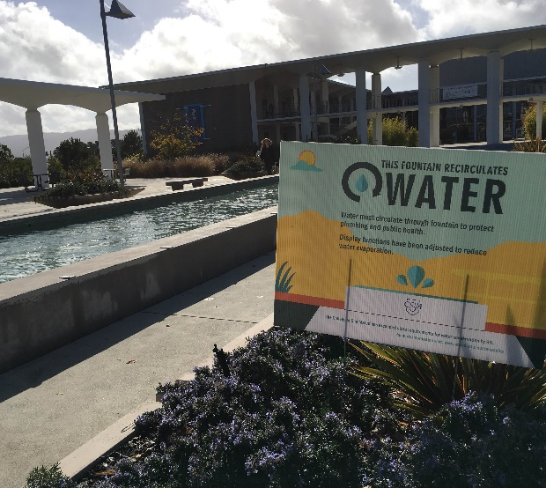
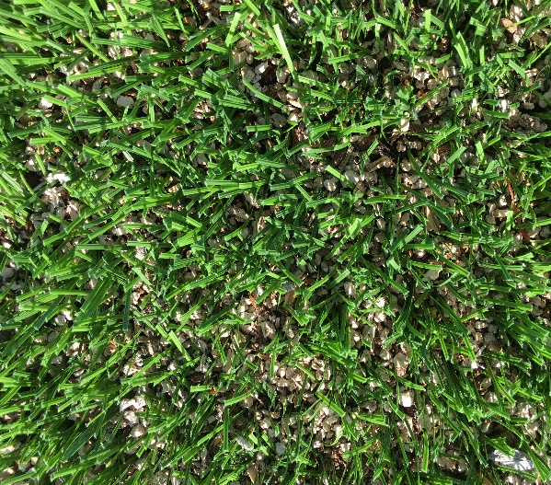
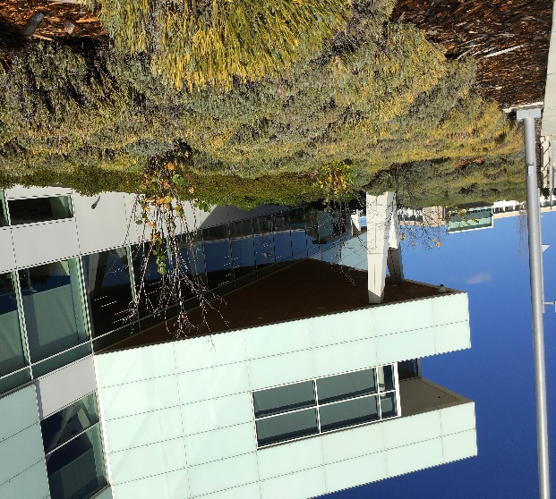

December 2015

Table of Contents
1.0 Executive Summary 4
2.0 Introduction 5
2.1 District & Campus Overview 5
2.2 District & Campus Geographic Location and Area Climate 6
2.3 Local Water Resources 6
2.4 Establishing District and Campus Water Conservation 7
2.4.1 Key Players 7
2.4.2 Regulatory Context of Water Conservation 8
2.4.3 History of Water Conservation at District Facilities 9
2.4.4 Benefits of Water Conservation at District Facilities 9
2.4.5 Establish Purpose 10
3.0 Water Efficiency Program 11
3.1 Step 1: Measure and Benchmark Current Water Consumption 14
3.2 Step 2: Develop a Water Use Profile 15
3.3 Step 3: Identify and Establish Water Reduction Target and Goals 16
3.4 Step 4: Identify, Evaluate, and Select Water Conservation Measures 18
3.5 Step 5: Plan, Budget, and Implement Selected Water Conservation Measures 19
3.6 Step 6: Monitor and Evaluate Water Efficiency Program Effectiveness 20
4.0 Student, Faculty and Community Engagement 22
4.1 Audience 22
4.2 Channels of Communication 22
4.2.1 Existing 22
4.2.2 New 23
4.3 Engagement 23
Appendix A: Water Utility Contact Information 24
Appendix B: Water Conservation Measures in Place 25
Appendix C: Step 4 Worksheet 26
Appendix D: Additional Resources 27

The purpose of the Water Efficiency Program (WEP) Template is to provide a framework for other colleges or districts to identify conservation measures and save water. This template will aid in identifying information gaps and close those gaps while serving to change behavior and create value within campus culture and the local community

1.0 Executive Summary

The purpose of this section is to provide the reader with an overview of your Water Efficiency Program (WEP). It is suggested to complete this section last after the WEP has been written and a summary delivered here. Answer the following questions to use as a guide in writing your executive summary.

- What is the need to address water efficiency in your geographic location and area climate?
- What is the name of your district and/or campus?
- What is the WEP?
- What is the purpose of the WEP?
- What value does the WEP bring to your institution?
- How does the WEP process provide a framework to map out accomplishments and projects?
- Why is this document is a continuous process and considered a “living document?”
- How will the WEP serve your campus and local community?

2.0 Introduction

The introduction serves to identify key background information and set the stage of the WEP. In this section, describe the essential role water plays in the environment and every day life. Continue with describing the importance and responsibility humans have in water conservation efforts in the face of drought and climate change.

2.1 District & Campus Overview
Describe when your institution was establsihed, number of students, faculty, and staff, average square feet, number of buildings, and acres of landscaped areas.

2.2 District & Campus Geographic Location and Area Climate
Describe district and/or campus geographic location and include a map that indicates the location(s). Define location(s) climate by including average temperatures in summer and winter, average annual precipitation, and note seasonal differences. If you are a district and there are signficant climatic differences on each campus, be sure to note these differences.

2.3 Local Water Resources
Describe the story of how water comes comes out of your tap. Start by describing the water system that serves your district or campus facilities and identify the agency that manages the system infrastructure. Water systems vary upon location, therefore it is important to identify the source and the water agency or utility that delivers water to your campus. Fill in Appendix A: Water Utility Contact Information to organize contact information for each utility.

Drought will have been described earlier when the introduction began, however in this section describe why drought is occuring in your water system. Ex: Reduced snowpack in the Sierra Nevada mountains is reducing snowmelt into the Hetch Hetchy system.

2.4 Establishing District and Campus Water Conservation
This section serves to combine the details of district and campus structure with water conservation. The following sub-sections will outline the key players, regulatory context of water, history of water conservation, benefits of water conservation, and establish WEP purpose and objectives.

2.4.1 Key Players
Describe your district and/or campus organizational structure by identifying the key players that are involved with the decision making and implementation of the WEP. Include a graphic like the one below that demonstrates the organizational structure.

Note: This graphic is an example of how the key players in your organization may be structured. Use Word “SmartArt” on the “Insert” tab to use an alternative hiearchy chart that best fits your organization.

2.4.2 Regulatory Context of Water Conservation

Begin by describing the importance of water conservation to district and campus sustainability goals. Briefly identify and describe the value water conservation brings to your institution. Next, describe the how water conservation has been established at your district and/or campus. Note pivotal moments, for example: “In January 2014 the SMCCCD Chancellor issued a 25% District-wide mandate for water use reduction compared to 2013 levels. This mandate was issued more than a year prior to Governor Brown’s emergency regulations.”

Include a timeline to provide a visual example of how water conservation has been put into regulatory context throughout your institution and compare it to concurrent regulations at a state and local level.

Move and copy and paste for additional timeline notches
Copy and paste text boxes to create more events
Add Year
Present
State/Local
District/Campus
Date
[Insert event here]
Date
[Insert event here]
Note: This timeline is a sample timelline to provide a visual example of district/campus regulations versus state/local regulations.

2.4.3 History of Water Conservation at District Facilities

Similar to SMCCCD, most districts and campuses have already implemented water conservation measures. It is important to identify these ahead of time in your plan so they can be acknowledged and potentially improved upon. Fill in the table in Appendix B: Water Conservation Measures in Place to organize your district and/or campus conservation measures by campus, measure type, water consercation measure, timeframe, expected water savings, and additional notes.
Briefly list and describe the water efficiency measures that have been implemented at district facilities. If there are associated savings, include the information with the water efficiency measure. For example: “Althletic grass fields replaced with synthetic turf. Maintenance and water cost savings are approximately 5.8 million gallons with an annual cost savings of approximately $370,000.”
Add a few pictures to support selected examples.

2.4.4 Benefits of Water Conservation at District Facilities
Describe the environmental, economic, and social benefits water conservation has to your district, to the community, local ecosystem, etc. For example: “Substantial money savings on water bills; Reduced stress on the environment by providing increased water available to local streams, wetlands, and their natural inhabitants.” This can be presented in the form of a paragraph, list, or table.

2.4.5 Establish Purpose

Things to keep in mind when establishing the purpose are your audience, what message you are trying to relay to them, and the value of this message to your audience.

.
The Water Efficiency Program (WEP) serves to…
{Add your purpose here by answer the questions above}

3.0 Water Efficiency Program
The purpose of this section is to go over each step of the WEP process. The schematic below shows the continous improvement process designed to constantly come back to the beginning in order to manage existing conservation measures, build upon these measures, add additional measures, and increase overall water efficiency. The details of each step are described on the following page.

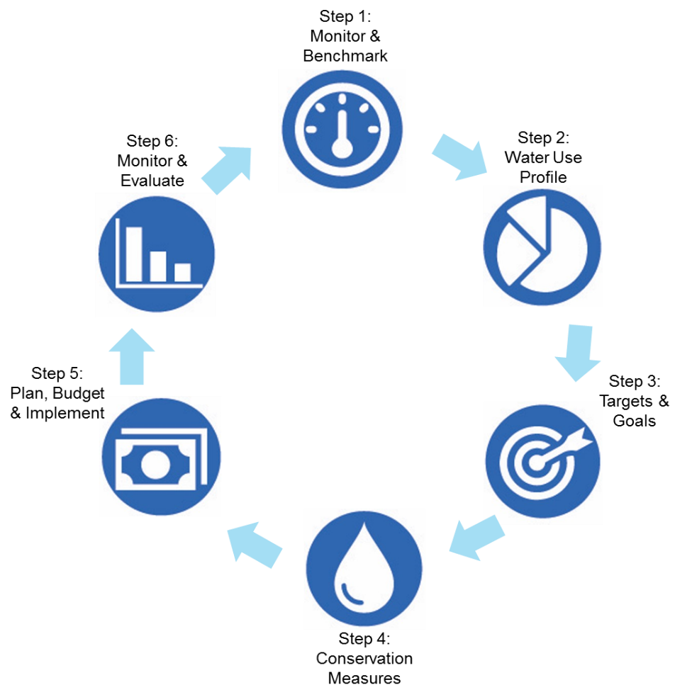

Note: Copy and paste this graphic into your WEP
Step 1: Measure and Benchmark Current Water Consumption
This is vital for tracking progress so that the District can continue to measure consumption on an ongoing basis and quantify the savings from reduction efforts. Water reduction opportunities will become apparent once water use is measured and benchmarked.
Step 2: Develop a Water Use Profile
This will help clarify how water is used in various building types and facilities systems in order for the District to identify and prioritize the best water reduction opportunities. Must also include determining the impact of existing conservation efforts on current water use.
Step 3: Identify and Establish Water Use Reduction Targets and Goals
Identify current short and long term targets and goals set by regulatory agencies or by District leadership and staff. Establish targets and goals that can be reached through water conservation strategies.
Step 4: Identify, Evaluate and Select Water Conservation Measures
Identify all conservation measures that save water – “hardware” devices and technologies as well as behavior and management practices – and develop a matrix of measures that may be considered suitable for District facilities. Evaluate candidate measures by performing a benefit-cost analysis, and select measures to implement. Appendix C contains a list of water conservation measures currently implemented at District facilities. Appendix D contains a list of potential conservation measures for evaluation.
Step 5: Plan, Budget, and Implement Selected Water Conservation Measures
Prepare an implementation plan by detailing the budget, schedule and staffing.
Step 6: Monitor and Evaluate Water Efficiency Program Effectiveness
The effectiveness of this WEP depends on timely review and adaptation as conditions change and knowledge evolves. This step is designed to verify that conservation measures are effectively reducing water use, to measure progress toward attainment of specific targets/goals, to track costs and savings, and to inform next steps toward further Program improvements.
Note: Copy and past this table into your WEP
Throughout the WEP process, each step will provide a background as to why that particular step is important to the process. Some steps will include additional background information, examples, and graphics to support the steps.
Each step will also include a table, shown below, that you will use to answer three questions:
- What do we know?
- What are our gaps of information?
- What are the actions completed so far and what do we need?
Ask each question in reference to the step of the process you are working on. For example: “What do we know about measuring and benchmarking current water consumption at our district and/or campuses?” or “What are our gaps of information in developing a water use profile?” (Sample Answer: Lack of real-time water data).
Answer the questions by filling in the table from LEFT to RIGHT. This will aid in identifying the actions that have already been completed and further opportunities for water efficiency at your instutition’s facilities.
What do we know? | What are our gaps of information? | What are our actions completed so far and what do we need?

The material from the tables will help organize the information you will write in the box below. Add assisting photos, tables, or graphics to support the text.
Take material from the table above and write information text in the textboxes provided.

3.1 Step 1: Measure and Benchmark Current Water Consumption
It is important to establish a benchmark in order to track water efficiency progress. Measuring current water consumption is commonly done by gathering and analyzing data from installed water meters. If your instituion has installed meters and has access to real time data, then this will be a good resource to assist in establishing a benchmark. If your institution does not have water meters, you can find water usage data from your monthly water utility bills and establish a benchmark using this information.

Fill in the table below with bulleted points for that answers each question.

What do we know? | What are our gaps of information? | What are our actions completed so far and what do we need?

Fill in the textbox below using the information from the table.

3.2 Step 2: Develop a Water Use Profile
Water use profiles are typically developed by analyzing real time data from installed water meters. If your campus has access to real time data with meters installed, analyze water usage and group the data into categories. Common categories used in a water use profile on college campuses include: irrigation/landscaping, industrial, domestic, laboratories, kitchens, dormoratories, recreational (pools), fountains, etc.

If you campus does not have access to real time data, identify the major water uses on your campus(es) and group them accordingly. For example at SMCCCD, our big water uses are described as followed in the graphic below:
Irrigation | Irrigation use to maintain landscaped areas, including planted areas of bushes, shrubs, fescues and trees
Industrial | Industrial use, which includes water used for such purposes as fabricating, processing, washing hard surfaces and heating and cooling
Domestic | Domestic use, which includes water used for drinking fountains, faucets, and flushing water closets and urinals.
Miscellaneous | Until further metering to separate out sub-categories, miscellaneous use is water used for preparing food, bathing, washing clothes, dishwashing, servicing swimming pools and fountains, and other uses not included in the above categories

Fill in the table below with bulleted points for that answers each question.

What do we know? | What are our gaps of information? | What are our actions completed so far and what do we need?
Fill in the textbox below using the information from the table.

3.3 Step 3: Identify and Establish Water Reduction Target and Goals
Short- and long-term targets and goals established by regulatory agencies or by District leadership or staff and can be designed to reflect a basic, intermediate or more aggressive approach to reducing water use. Targets/goals will help inform which water conservation measures to implement to achieve stated goals. These may include percent or volume reductions for a given time period, reduced costs for water and/or wastewater services, reducing energy combustion byproducts that contribute to air pollution including greenhouse gas emissions, reduced impacts in the water environment (instream flows, effects on wetlands), increased student and community involvement in WEP implementation, etc.

Certain goals may not provide measurable data with which to evaluate progress toward achieving water use reduction targets. For example, an outreach goal may involve providing a defined number of K-12 school programs each year, or issuing a defined number of announcements each year through a specific social media outlet. Targets and goals may not be the same from campus to campus because of differences in the water use profile at each campus, and targets/goals will likely change over time as the WEP is refined to adapt to changing conditions.

It is important to keep in mind the different levels of regulatory targets and goals already set. The graphic to the left demonstrates the various levels to keep in mind when identifying and estbalishing goals.

Fill in the table below with bulleted points for that answers each question.

What do we know? | What are our gaps of information? | What are our actions completed so far and what do we need?

Fill in the textbox below using the information from the table.

3.4 Step 4: Identify, Evaluate, and Select Water Conservation Measures
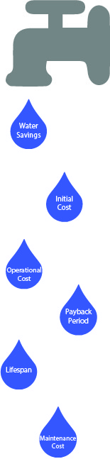
When identifying water conservation measures, it is important to revisit the water use profile established in Step 2. This will assist in identifying the highest uses and focus on implementing water conservation measures for larger savings. For example, SMCCCD has identified irrigation as its largest user and has implemented a variety of conservation measures to reduce irrigation of athletic fields and patches of aesthetic natural turf.

After identifying conservation measure options, keep in mind the varying economic, environmental, and social factors will have a major influence on efficiency strategies for a campus. The graphic to the right is a visual example of these things to keep in mind.

When selecting water conservation measures, it is important to examine the initial cost, maintenance cost(s), estimated water reduction, estimated annual cost savings, payback period, and any additional notes for each measure you select. Use Appendix C: Step 4 Worksheet to fill in and organize water conservation measures.

Fill in the table below with bulleted points for that answers each question.

What do we know? | What are our gaps of information? | What are our actions completed so far and what do we need?

Fill in the textbox below using the information from the table.

3.5 Step 5: Plan, Budget, and Implement Selected Water Conservation Measures
In this section you will develop a plan from the most attractive measures that includes budgets, a schedule for implementation and a staffing plan, where applicable.

Planning the implementation of the selected water conservation measures can be organized by creating a timeline. This timeline will include when a measure is implemented, when it requires maintenance, pay-back period, and when it needs to be upgraded.

Creating a budget that goes along with the planning process will help organize the cost of the initial project, maintenance, and upgrades and match it with the pay-back period.

The plan and budget will need to be reviewed by the respective administrative parties and once it is approved, the water conservation measures can be implemented.

Fill in the table below with bulleted points for that answers each question.

What do we know? | What are our gaps of information? | What are our actions completed so far and what do we need?

Fill in the textbox below using the information from the table.

3.6 Step 6: Monitor and Evaluate Water Efficiency Program Effectiveness
Once water conservation measures are in place, monitoring water consumption will tell you if your efficiency measures are working. If you have water metering infrastructure, real-time water meter data is the most effective way to evaluate the measures’ effectiveness. Water meter data should be monitored daily and weekly at a minimum to identify leaks. If you don’t have water meter infrastructure, monthly utility bills will provide you with monthly consumption data. Some things to look for when monitoring monthly and annual data include:
- If the water conservation measure is working as you expected [reword]
- New buildings and projects
- Student population changes
- Seasonal and weather variations
- Number of academic days per month
- Special events held on campus (i.e. buildings and rooms rented out on the weekends for community events, conferences, or weddings)

Fill in the table below with bulleted points for that answers each question.

What do we know? | What are our gaps of information? | What are our actions completed so far and what do we need?

Fill in the textbox below using the information from the table.

Water consumption data will identify the effectiveness of the measure and if maintenance is required to increase efficiency. It may be helpful to assess Program effectiveness according to an established schedule to ensure an adaptive approach to Program management and continual improvement in water use efficiency.

One such schedule is outlined in the table below. Findings from each evaluation performed should be well-documented, with information summarized for presentation to District leadership, students, faculty and other groups of interest.
Frequency | Evaluation
Annually | - Compile all meter and sub-meter data for the year.  - Compile all cost data for the year.  - Evaluate the data set with data from previous years to assess water use trends, including annual water usage and costs.  - Evaluate cost and usage reductions or increases, and attempt to correlate these with implemented water conservation measures, to campus population dynamics, campus build-out, or other variables.  - Compare water use reductions with reduction targets and goals to determine whether the gap is closing.  - Review conservation measures that target behavior modification to determine if goals were met.  - Prepare a brief summary of program activities and achievements for the year, and include any recommendations for program improvements.  - Publicize successes.
Every 2 Years | - Identify, if possible, which water conservation measures are effectively making gains toward attaining water reduction targets and which are not.  - If possible, determine why ineffective measures are ineffective and document findings.  - Compare expected reductions for each conservation measure vs. actual reductions. Refine assumptions as necessary.  - Revisit the benefit-cost analysis to update assumptions, and recalculate benefit-cost ratios.  - Review literature for new technologies or processes, and append the list of potential conservation measures with new measures.  - Perform the benefit-cost analysis on new measures.
Every 5 Years | - Evaluate conservation measures implemented.  - Decide whether to modify the approach or continue working the same implementation plan.  - Implement new or more aggressive conservation measures if necessary to meet established targets/goals.  - Revise the schedule for attaining targets/goals if necessary.

4.0 Student, Faculty and Community Engagement

The purpose of this section is to identify your audience and how you will communicate the WEP to them through existing and new channels of communication.

4.1 Audience

Identify your district and/or campus audience. This may include students, staff, faculty, visitors, and the greater local community. Give a brief profile of each audience type.

4.2 Channels of Communication
This section will identify the channels of communication your insitution currently utilizes and also potential opportunities.

4.2.1 Existing

Describe the existing channels of communication that are being utizilized currently to communicate water efficiency with your audience. This may include cirriculum, signage, email newsletters, weekly/monthly newspapers, etc.

4.2.2 New
Identify and describe new channels of communication that have not been used to communicate water efficiency. This maybe include social media, email newsletters, signage in different locations, etc.

4.3 Engagement
Now that you have identified your audience and channels of communication, establish a plan that identifies which channels you will use. Include a brief plan that describes how you will engage your audience. This can be organized in a table, list, or paragraphs.

Appendix A: Water Utility Contact Information
Campus / Utility | Information | Contact | Title/Dept | Phone No. | Email address
Example:  Skyline College  City of San Bruno | Rebates & Programs | Mark Reinhardt | Water System and Conservation Manager | [650] 616-7167 | mreinhardt@sanbruno.ca.gov
 | Billing &  Usage | Joanne Ryan | Utility Billing | [650] 616-7033 | jryan@sanbruno.ca.gov
 | Regulations | Mark Reinhardt | Water System and Conservation Manager | [650] 616-7167 | mreinhardt@sanbruno.ca.gov
Website: http://sanbrunowater.ca.gov/
UWMP: www.sanbruno.ca.gov/works_images/UWMP_San_Bruno_%202011.pdf

Appendix B: Water Conservation Measures in Place

Campus | Measure Type | Water Conservation Measure | Timeframe | Expected  Water Savings | Notes
Example: District-Wide | Irrigation | Replace natural turf with artifcial turf | Complete | 25%

Appendix C: Step 4 Worksheet

Conservation Measure | Initial Cost | Maintenance Cost(s) | Water Reduction | Annual Cost Savings | Payback Period (years) | Lifespan | Notes

Appendix D: Additional Resources
Associations, Agencies, etc.
- Alliance for Water Efficiency: http://www.allianceforwaterefficiency.org
- American Water Works Association: www.awwa.org
- Association of California Water Agencies (ACWA): www.acwa.com
- Bay Area Water Supply and Conservation Agency: www.bawsca.org
- BeWaterWise.com (Metropolitan Water District of Southern CA)
- California Urban Water Conservation Council: www.cuwcc.org
- National Association of Water Companies: www.nawc.org
- Pacific Institute/The California Drought: www.californiadrought.org
- San Francisco Public Utilities Commission: www.sfwater.org
- San Mateo County Energy Watch: www.smcenergywatch.com
- SaveOurWater.com (ACWA, CA DWR)
- WaterReuse Association: www.watereuse.org

Publications
- BC Water News/California (requires subscription): www.bcwaternews.com
- California Water Service Company, Mid-Peninsula District Conservation Master Plan: 2011-2015, http://www.water.ca.gov/urbanwatermanagement/2010uwmps/CA%20Water%20Service%20Co%20-%20Mid%20Peninsula%20District/Appendix_G_-_Conservation_MP.pdf
- Handbook of Water Use and Conservation (Vickers, WaterPlow Press, 2010)
- WaterSmart Guidebook for Businesses (EBMUD): http://www.ebmud.com/water-and-wastewater/water-conservation/watersmart-guidebook
State and Federal Resources
- California Department of Water Resources: http://www.water.ca.gov/waterconditions
- California Green Building Standards Code: http://law.resource.org/pub/us/code/bsc.ca.gov/gov.ca.bsc.2013.11.pdf
- California Integrated Management Information System (CIMIS): www.cimis.water.ca.gov
- California Plumbing Code: www.iapmo.org/2010%20California%20Plumbing%20Code/Chapter%2004.pdf
- California Weekly Drought Brief: ca.gov/drought/pdf/Weekly-Drought-Update.pdf
- Energy Efficiency and Renewable Energy: energy.gov/eere/efficiency/buildings
- Greening EPA: http://www.epa.gov/oaintrnt/water/best_practices.htm
- National Renewable Energy Laboratory: www.nrel.gov
- State Water Resources Control Board: www.swrcb.ca.gov/waterrights/water_issues/programs/drought/emergency_regulations_waterconservation.shtml
- US Drought Monitor (CA): CA
- US Drought Portal: www.drought.gov/drought
- US Geological Survey: ca.water.usgs.gov/data/drought/
- Water Recycling and Reuse (EPA Region 9): www.epa.gov/region9/water/recycling
- WaterSense: http://www.epa.gov/watersense
- WaterSMART (Bureau of Reclamation): www.usbr.gov/WaterSMART/
University Programs
- California Institute for Water Resources (UC): ciwr.ucanr.edu
- Chapman University: www.chapman.edu (see Environmental Audit Results: http://www.chapman.edu/campus-services/facilities-management/sustainability/environmental-audit

